# AWS Basics

<https://aws.amazon.com/about-aws/global-infrastructure/?p=ngi&loc=0>

AWS infrastructure

1. AWS Regions 🡪Based on geography
2. AWS Availability Zones 🡪 3 or more AZ compose a region
3. AWS Data Centers 🡪 Each availability zone is a **physically separate data center** within a region, with independent power, cooling, and networking infrastructure
4. AWS Edge Locations or Points of Presence 🡪 The Edge Locations are strategically positioned data centers located around the world designed to optimize the delivery of content and applications. They serve as points of presence (PoPs) for the AWS services enabling data to be served from the location closest to the end user which significantly reduces latency.

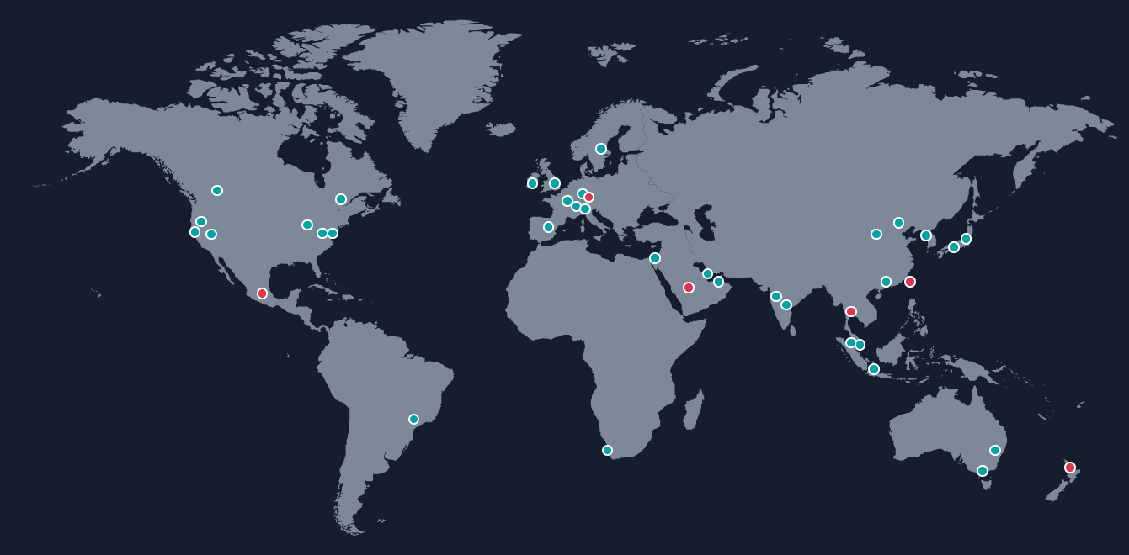

AWS Regions

* AWS has Regions all around the world based on geography
* Names can be us-east-1, eu-west-3…
* A region is a cluster of data centers
* Most AWS services are region-scoped

How to choose an AWS Region?

* Compliance with data governance and legal requirements: data never leaves a region without your explicit permission
* Proximity to customers: reduced latency
* Available services within a Region: new services and new features aren’t available in every Region
* Pricing: pricing varies region to region and is transparent in the service pricing page

AWS Availability Zones

* Each region has many availability zones (usually 3, min is 3, max is 6). Example:

1. ap-southeast-2a
2. ap-southeast-2b
3. ap-southeast-2c

* Each availability zone (AZ) is one or more discrete data centers with redundant power, networking, and connectivity
* They’re separate from each other, so that they’re isolated from disasters
* They’re connected with high bandwidth, ultra-low latency networking

**AWS has Global Services:**

* Identity and Access Management (IAM)
* Route 53 (DNS service)
* CloudFront (Content Delivery Network)
* WAF (Web Application Firewall)

**AWS services are Region-scoped:**

* Amazon EC2 (Infrastructure as a Service)
* Elastic Beanstalk (Platform as a Service)
* Lambda (Function as a Service)
* Rekognition (Software as a Service)

Region Table: <https://aws.amazon.com/about-aws/global-infrastructure/regional-product-services>

# EC2

EC2 is one of the most popular of AWS’ offerings

* EC2 = Elastic Compute Cloud = Infrastructure as a Service
* It mainly consists of the capability of:

1. Renting virtual machines (EC2)
2. Storing data on virtual drives (EBS)
3. Distributing loads across machines (ELB)

* Scaling the services using an auto-scaling group (ASG)

**EC2 size & configuration options**

1. Operating System (OS): Linux, Windows or Mac OS
2. How much power & cores (CPU)
3. How much random-access memory (RAM)
4. How much storage space: Network-attached (EBS & EFS) hardware (EC2 Instance Store)
5. Network card: speed of the card, Public IP address
6. Firewall rules: security group
7. Bootstrap script (configure at first launch): EC2 User Data

**EC2 User Data**

* It is possible to boot-strap our instances using an EC2 User data script. Bootstrapping means launching commands when a machine starts. That script is only run once at the first start
* EC2 user data is used to automate boot tasks such as:

1. Installing updates
2. Installing software
3. Downloading common files from the internet

* The EC2 User Data Script runs with the root user

**EC2 Instance Types - Overview**

You can use different types of EC2 instances that are optimized for different use cases (<https://aws.amazon.com/ec2/instance-types/> ).AWS has the following naming convention:

m5.2xlarge

* m: instance class
* 5: generation (AWS improves them over time)
* 2xlarge: size within the instance class

Different types

**General Purpose** Great for a diversity of workloads such as web servers or code repositories. Starts with M or T. It balances between:

* Compute
* Memory
* Networking

**Compute Optimized** Great for compute-intensive tasks that require high performance processors: Starts with C. Use cases

* Batch processing workloads
* Media transcoding
* High performance web servers
* High performance computing (HPC)
* Scientific modeling & machine learning
* Dedicated gaming servers

**Memory Optimized** Fast performance for workloads that process large data sets in memory.Use cases:

* High performance, relational/non-relational databases
* Distributed web scale cache stores
* In-memory databases optimized for BI (business intelligence)
* Applications performing real-time processing of big unstructured data

**Storage Optimized** Great for storage-intensive tasks that require high, sequential read and write access to large data sets on local storage. Use cases

* High frequency online transaction processing (OLTP) systems
* Relational & NoSQL databases
* Cache for in-memory databases (for example, Redis)
* Data warehousing applications
* Distributed file systems

## Security Groups

Security Groups are the fundamental of network security in AWS. They control how traffic is allowed into or out of our EC2 Instances. Security groups only contain rules. Security groups rules can reference by IP or by security group.

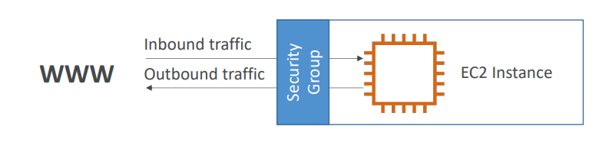

Security groups are acting as a “firewall” on EC2 instances They regulate:

* Access to Ports
* Authorized IP ranges – IPv4 and IPv6
* Control of inbound network (from other to the instance)
* Control of outbound network (from the instance to other)

Imp

Can be attached to multiple instances

* Locked down to a region / VPC combination
* Does live “outside” the EC2 – if traffic is blocked the EC2 instance won’t see it
* It’s good to maintain one separate security group for SSH access
* If your application is not accessible (time out), then it’s a security group issue
* If your application gives a “connection refused “error, then it’s an application error or it’s not launched
* All inbound traffic is blocked by default
* All outbound traffic is authorized by default

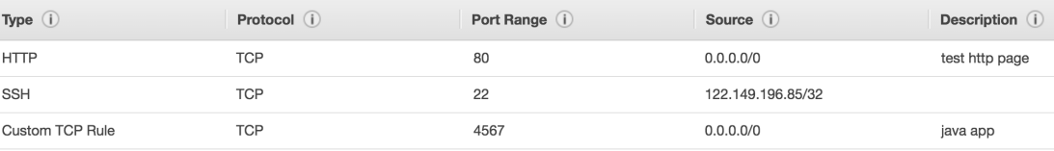

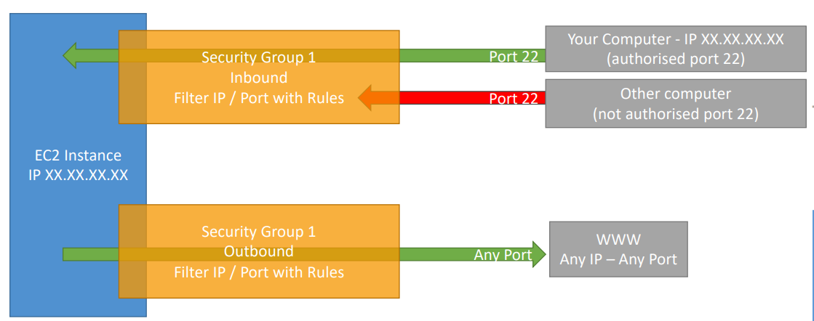

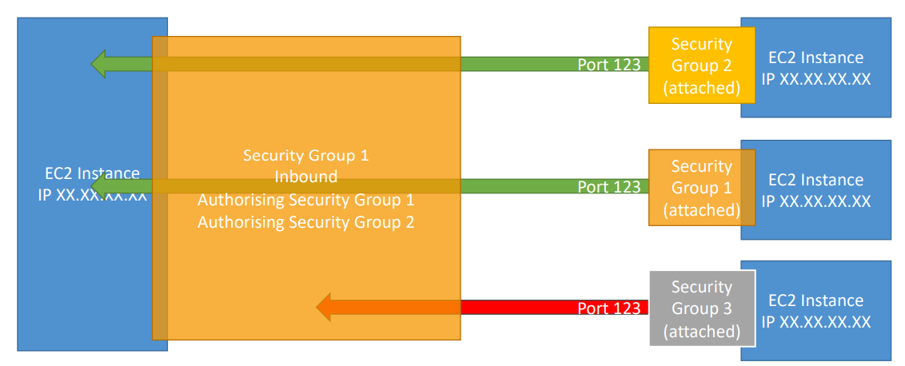

• 22 = SSH (Secure Shell) - log into a Linux instance

• 21 = FTP (File Transfer Protocol) – upload files into a file share

• 22 = SFTP (Secure File Transfer Protocol) – upload files using SSH

• 80 = HTTP – access unsecured websites

• 443 = HTTPS – access secured websites

• 3389 = RDP (Remote Desktop Protocol) – log into a Windows instance

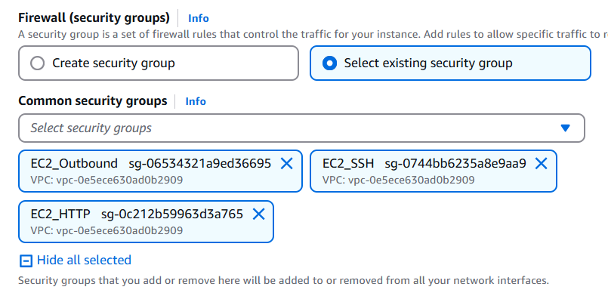

## Purchasing options

1. **On-Demand Instances** – short workload, predictable pricing, pay by second
2. **Reserved** (1 & 3 years)

* Reserved Instances – long workloads
* Convertible Reserved Instances – long workloads with flexible instances

1. **Savings Plans** (1 & 3 years) –commitment to an amount of usage, long workload
2. **Spot Instances** – short workloads, cheap, can lose instances (less reliable)
3. **Dedicated Hosts** – book an entire physical server, control instance placement
4. **Dedicated Instances** – no other customers will share your hardware
5. **Capacity Reservations** – reserve capacity in a specific AZ for any duration

### 1 EC2 On Demand

* Pay for what you use:
* Linux or Windows - billing per second, after the first minute
* All other operating systems - billing per hour
* It has the highest cost but no upfront payment
* No long-term commitment
* Recommended for short-term and un-interrupted workloads, where you can't predict how the application will behave

### 2 EC2 Reserved Instances

* Up to 72% discount compared to On-demand
* You reserve a specific instance attribute (Instance Type, Region, Tenancy(multi-tenant means multiple customer apps will run), OS)
* Reservation Period – 1 year (+discount) or 3 years (+++discount)
* Payment Options – No Upfront (+), Partial Upfront (++), All Upfront (+++)
* Reserved Instance’s Scope – Regional or Zonal (reserve capacity in an AZ)
* Recommendation for steady-state usage applications (think database)
* You can buy and sell in the Reserved Instance Marketplace
* **Convertible Reserved Instance**
* Can change the EC2 instance type, instance family, OS, scope and tenancy
* Up to 66% discount

### 3 EC2 Savings Plans

* Get a discount based on long-term usage (up to 72% - same as RIs)
* Commit to a certain type of usage ($10/hour for 1 or 3 years)
* Usage beyond EC2 Savings Plans is billed at the On-Demand price
* Locked to a specific instance family & AWS region (e.g., M5 in us-east-1)
* Flexible across below metrics:
* Instance Size (e.g., m5. xlarge, m5.2xlarge)
* OS (e.g., Linux, Windows)
* Tenancy (Host, Dedicated, Default)

### 4 EC2 Spot Instances

* Can get a discount of up to 90% compared to On-demand
* Instances that you can “lose” at any point of time if your max price is less than the current spot price
* The MOST cost-efficient instances in AWS
* Useful for workloads that are resilient to failure
* Batch jobs
* Data analysis
* Image processing
* Any distributed workloads
* Workloads with a flexible start and end time
* Not suitable for critical jobs or databases

How does spot booking work?

* Define **max spot price** and get the instance while **current spot price < max**
* The hourly spot price varies based on offer and capacity.
* If the current spot price > your max price you can choose to stop or terminate your instance with a 2-minute grace period. When we stop, we can restart once the current spot price is below max spot price. If we terminate, we will have to start fresh. We can select the behaviour we want from UI when we are creating spot requests

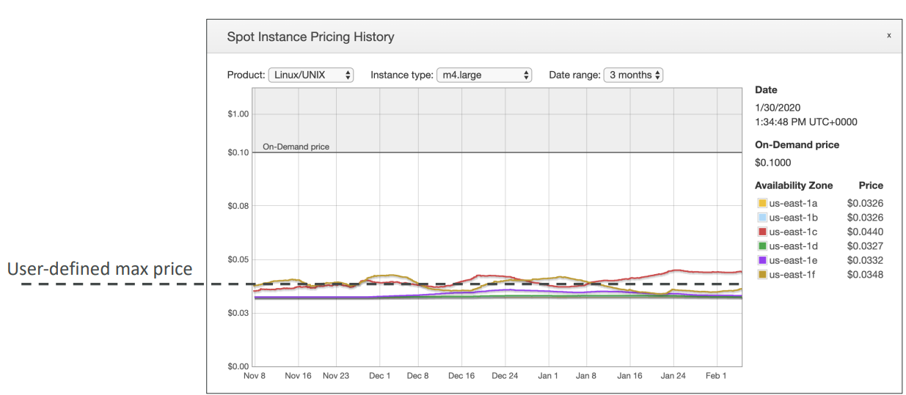

**How to do spot requests**

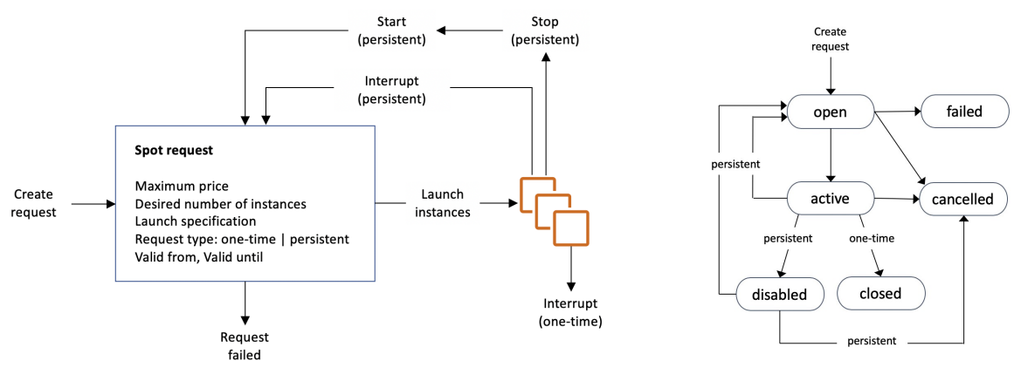

With the spot request, you are defining how many instances you want, your maximum price you're going to pay, the launch specification, so the AMI and so on, and when your request is valid from and until, but it can be infinite. And then the request type.

There are two types of requests.

* **one-time request:** if it's a one-time request, as soon as your spot request is fulfilled, your instances are going to be launched and then your spot request itself will get deleted.
* **persistent request** that means that we want this number of instances to be valid if the spot request is valid from to valid until. And so, that means that if somehow your instances do get stopped or interrupted based on the spot price, then your spot request will go back into action and when the prices are favorable, the instances will be launched again. Also, if you stop a spot instance in persistent mode and your spot request is still active, your spot request automatically will be smart enough to restart a launch and instance for you.

You can only cancel Spot Instance requests that are open, active, or disabled. Cancelling a Spot Request does not terminate instances. You must first cancel a Spot Request, and then terminate the associated Spot Instances. If you want to terminate spot instances for good and not have them relaunch, you need to first cancel the spot request and then you terminate the associated spot instances.

**Spot Fleets**

* Spot Fleets = set of Spot Instances + (optional) On-Demand Instances
* The Spot Fleet will try to meet the target capacity with price constraints
* Define possible launch pools: instance type (m5. large), OS, Availability Zone
* Can have multiple launch pools, so that the fleet can choose
* Spot Fleet stops launching instances when reaching capacity or max cost
* Strategies to allocate Spot Instances:
* **lowest Price**: from the pool with the lowest price (cost optimization, short workload)
* **diversified**: distributed across all pools (great for availability, long workloads)
* **capacity Optimized**: pool with the optimal capacity for the number of instances
* **price Capacity Optimized** (recommended): pools with the highest capacity available, then select the pool with the lowest price (best choice for most workloads)
* Spot Fleets allow us to automatically request Spot Instances with the lowest price

We can also launch spot instances directly from instances

### 5 EC2 Dedicated Hosts

* A physical server with EC2 instance capacity fully dedicated to your use
* Allows you address compliance requirements and use your existing server- bound software licenses (per-socket, per-core, pe—VM software licenses)
* Purchasing Options:
* On-demand – pay per second for active Dedicated Host
* Reserved - 1 or 3 years (No Upfront, Partial Upfront, All Upfront)
* The most expensive option
* Useful for software that have complicated licensing model (BYOL – Bring Your Own License)
* Or for companies that have strong regulatory or compliance needs

### 6 EC2 Dedicated Instances

|  |  |
| --- | --- |
| * Instances run on hardware that’s dedicated to you * May share hardware with other instances in same account * No control over instance placement (can move hardware after Stop / Start)   Dedicated instances mean that you have your own instance on your own hardware, whereas dedicated host, you get access to the physical server itself, and it gives you visibility into the lower-level hardware. |  |

### 7 EC2 Capacity Reservations

* Reserve On-Demand instances capacity in a specific AZ for any duration
* You always have access to EC2 capacity when you need it
* No time commitment (create/cancel anytime), no billing discounts
* Combining with Regional Reserved Instances and Savings Plans to benefit from billing discounts
* You’re charged at On-Demand rate whether you run instances or not
* Suitable for short-term, uninterrupted workloads that need to be in a specific AZ

### Summary

Comparing EC2 instance to a hotel

* **On demand:** come and stay in a resort whenever we like, we pay the full price
* **Reserved:** like planning ahead and if we plan to stay for a long time, we may get a good discount.
* **Savings Plans:** pay a certain amount per hour for certain period and stay in any room type (e.g., King, Suite, Sea View, …)
* **Spot instances:** the hotel allows people to bid for the empty rooms and the highest bidder keeps the rooms. You can get kicked out at any time
* **Dedicated Hosts:** We booked an entire building of the resort
* **Capacity Reservations:** you book a room for a period with full price you don’t stay in it

Price Comparison Example – m4. large – us-east-1

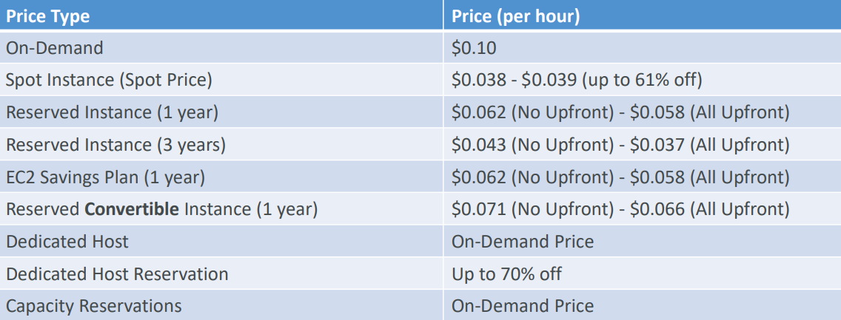

## Public IP charges

Starting February 1st, 2024, there’s a charge for all Public IPv4 created in your account

* $0.005 per hour of Public IPv4 (~ $3.6 per month)
* For new accounts in AWS, you have a free tier for the EC2 service: 750 hours of Public IPv4 per month for the first 12 months
* For all other services there is no free tier.

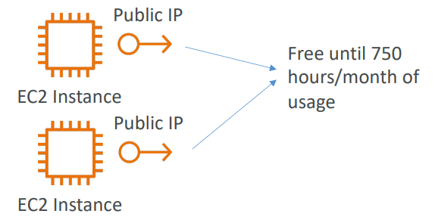 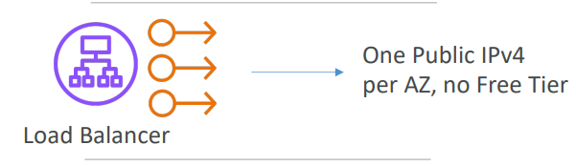 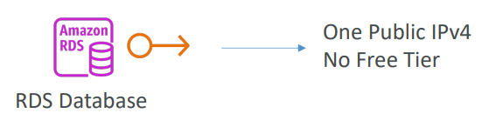

**What about IPv6?**

* Unfortunately, many Internets Service Provider (ISP) around the world don’t support IPv6, so the course would not work for some of you
* You can test IPv6 by going to https://test-ipv6.com/
* If you use IPv6 in this course, you’re on your own (security groups, networking…) but you can do it!

**How do you troubleshoot charges?**

* Go into your AWS Bill
* Look into the AWS Public IP Insights service
* Nice article here: <https://repost.aws/articles/ARknH_OR0cTvqoTfJrVGaB8A/why-am-i-seeing-charges-for-public-ipv4-addresses-when-i-am-under-the-aws-free-tier>

## Public Private IP

* Networking has two sorts of IPs. IPv4 and IPv6:
* IPv4: 1.160.10.240
* IPv6: 3ffe: 1900:4545:3:200: f8ff: fe21:67cf
* IPv4 is still the most common format used online.
* IPv6 is newer and solves problems for the Internet of Things (IoT).
* IPv4 allows for 3.7 billion different addresses in the public space which are running out
* IPv4: [0-255]. [0-255]. [0-255]. [0-255].

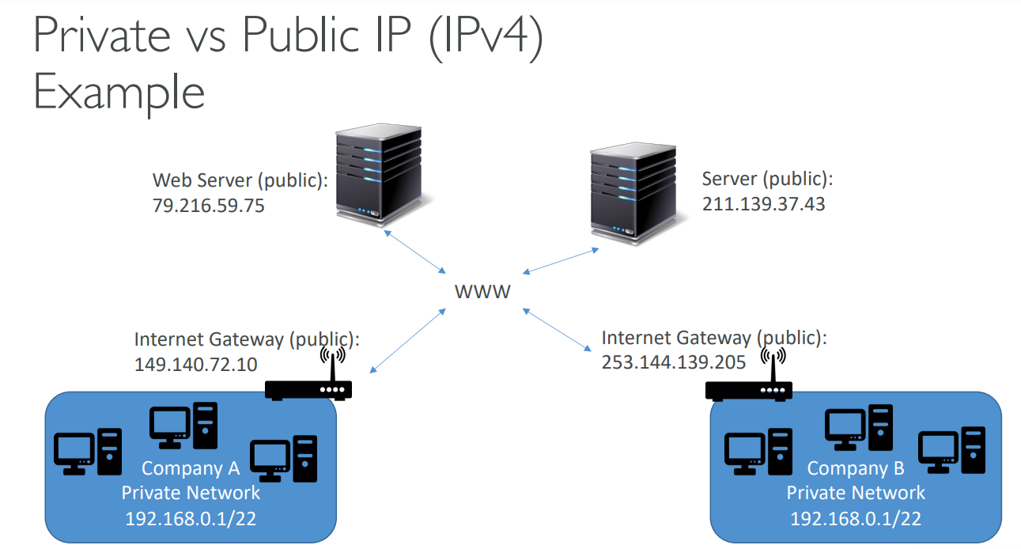

**Private vs Public IP (IPv4) Fundamental Differences**

* Public IP:
* Public IP means the machine can be identified on the internet (WWW)
* Must be unique across the whole web (not two machines can have the same public IP).
* Can be geo-located easily
* Private IP:
* Private IP means the machine can only be identified on a private network only
* The IP must be unique across the private network
* BUT two different private networks (two companies) can have the same IPs.
* Machines connect to WWW using a NAT + internet gateway (proxy)
* Only a specified range of IPs can be used as private

**Elastic IPs**

When you stop and then start an EC2 instance, it can change its public IP. If you need to have a fixed public IP for your instance, you need an Elastic IP An Elastic IP is a public IPv4 IP you own if you don’t delete it. You can attach it to one instance at a time

With an Elastic IP address, you can mask the failure of an instance or software by rapidly remapping the address to another instance in your account. You can only have 5 Elastic IP in your account (you can ask AWS to increase that).

* Overall, try to avoid using Elastic IP:
* They often reflect poor architectural decisions
* Instead, use a random public IP and register a DNS name to it
* Or, as we’ll see later, use a Load Balancer and don’t use a public IP

**Private vs Public IP (IPv4) In AWS EC2**

* By default, your EC2 machine comes with:
* A private IP for the internal AWS Network
* A public IP, for the WWW.
* When we are doing SSH into our EC2 machines:
* We can’t use a private IP, because we are not in the same network
* We can only use public IP.
* If your machine is stopped and then started, the public IP can change

## Placement Groups

We don't get direct interaction with the hardware of AWS, but we let AWS know how we would like our EC2 instance to be placed compared to one another. When we want control over the EC2 Instance placement strategy. That strategy can be defined using placement groups

* When you create a placement group, you specify one of the following strategies for the group:
* Cluster—clusters instances into a low-latency group in a single Availability Zone
* Spread—spreads instances across different hardware (max 7 instances per group per AZ)
* Partition—spreads instances across many different partitions (which rely on different sets of racks) within an AZ. Scales to 100s of EC2 instances per group. The idea with this is that you can scale to hundreds of EC2 instances per group, and that allows you to run applications such as Hadoop, Cassandra, or Kafka.

**Placement Groups Cluster**

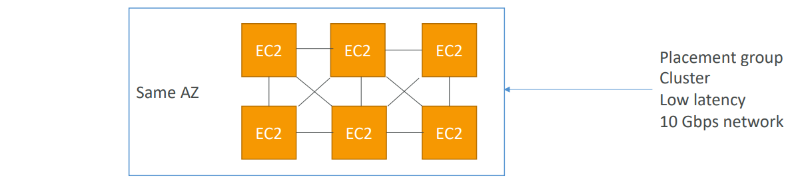

* Pros: Great network (10 Gbps bandwidth between instances with Enhanced Networking enabled - recommended)
* Cons: If the AZ fails, all instances fail at the same time
* Use case:
* Big Data job that needs to complete fast
* Application that needs extremely low latency and high network throughput

**Placement Groups Spread**

|  |  |
| --- | --- |
| * Pros * Can span across Availability Zones (AZ) * Reduced risk is simultaneous failure * EC2 Instances are on different physical hardware * Cons: * Limited to 7 instances per AZ per placement group * Use case: * Application that needs to maximize high availability * Critical Applications where each instance must be isolated from failure from each other |  |

**Placements Groups Partition**

|  |  |
| --- | --- |
| * Up to 7 partitions per AZ * Can span across multiple AZs in the same region * Up to 100s of EC2 instances * The instances in a partition do not share racks with the instances in the other partitions * Partition failure can affect many EC2 but won’t affect other partitions * EC2 instances get access to the partition information as metadata * Use cases: HDFS, HBase, Cassandra, Kafka |  |

## Elastic Network Interfaces (ENI)

Logical component in a VPC that represents a virtual network card. So they're what gives EC2 Instances access to the network,

but they're used outside EC2 Instances as well

|  |  |
| --- | --- |
| For example in the diagram we have an availability zone and we have one EC2 Instance and to it is attached on eth0, your primary ENI and this will provide your EC2 Instance network connectivity and for example, a private IP.   * The ENI can have the following attributes:  1. Primary private IPv4, one or more secondary IPv4 (Eth1 for .e.g. in diagram) 2. One Elastic IP (IPv4) per private IPv4 3. One Public IPv4 4. One or more security groups 5. A MAC address  * You can create ENI independently and attach them on the fly (move them) on EC2 instances for failover * Bound to a specific availability zone (AZ) |  |

Use case: Say our application connects to an internal AWS IP. EC2, whenever they are created, will get a dynamic IP. We can create a ENI and attach to EC2 and use that in our application . In case of failover, we can attach the ENI to a new EC2 instance.

**EC2 Hibernate**

* We know we can stop, terminate instances

1. Stop – the data on disk (EBS) is kept intact in the next start
2. Terminate – any EBS volumes (root) also set-up to be destroyed is lost

* At the start, the following happens:

1. First start: the OS boots & the EC2 User Data script is run
2. Following starts: the OS boots up
3. Then your application starts, caches get warmed up, and that can take time!

|  |  |
| --- | --- |
| Introducing EC2 Hibernate:   * The in-memory (RAM) state is preserved * The instance boot is much faster! (the OS is not stopped / restarted) * Under the hood: the RAM state is written to a file in the root EBS volume * The root EBS volume must be encrypted   Use cases:   * Long-running processing * Saving the RAM state * Services that take time to initialize |  |

* Supported Instance Families – C3, C4, C5, I3, M3, M4, R3, R4, T2, T3, …
* Instance RAM Size – must be less than 150 GB.
* Instance Size – not supported for bare metal instances.
* AMI – Amazon Linux 2, Linux AMI, Ubuntu, RHEL, CentOS & Windows…
* Root Volume – must be EBS, encrypted, not instance store, and large
* Available for On-Demand, Reserved and Spot Instances
* An instance can NOT be hibernated more than 60 days

## Questions

Top of Form

Which EC2 Purchasing Option can provide you the biggest discount, but it is not suitable for critical jobs or databases?

* **Convertible Reserved Instances**
* **Dedicated Hosts**
* **Spot Instances**

Bottom of Form

Top of Form

What should you use to control traffic in and out of EC2 instances?

* **Network Access Control List (NACL)**
* **Security Groups**
* **IAM Policies**

Bottom of Form

Top of Form

How long can you reserve an EC2 Reserved Instance?

* **1 or 3 years**
* **2 or 4 years**
* **6 months or 1 year**
* **Anytime between 1 and 3 years**

Bottom of Form

1 or 3 years

Top of Form

You would like to deploy a High-Performance Computing (HPC) application on EC2 instances. Which EC2 instance type should you choose?

* **Storage Optimized**
* **Compute Optimized**
* **Memory Optimized**
* **General Purpose**

Bottom of Form

Compute Optimized EC2 instances are great for compute-intensive workloads requiring high-performance processors (e.g., batch processing, media transcoding, high-performance computing, scientific modeling & machine learning, and dedicated gaming servers).

Top of Form

Which EC2 Purchasing Option should you use for an application you plan to run on a server continuously for 1 year?

* **Reserved Instances**
* **Spot Instances**
* **On-Demand Instances**

Bottom of Form

Reserved Instances are good for long workloads. You can reserve EC2 instances for 1 or 3 years.

Top of Form

You are preparing to launch an application that will be hosted on a set of EC2 instances. This application needs some software installation, and some OS packages need to be updated during the first launch. What is the best way to achieve this when you launch the EC2 instances?

* **Connect to each EC2 instance using SSH, then install the required software and update your OS packages manually**
* **Write a bash script that installs the required software and updates to your OS, then contact AWS Support and provide them with the script. They will run it on your EC2 instances at launch**
* **Write a bash script that installs the required software and updates to your OS, then use this script in EC2 User Data when you launch your EC2 instances**

EC2 User Data is used to bootstrap your EC2 instances using a bash script. This script can contain commands such as installing software/packages, download files from the Internet, or anything you want.

Bottom of Form

Top of Form

Which EC2 Instance Type should you choose for a critical application that uses an in-memory database?

* **Compute Optimized**
* **Storage Optimized**
* **Memory Optimized**
* **General Purpose**

Memory Optimized EC2 instances are great for workloads requiring large data sets in memory.Bottom of Form

Top of Form

You have an e-commerce application with an OLTP database hosted on-premises. This application has popularity which results in its database has thousands of requests per second. You want to migrate the database to an EC2 instance. Which EC2 Instance Type should you choose to handle this high-frequency OLTP database?

* **Compute Optimized**
* **Storage Optimized**
* **Memory Optimized**
* **General Purpose**

Bottom of Form

Storage Optimized EC2 instances are great for workloads requiring high, sequential read/write access to large data sets on local storage.

Top of Form

Security Groups can be attached to only one EC2 instance.

* **False**
* **True**

Bottom of Form

Security Groups can be attached to multiple EC2 instances within the same AWS Region/VPC.

Top of Form

You're planning to migrate on-premises applications to AWS. Your company has strict compliance requirements that require your applications to run on dedicated servers. You also need to use your own server-bound software license to reduce costs. Which EC2 Purchasing Option is suitable for you?

* **Convertible Reserved Instances**
* **Dedicated Hosts**
* **Spot Instances**

Bottom of Form

Dedicated Hosts are good for companies with strong compliance needs or for software that have complicated licensing models. This is the most expensive EC2 Purchasing Option available.

Top of Form

You would like to deploy database technology on an EC2 instance and the vendor license bills you based on the physical cores and underlying network socket visibility. Which EC2 Purchasing Option allows you to get visibility into them?

* **Spot Instances**
* **On-Demand**
* **Dedicated Hosts**
* **Reserved Instances**

Bottom of Form

Dedicated Hosts

Top of Form

Spot Fleet is a set of Spot Instances and optionally ...............

* **Reserved Instances**
* **On-Demand Instances**
* **Dedicated Hosts**
* **Dedicated Instances**

Bottom of Form

Spot Fleet is a set of Spot Instances and optionally On-demand Instances. It allows you to automatically request Spot Instances with the lowest price.

Top of Form

You have launched an EC2 instance that will host a NodeJS application. After installing all the software required and configuring your application, you noted down the EC2 instance public IPv4 so you can access it. Then, you stopped and then started your EC2 instance to complete the application configuration. After restart, you can't access the EC2 instance, and you found that the EC2 instance public IPv4 has been changed. What should you do to assign a fixed public IPv4 to your EC2 instance?

* **Allocate an Elastic IP and assign it to your EC2 instance**
* **From inside your EC2 instance OS, change network configuration from DHCP to static and assign it a public IPv4**
* **Contact AWS Support and request a fixed public IPv4 to your EC2 instance**
* **This can't be done, you can only assign a fixed private IPv4 to your EC2 instance**

Elastic IP is a public IPv4 that you own as long as you want and you can attach it to one EC2 instance at a time.Bottom of Form

Top of Form

You have an application performing big data analysis hosted on a fleet of EC2 instances. You want to ensure your EC2 instances have the highest networking performance while communicating with each other. Which EC2 Placement Group should you choose?

* **Spread Placement Group**
* **Cluster Placement Group**
* **Partition Placement Group**

Cluster Placement Groups place your EC2 instances next to each other which gives you high-performance computing and networking.Bottom of Form

Top of Form

You have a critical application hosted on a fleet of EC2 instances in which you want to achieve maximum availability when there's an AZ failure. Which EC2 Placement Group should you choose?

* **Cluster Placement Group**
* **Partition Placement Group**
* **Spread Placement Group**

Spread Placement Group places your EC2 instances on different physical hardware across different AZs.Bottom of Form

Top of Form

Elastic Network Interface (ENI) can be attached to EC2 instances in another AZ.

* **True**
* **False**

Elastic Network Interfaces (ENIs) are bounded to a specific AZ. You cannot attach an ENI to an EC2 instance in a different AZ.Bottom of Form

Top of Form

The following are true regarding EC2 Hibernate, **EXCEPT**:

* **EC2 Instance Root Volume must be an Instance Store volume**
* **Supports On-Demand and Reserved Instances**
* **EC2 Instance RAM must be less than 150GB**
* **EC2 Instance Root Volume type must be an EBS volume**

To enable EC2 Hibernate, the EC2 Instance Root Volume type must be an EBS volume and must be encrypted to ensure the protection of sensitive content.Bottom of Form

# IAM

## IAM: Users & Groups

* IAM = Identity and Access Management, is a Global service
* Root account created by default when we register for AWS, it shouldn’t be used or shared
* We can give access to other Users within your organization by creating separate logins for them. They can use individual credentials to log in.
* For giving privileges to do something in AWS the users need permission.
* The best practice is to create a group in AWS for users who have similar role and give permission to this Groups from which users can inherit the permission.
* Groups only contain users, not other groups.
* There can be users which don’t belong to any group but it’s not best practice.
* Users can belong to multiple groups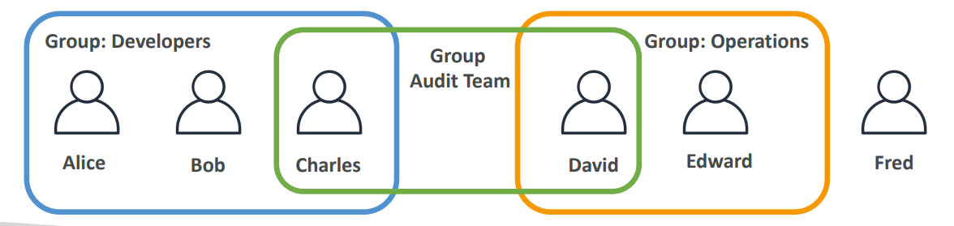

## IAM policies & permission

|  |  |
| --- | --- |
| Users or Groups can be assigned JSON documents called policies   * These policies define the permissions of the users * In AWS, you don't allow everyone to do everything that would be catastrophic, because a new user could basically launch so many services and they will cost you a lot of money or would be valid for security. In AWS you apply the least privileged principle: don’t give more permissions than a user needs. * In this example, we can see that we allow people to use the EC2 to service and do describe on it, to use the elastic load balancing service and to describe on it and to use CloudWatch. | {      "Version": "2012-10-17",      "Statement": [          {              "Effect": "Allow",              "Action": "ec2:Describe*",              "Resource": "*"          },          {              "Effect": "Allow",              "Action": "elasticloadbalancing:Describe*",              "Resource": "*"          },          {              "Effect": "Allow",              "Action": [                  "cloudwatch:ListMetrics",                  "cloudwatch:GetMetricStatistics",                  "cloudwatch:Describe*"              ],              "Resource": "*"          }      ]  } |

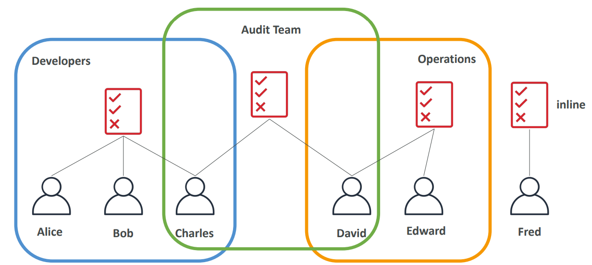

|  |  |
| --- | --- |
| Policy consists of   * Version: policy language version, always include “2012 -10-17” * Id: an identifier for the policy (optional) * Statement: one or more individual statements (required)   • Statements consists of   * **Sid**: an identifier for the statement (optional) * **Effect**: whether the statement allows or denies access (Allow, Deny) * **Principal**: account/user/role to which this policy applied to * **Action**: list of actions this policy allows or denies * **Resource**: list of resources to which the actions applied to * **Condition**: conditions for when this policy is in effect (optional) |  |

## CLI SDK

How can users access AWS?

* To access AWS, you have three options:

1. AWS Management Console (protected by password + MFA)
2. AWS Command Line Interface (CLI): protected by access keys
3. AWS Software Developer Kit (SDK) - for code: protected by access keys

Access Keys are generated through the AWS Console. Users manage their own access keys. Access Keys are secret, just like a password. Don’t share them

* Access Key ID ~= username
* Secret Access Key ~= password

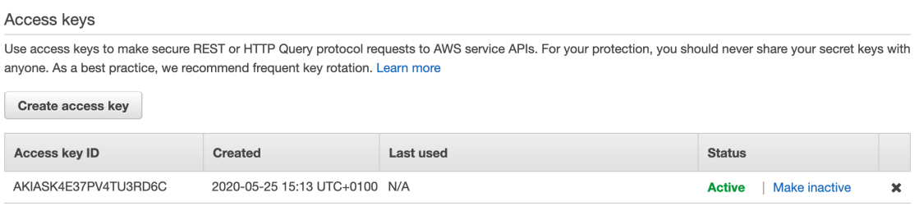

## AWS CLI

What’s AWS CLI?

* A tool that enables you to interact with AWS services using commands in your command-line shell
* Direct access to the public APIs of AWS services.
* You can develop scripts to manage your resources
* It’s open source <https://github.com/aws/aws-cli> EC2 Instance Storage

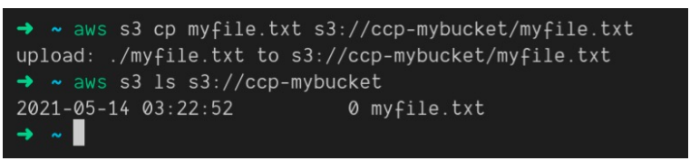

## SDK

What’s AWS SDK? AWS Software Development Kit (AWS SDK)

* Language-specific APIs (set of libraries)
* Enables you to access and manage AWS services
* programmatically
* Embedded within your application
* Supports

1. SDKs (JavaScript, Python, PHP, .NET, Ruby, Java, Go, Node.js, C++)
2. Mobile SDKs (Android, iOS, …)
3. IoT Device SDKs (Embedded C, Arduino, …)

* Example: AWS CLI is built on AWS SDK for Python

## IAM Roles

IAM Roles for Services

Some AWS services will need to perform action on your behalf, for example we want to list no of users from EC2. We can do that using AWS configure on EC2 with AWS CLI, but we should never do such things because then all the actions will be tagged with the user with which CLI is initialized. Instead we should use IAM role, where we will assign permissions to AWS services

For example, we can give permission to EC2 instance to list users

Go to IAM 🡪 role 🡪 Create role

Select “AWS services” from options and then from drop down select which service we want to add role, we can select EC2.

Then select IAMReadOnlyAccess

Give Role name

Then while creating instance add this IAM role

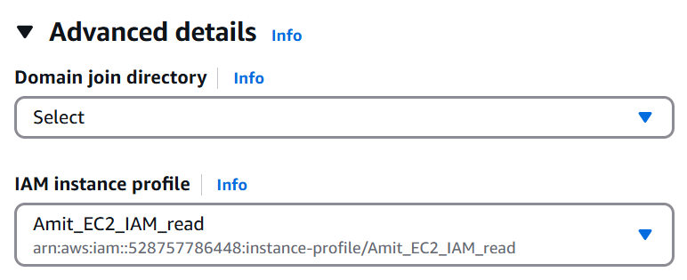

Common roles:

1. EC2 Instance Roles
2. Lambda Function Roles
3. Roles for CloudFormation

**IAM Guidelines & Best Practices**

* Don’t use the root account except for AWS account setup
* One physical user = One AWS user
* Assign users to groups and assign permissions to groups
* Creating a strong password policy
* Use and enforce the use of Multi Factor Authentication (MFA)
* Create and use Roles for giving permissions to AWS services
* Use Access Keys for Programmatic Access (CLI / SDK)
* Audit permissions of your account using IAM Credentials Report & IAM
* Access Advisor
* Never share IAM users & Access Keys

**IAM Section – Summary**

* **Users**: mapped to a physical user, has a password for AWS Console
* **Groups**: contain users only
* **Policies**: JSON document that outlines permissions for users or groups
* **Roles**: for EC2 instances or AWS services
* **Security**: MFA + Password Policy
* **AWS CLI**: manage your AWS services using the command-line
* **AWS SDK**: manage your AWS services using a programming language
* **Access** Keys: access AWS using the CLI or SDK
* **Audit**: IAM Credential Reports & IAM Access Advisor

## Questions

Top of Form

What is the proper definition of an IAM Role?

* **IAM Users in multiple User Groups**
* **An IAM entity that defines a password policy for IAM Users**
* **An IAM entity that defines a set of permissions for making requests to AWS services, and will be used by an AWS service**
* **Permissions assigned to IAM Users to perform actions**

Bottom of Form

Top of Form

Which of the following is an IAM Security Tool?

* **IAM Credentials Report**
* **IAM Root Account Manager**
* **IAM Services Report**
* **IAM Security Advisor**

Bottom of Form

IAM Credentials report lists all your AWS Account's IAM Users and the status of their various credentials.

Top of Form

Which answer is **INCORRECT** regarding IAM Users?

* **IAM Users can belong to multiple User Groups**
* **IAM Users don't have to belong to a User Group**
* **IAM Policies can be attached directly to IAM Users**
* **IAM Users access AWS services using root account credentials**

Bottom of Form

Top of Form

Which of the following is IAM best practice?

* **Create several IAM Users for one physical person**
* **Don't use the root user account**
* **Share your AWS account credentials with your colleague, so (s)he can perform a task for you**
* **Do not enable MFA for easier access**

Bottom of Form

Top of Form

What are IAM Policies?

* **A set of policies that defines how AWS accounts interact with each other**
* **JSON documents that define a set of permissions for making requests to AWS services, and can be used by IAM Users, User Groups, and IAM Roles**
* **A set of policies that define a password for IAM Users**
* **A set of policies defined by AWS that show how customers interact with AWS**

Bottom of Form

Top of Form

Which principle should you apply regarding IAM Permissions?

* **Grant most privilege**
* **Grant more permissions if your employee asks you to**
* **Grant least privilege**
* **Restrict root account permissions**

Top of Form

What should you do to increase your root account security?

* **Remove permissions from the root account**
* **Only access AWS services through AWS Command Line Interface (CLI)**
* **Don't create IAM Users, only access your AWS account using the root account**
* **Enable Multi-Factor Authentication (MFA)**Bottom of Form

Bottom of Form

Top of Form

IAM User Groups can contain IAM Users and other User Groups.

* **True**
* **False**

Bottom of Form

IAM User Groups can not be part of other User Groups.

Top of Form

An IAM policy consists of one or more statements. A statement in an IAM Policy consists of the following, **EXCEPT**:

* **Effect**
* **Principal**
* **Version**
* **Action**
* **Resource**

Bottom of Form

# EBS

Some basics before going into ESB

**I/O** An I/O is a single read/write request. That I/O is issued to a storage medium (like a hard drive or solid-state drive). It can be a request to read a particular file from a disk. Or it can be a request to write some data to an existing file. Reading or writing a file can result in multiple I/O requests.

**I/O Request Size** The I/O request has a size. The request can be small (like 1 Kilobyte) or large (several megabytes)

**IOPS:** stands for I/O Operations Per Second. It is a performance metric that is used (and abused) a lot in the world of storage. It tells us how many I/O requests per second can be handled by storage (for a particular workload). This metric is meaningless without a latency figure

**Bandwidth or throughput** If you multiply the IOPS figure with the (average) I/O request size, you get the bandwidth or throughput. We state storage bandwidth mostly in Megabytes and Gigabytes per second. To give you an example: if we issue a workload of 1000 IOPS with a request size of 4 Kilobytes, we will get a throughput of 1000 x 4 KB = 4000 KB. This is about ~4 Megabytes per second.

**Latency** is the time it takes for the I/O request to be completed. We start our measurement from the moment the request is issued to the storage layer and stop measuring when either we get the requested data or get confirmation that the data is stored on disk. Latency is the single most important metric to focus on when it comes to storage performance, under most circumstances. For hard drives, an average latency somewhere between 10 to 20 MS is considered acceptable (20 MS is the upper limit). For solid state drives, depending on the workload, it should never reach higher than 1-3 MS. In most cases, workloads will experience less than 1ms latency numbers.

**IOPS and Latency:** The IOPS metric is meaningless without a statement about latency. You must understand how long each I/O operation will take because latency dictates the responsiveness of individual I/O operations. If a storage solution can reach 10,000 IOPS but only at an average latency of 50 MS that could result in very bad application performance. If we want to hit an upper latency target of 10 MS the storage solution may only be capable of 2,000 IOPS.

**EBS Volume**

* An EBS (Elastic Block Store) Volume is a network drive you can attach to your instances while they run. When we create EC2 an volume is attached by default. We can create move volumes and attach to our instance.
* It allows your instances to persist data, even after their termination
* They can only be mounted to one instance at a time (at the CCP level)
* They are bound to a specific availability zone
* Free tier: 30 GB of free EBS storage of type General Purpose (SSD) or Magnetic per month
* It’s a network drive (i.e. not a physical drive)

1. It uses the network to communicate the instance, which means there might be a bit of latency
2. It can be detached from an EC2 instance and attached to another one quickly

* It’s locked to an Availability Zone (AZ)

1. An EBS Volume in us-east-1a cannot be attached to us-east-1b
2. To move a volume across, you first need to snapshot it

* Have a provisioned capacity (size in GBs, and IOPS) which means while creating we must mention the size IOPS needed

1. You get billed for all the provisioned capacity
2. You can increase the capacity of the drive overtime

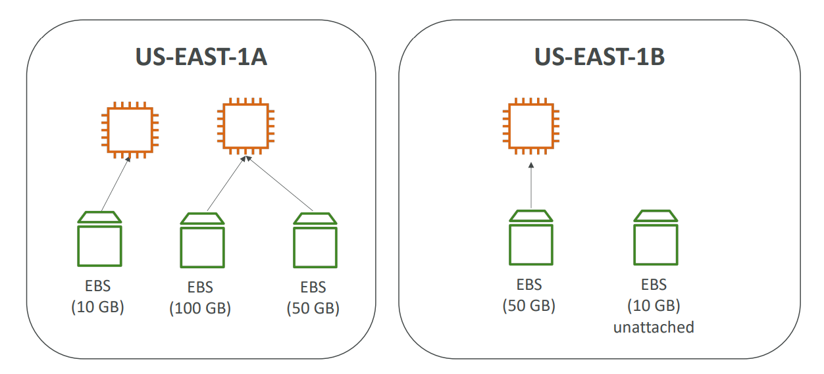

**EBS – Delete on Termination attribute**

* We can control the EBS behavior when an EC2 instance terminates

1. By default, the root EBS volume is deleted (attribute enabled). The volume created while EC2 is created is set to delete on termination
2. By default, any other attached EBS volume is not deleted (attribute disabled)

* This can be controlled by the AWS console / AWS CLI
* Use case: preserve root volume when instance is terminated

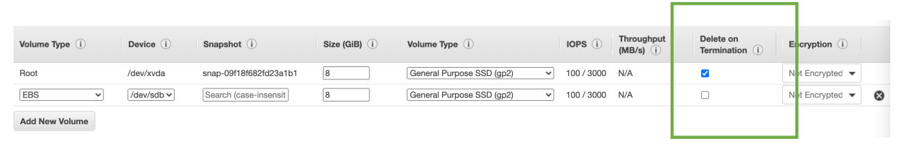

## EBS Snapshots

* Make a backup (snapshot) of your EBS volume at a point in time
* It is not necessary to detach volume to do snapshots, but recommended
* Create snapshots from vol 🡪 Can copy snapshots across AZ or Region🡪 Recreate volume
* If we are just creating snapshots and recreating volume without copying, we can do it across any AZ within same region

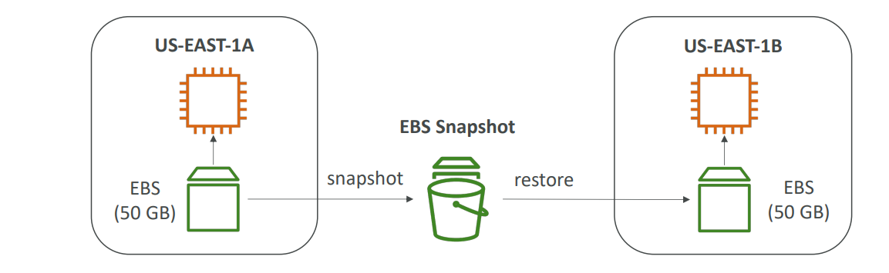

**EBS Snapshots Features**

|  |  |
| --- | --- |
| EBS Snapshot Archive   * Move a Snapshot to an” archive tier” that is 75% cheaper * It takes 24 to 72 hours to restore the archive |  |
| Recycle Bin for EBS Snapshots   1. Setup retention rules to retain deleted snapshots so you can recover them after an accidental deletion 2. Specify retention (from 1 day to 1 year) |  |

Fast Snapshot Restore (FSR) - this forces a full initialization of your snapshot to have no latency on the first use. This is particularly helpful if your snapshot is big, very big and need to initialize an EBS volume or needs to instance out of it very quickly, but this feature costs a lot of money

## AMI

* AMI = Amazon Machine Image
* AMI are a customization of an EC2 instance

1. You add your own software, configuration, operating system, monitoring…
2. Faster boot / configuration time because all your software is pre-packaged

* AMI are built for a specific region (and can be copied across regions)
* You can launch EC2 instances from:

1. A Public AMI: AWS provided like Amazon Linux 2
2. Your own AMI: you make and maintain them yourself
3. An AWS Marketplace AMI: an AMI someone else made (and potentially sells)

**AMI Process (from an EC2 instance)**

* Start an EC2 instance and customize it like below

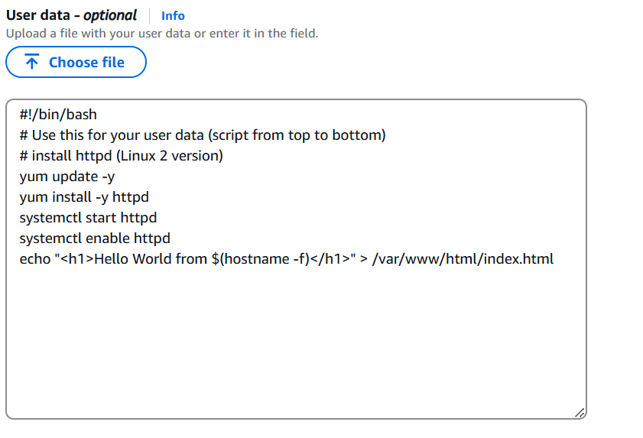

* Stop the instance (for data integrity)
* Build an AMI – this will also create EBS snapshots
* Launch instances from other AMIs

Features like security group, IAM role and SSH keys are not copied just the user data

AMIs are built for a specific AWS Region, they're unique for each AWS Region. You can't launch an EC2 instance using an AMI in another AWS Region, but you can copy the AMI to the target AWS Region and then use it to create your EC2 instances.

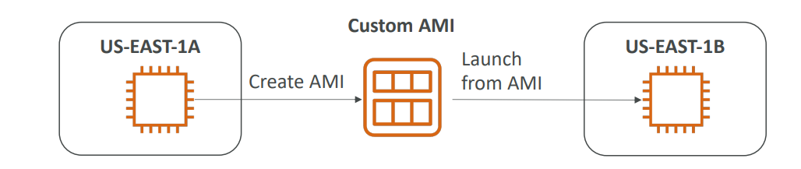

## EC2 Instance Store

EC2 Instance Store is a storage located on disks that are physically attached to the host of your EC2 instance. Can be used only on one EC2 instance at a time. It's ideal for temporary storage such as buffers, caches, etc.

* EBS volumes are network drives with good but “limited” performance
* If you need a high-performance hardware disk, use EC2 Instance Store
* Better I/O performance
* EC2 Instance Store lose their storage if they’re stopped (ephemeral)
* Good for buffer / cache / scratch data / temporary content
* Risk of data loss if hardware fails
* Backups and Replication are your responsibility

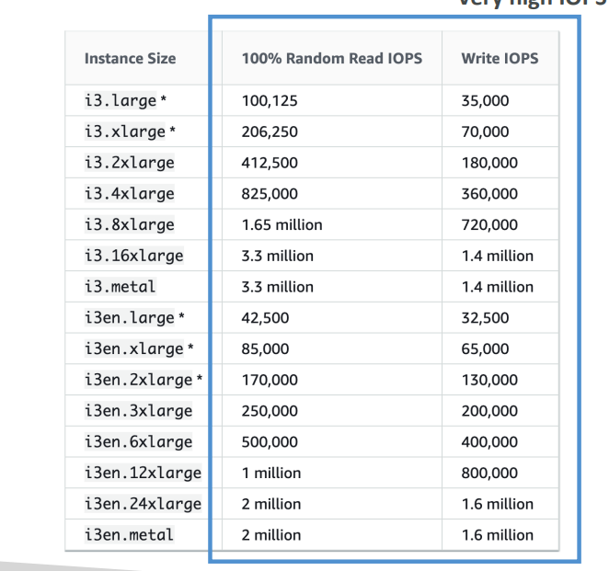

## EBS Volume Types

* EBS Volumes come in 6 types

1. **gp2 / gp3 (SSD):** General purpose SSD volume that balances price and performance for a wide variety of workloads
2. **io1 / io2 Block Express (SSD)**: Highest-performance SSD volume for mission-critical low-latency or high-throughput workloads
3. **st1 (HDD):** Low-cost HDD volume designed for frequently accessed, throughput- intensive workloads
4. **sc1 (HDD):** Lowest cost HDD volume designed for less frequently accessed workloads

* EBS Volumes are characterized in Size | Throughput | IOPS (I/O Ops Per Sec)
* Only gp2/gp3 and io1/io2 Block Express can be used as boot volumes for EC2

**EBS Volume Types Use cases**

**General Purpose SSD GP2/GP3**

It is cost-effective storage, with low latency good for System boot volumes, Virtual desktops, Development and test environments

* 1 GiB - 16 TiB
* IOPS is linked with size with max IOPS at 16000
* gp2:

1. Small gp2 volumes can burst IOPS to 3,000
2. Size of the volume and IOPS are linked, max IOPS is 16,000
3. 3 IOPS per GB, means at 5,334 GB we are at the max IOPS

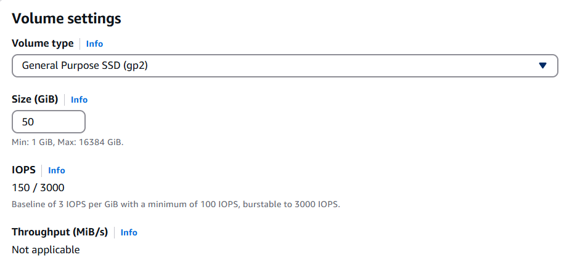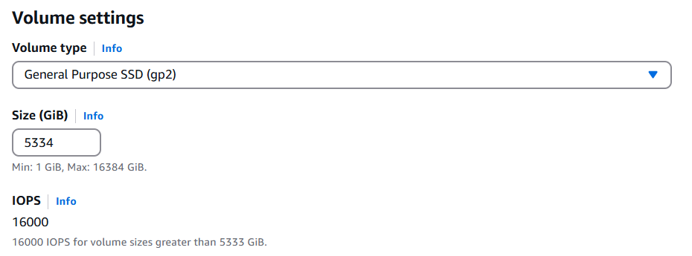

* gp3:

1. Baseline of 3,000 IOPS and throughput of 125 MiB/s
2. Can increase IOPS up to 16,000 and throughput up to 1000 MiB/s independently

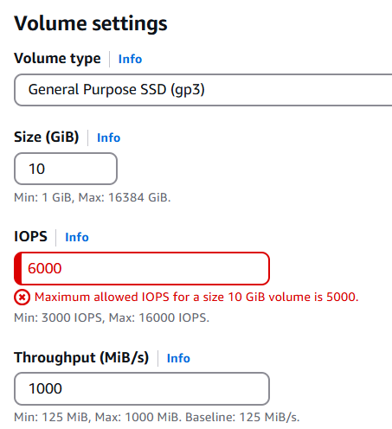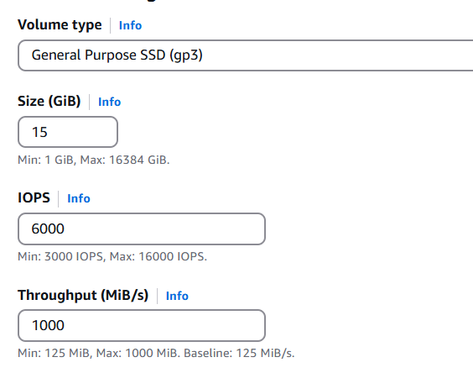

Summary: gp2, gp3, is for cost-effective storage latency, and then gp3, you can independently set the IOPS and the throughput, whereas for gp2, they're linked together. Both have max IOPS at 16000, however in gp2, IOPS is very tightly linked to size of the disk, gp3 also is linked but a bit more freedom

**Provisioned IOPS (PIOPS) SSD**

* Critical business applications with sustained IOPS performance
* Or applications that need more than 16,000 IOPS
* Great for databases workloads (sensitive to storage perf and consistency)
* io1 (4 GiB - 16 TiB):

1. Max PIOPS: 64,000 for Nitro EC2 instances & 32,000 for others
2. Can increase PIOPS independently from storage size

* io2 Block Express (4 GiB – 64 TiB):

1. Sub-millisecond latency
2. Max PIOPS: 256,000 with an IOPS:GB ratio of 1,000:1

* Supports EBS Multi-attach

**Hard Disk Drives (HDD)**

* Cannot be a boot volume
* 125 GiB to 16 TiB
* Throughput Optimized HDD (st1)

1. Big Data, Data Warehouses, Log Processing
2. Max throughput 500 MiB/s – max IOPS 500

* Cold HDD (sc1):

1. For data that is infrequently accessed
2. Scenarios where the lowest cost is important
3. Max throughput 250 MiB/s – max IOPS 250

From requirement point of view

|  |  |  |  |
| --- | --- | --- | --- |
| Gp2 | 1GB-16TB | 16000 | Throughput linked with size good for VDI, System vol, Dev test. Low latency |
| Gp3 | 1GB-16TB | 16000 |
| Io1 | 4 GB - 16 TB | 64k with EC2 nitro  32k | Throughput IOSP provisioned not lined with size, millisecond latency uses case Data base |
| Io2 | 4 GB - 16 TB | 256,000 K |
| St1 | 125 GiB to 16 TiB | 500 | Big data, log processing |
| Sc1 |  | 250 | Infrequent data |

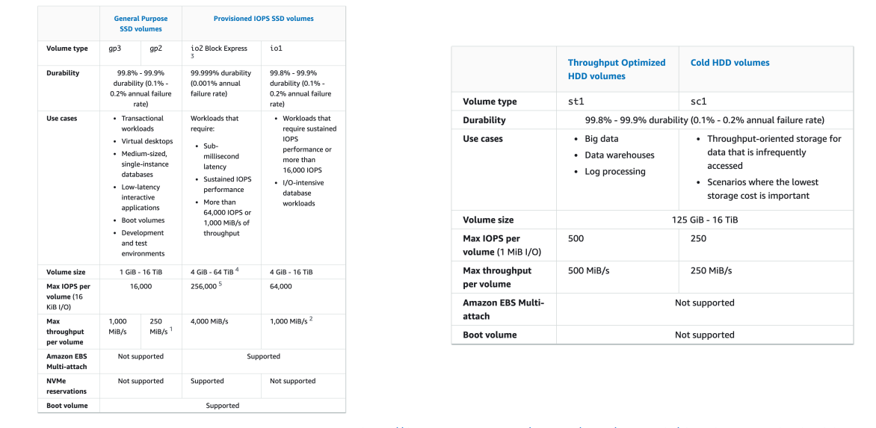

## EBS multi-attach

– io1/io2 family only

|  |  |
| --- | --- |
| * Attach the same EBS volume to multiple EC2 instances in the same AZ * Each instance has full read & write permissions to the high-performance volume * Use case:  1. Achieve higher application availability in clustered Linux applications (ex: Teradata) 2. Applications must manage concurrent write operations  * Up to 16 EC2 Instances at a time * Must use a file system that’s cluster-aware (not XFS, EXT4, etc.) |  |

## EBS Encryption

* When you create an encrypted EBS volume, you get the following:

1. Data at rest is encrypted inside the volume
2. All the data in flight moving between the instance and the volume is encrypted
3. All snapshots are encrypted
4. All volumes created from the snapshot

* Encryption and decryption are handled transparently (you have nothing to do)
* Encryption has a minimal impact on latency
* EBS Encryption leverages keys from KMS (AES-256)
* Copying an unencrypted snapshot allows encryption
* Snapshots of encrypted volumes are encrypted

**Encryption: encrypt an unencrypted EBS volume**

* Create an EBS snapshot of the volume
* Encrypt the EBS snapshot (using copy )
* Create new EBS volume from the snapshot (the volume will also be encrypted )
* Now you can attach the encrypted volume to the original instance

## Amazon EFS – Elastic File System

* Managed NFS (network file system) that can be mounted on many EC2
* EFS works with EC2 instances in multi-AZ
* Highly available, scalable, expensive (3x gp2), pay per use

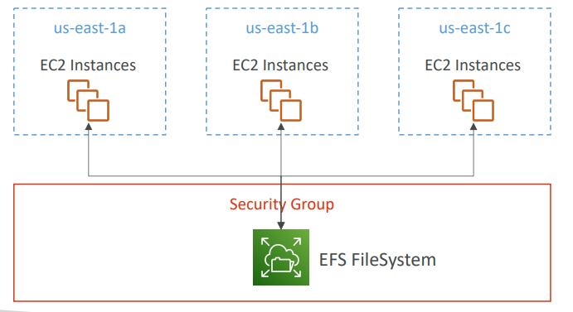

**Amazon EFS – Elastic File System**

* Use cases: content management, web serving, data sharing, WordPress
* Uses NFSv4.1 protocol
* Uses security group to control access to EFS
* Compatible with Linux based AMI (not Windows)
* Encryption at rest using KMS
* POSIX file system (~Linux) that has a standard file API
* File system scales automatically, pay-per-use, no capacity planning!

**EFS – Performance & Storage Classes**

* EFS Scale

1. 1000s of concurrent NFS clients, 10 GB+ /s throughput (systems that access files stored on a remote shared server over a network and make use of those file systems as if they are locally mounted)
2. Grow to Petabyte-scale network file system, automatically

* Performance Mode (set at EFS creation time)

1. General Purpose (default) – latency-sensitive use cases (web server, CMS, etc…)
2. Max I/O – higher latency, throughput, highly parallel (big data, media processing)

* Throughput Mode

1. Bursting – 1 TB = 50MiB/s + burst of up to 100MiB/s
2. Provisioned – set your throughput regardless of storage size, ex: 1 GiB/s for 1 TB storage
3. Elastic – automatically scales throughput up or down based on your workloads

* Up to 3GiB/s for reading and 1GiB/s for writes
* Used for unpredictable workloads

**EFS – Storage Classes**

|  |  |
| --- | --- |
| • Storage Tiers We can move data across different storage tiers to save costs.   1. Standard: for frequently accessed files 2. Infrequent access (EFS-IA): cost to retrieve files, lower price to store. 3. Archive: rarely accessed data (few times each year), 50% cheaper 4. When the file is accessed again we can move back to standard tier.     • Availability and durability   1. Standard: Multi-AZ, great for prod 2. One Zone: One AZ, great for dev,      1. backup enabled by   default, compatible with IA (EFS One Zone-IA)  • Over 90% in cost savings |  |

**Performance setting Throughput**

1. **Bursting** is a way for you to have the throughput scale with the amount of storage you're using and going a little bit over. If you have one gigabyte, you get a throughput based on one gigabyte. If you have one terabyte, you get higher throughput .

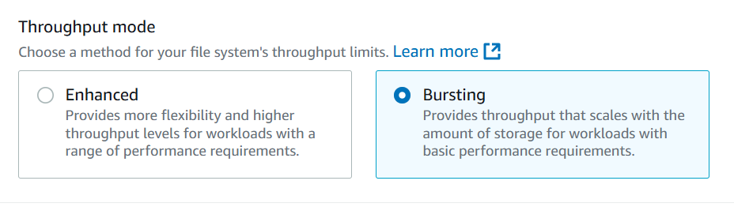

1. **Enhanced mode elastic** (recommended): Regardless of the size of your EFS file system, we’re going to give you all the I/O you need, and we'll scale automatically. This is best when you have a workload with unpredictable I/O where, for example, you can scale from zero megabytes per second to a hundred megabytes per second in no time. This is why it is the recommended mode because it doesn't require you to think about any settings

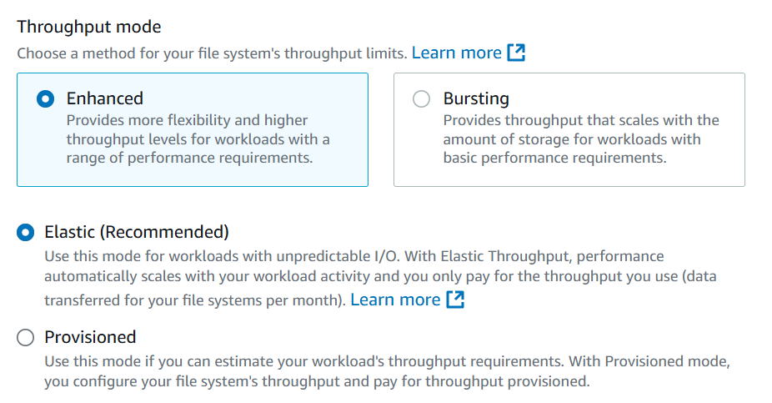

1. **Enhanced mode Provisioned:** This is when you know in advance the throughput you're going to be needing. So, you say, Hey, I will need 100 megabytes per second for sure. And then you also have a bursting limit of 300 megabytes per second. And because you provision throughput in advance, you're going to pay for it in advance.

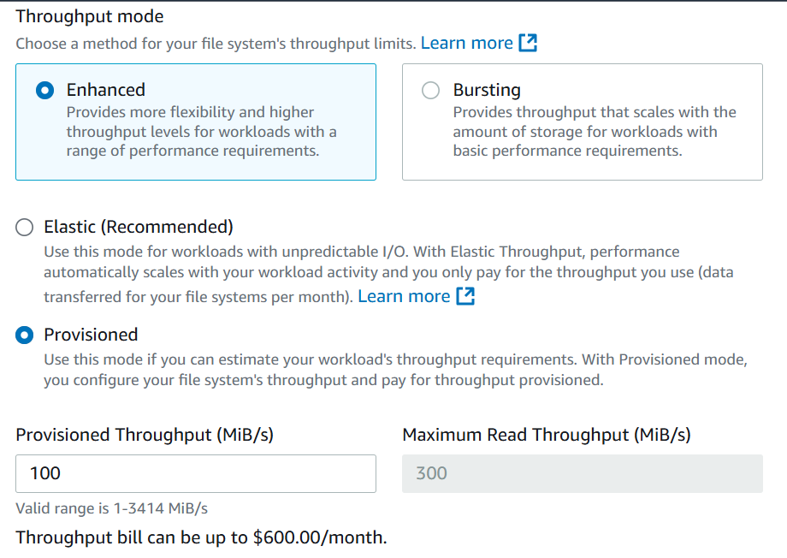

**Performance setting Performance Mode**

If you use bursting or if you use provisioned, then you have the option between two settings.

* **General purpose**, which is giving you high performance and low latency,
* **Max I/O** if you want to get a maximum amount of I/O mode, and you can tolerate higher latency then you can choose I/O. So, at the expense of a higher latency, you also get more I/O. This is for highly paralyzed workloads like big data type of setting

But the best recommended setting now for AWS is to use enhanced with general purpose and elastic.

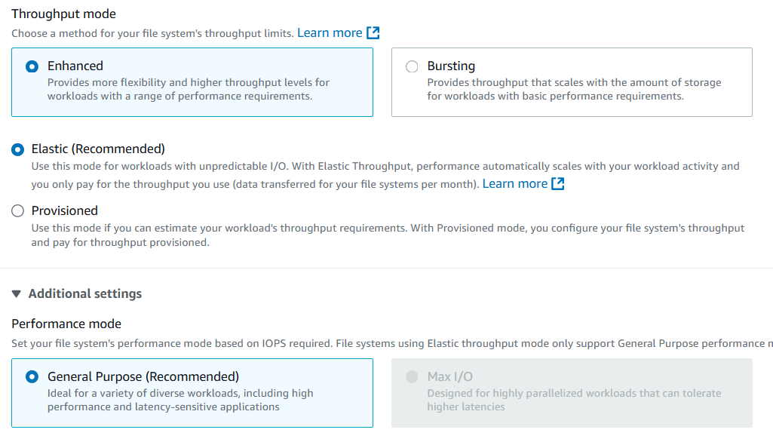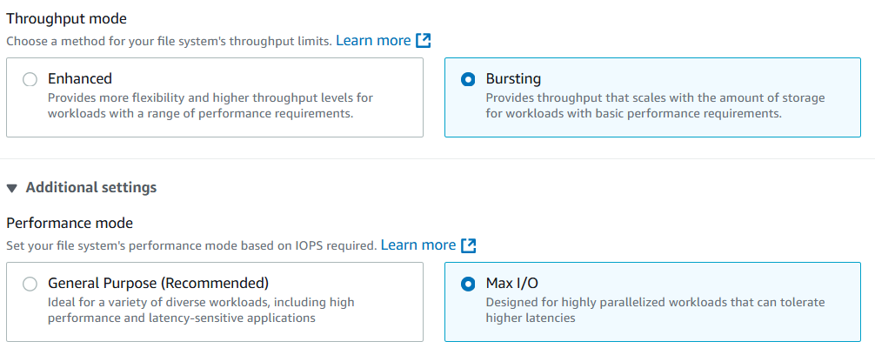

**How to create EFS and mount to EC2**

1. Create a Security Group with outbound rules to allow all traffic

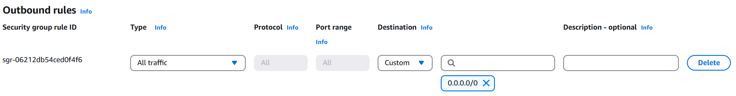

1. Create EFS with the settings below

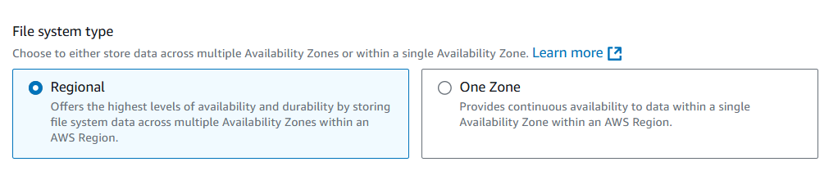

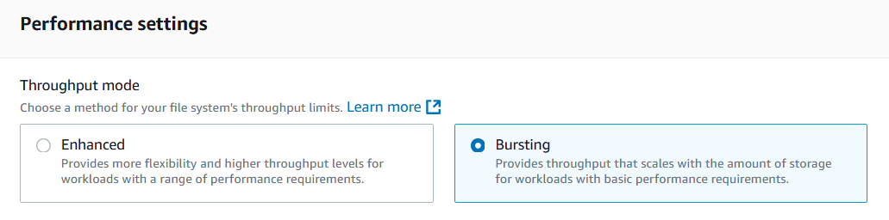

1. Add security Group

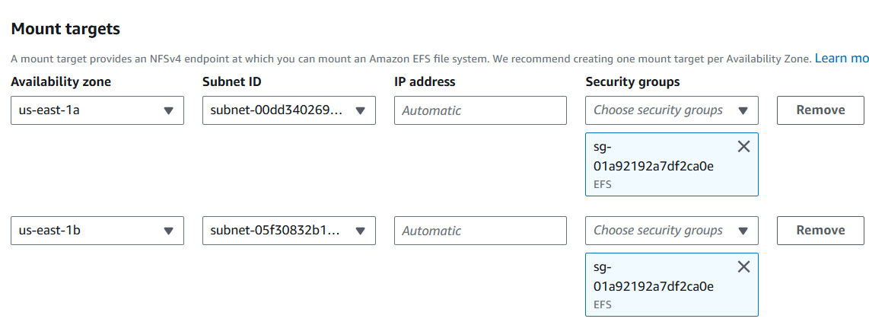

1. Create EFC
2. Create EC2 instance in one region e.g. Us-east-1d

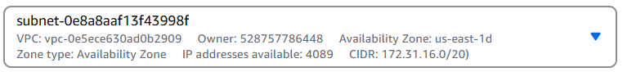

1. Add file systems



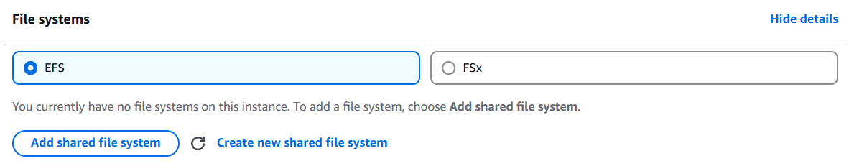

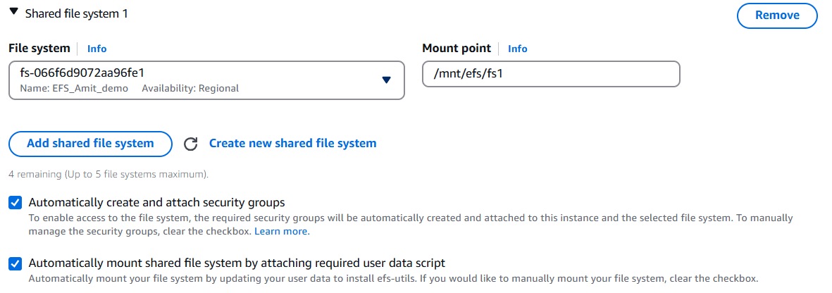

1. Now launch another Ec2 in another AZ with same steps
2. Login to any EC2 instance
3. Elevate to sudo access sudo su
4. Check mounted drive cd /mnt/efs/fs1
5. Create a file touch hello.txt. Write into file using vim or nano
6. Read file cat hello.txt and ls
7. Now connect from other instance and check that file is present

## EBS vs EFS – Elastic Block Storage

|  |  |
| --- | --- |
| EBS volumes…   1. one instance (except multi-attach io1/io2) 2. are locked at the Availability Zone (AZ) level 3. gp2: IO increases if the disk size increases 4. gp3 & io1: can increase IO independently   • To migrate an EBS volume across AZ   1. Take a snapshot 2. Restore the snapshot to another AZ 3. EBS backups use IO, and you shouldn’t run 4. them while your application is handling a lot 5. of traffic   • Root EBS Volumes of instances get  terminated by default if the EC2 instance  gets terminated. (you can disable that) | • Mounting 100s of instances across AZ  • EFS share website files (WordPress)  • Only for Linux Instances (POSIX)  • EFS has a higher price point than EBS  • Can leverage Storage Tiers for cost savings |

## Questions

Top of Form

You have just terminated an EC2 instance in us-east-1a, and its attached EBS volume is now available. Your teammate tries to attach it to an EC2 instance in us-east-1b but he can't. What is a possible cause for this?

* **He's missing IAM permissions**
* **EBS volumes are locked to an AWS Region**
* **EBS volumes are locked to an Availability Zone**

Bottom of Form

EBS Volumes are created for a specific AZ. It is possible to migrate them between different AZs using EBS Snapshots.

Top of Form

You have launched an EC2 instance with two EBS volumes, Root volume type and the other EBS volume type to store the data. A month later you are planning to terminate the EC2 instance. What's the default behavior that will happen to each EBS volume?

* **Both the root volume type and the EBS volume type will be deleted**
* **The Root volume type will be deleted and the EBS volume type will not be deleted**
* **The root volume type will not be deleted and the EBS volume type will be deleted**
* **Both the root volume type and the EBS volume type will not be deleted**

Bottom of Form

By default, the Root volume type will be deleted as its "Delete On Termination" attribute checked by default. Any other EBS volume types will not be deleted as its "Delete On Termination" attribute disabled by default.

Top of Form

You can use an AMI in N.Virginia Region us-east-1 to launch an EC2 instance in any AWS Region.

* **True**
* **False**

Bottom of Form

AMIs are built for a specific AWS Region, they're unique for each AWS Region. You can't launch an EC2 instance using an AMI in another AWS Region, but you can copy the AMI to the target AWS Region and then use it to create your EC2 instances.

Top of Form

Which of the following EBS volume types can be used as boot volumes when you create EC2 instances?

* **gp2, gp3, st1, sc1**
* **gp2, gp3, io1, io2**
* **io1, io2, st1, sc1**

Bottom of Form

When creating EC2 instances, you can only use the following EBS volume types as boot volumes: gp2, gp3, io1, io2, and Magnetic (Standard).

Top of Form

What is EBS Multi-Attach?

* **Attach the same EBS volume to multiple EC2 instances in multiple AZs**
* **Attach multiple EBS volumes in the same AZ to the same EC2 instance**
* **Attach the same EBS volume to multiple EC2 instances in the same AZ**
* **Attach multiple EBS volumes in multiple AZs to the same EC2 instance**

Bottom of Form

Using EBS Multi-Attach, you can attach the same EBS volume to multiple EC2 instances in the same AZ. Each EC2 instance has full read/write permissions.

Top of Form

You would like to encrypt an unencrypted EBS volume attached to your EC2 instance. What should you do?

* **Create an EBS snapshot of your EBS volume. Copy the snapshot and tick the option to encrypt the copied snapshot. Then, use the encrypted snapshot to create a new EBS volume**
* **Select your EBS volume, choose Edit Attributes, then tick the Encrypt using KMS option**
* **Create a new encrypted EBS volume, then copy data from your unencrypted EBS volume to the new EBS volume.**
* **Submit a request to AWS Support to encrypt your EBS volume**

Bottom of Form

Ans 1

Top of Form

You have a fleet of EC2 instances distributes across AZs that process a large data set. What do you recommend to make the same data to be accessible as an NFS drive to all of your EC2 instances?

* **Use EBS**
* **Use EFS**
* **Use an Instance Store**

Bottom of Form

EFS is a network file system (NFS) that allows you to mount the same file system on EC2 instances that are in different AZs.

Top of Form

You would like to have a high-performance local cache for your application hosted on an EC2 instance. You don't mind losing the cache upon the termination of your EC2 instance. Which storage mechanism do you recommend as a Solutions Architect?

* **EBS**
* **EFS**
* **Instance Store**

Bottom of Form

EC2 Instance Store provides the best disk I/O performance.

Top of Form

You are running a high-performance database that requires an IOPS of 310,000 for its underlying storage. What do you recommend?

* **Use an EBS gp2 drive**
* **Use an EBS io1 drive**
* **Use an EC2 Instance Store**
* **Use an EBS io2 Block Express drive**

Bottom of Form

256,000 is the maximum IOPS you can achieve when you're using the EBS io2 Block Express volume type.

You can run a database on an EC2 instance that uses an Instance Store, but you'll have a problem that the data will be lost if the EC2 instance is stopped (it can be restarted without problems). One solution is that you can set up a replication mechanism on another EC2 instance with an Instance Store to have a standby copy. Another solution is to set up backup mechanisms for your data. It's all up to you how you want to set up your architecture to validate your requirements. In this use case, it's around IOPS, so we have to choose an EC2 Instance Store.

# High Availability & Scalability

* Scalability means that an application / system can handle greater loads. There are two kinds of scalability:

1. Vertical Scalability
2. Horizontal Scalability (= elasticity)

* Scalability and high availability is linked but not exactly same.

**Vertical Scalability**

* Vertically scalability means increasing the size of the instance
* For example, your application runs on t2. Micro. Scaling that application vertically means running it on a t2. large
* Vertical scalability is very common for non-distributed systems, such as databases and monolith applications.
* RDS and Elastic Cache are services that can scale vertically.
* There’s usually a limit to how much you can vertically scale (hardware limit)

**Horizontal Scalability**

* Horizontal Scalability means increasing the number of instances / systems for your application
* Horizontal scaling implies distributed systems. This is very common for web applications /modern applications
* It’s easy to horizontally scale thanks the cloud offerings such as Amazon EC2

**High Availability**

* High Availability usually goes hand in hand with horizontal scaling
* High availability means running your application / system in at least 2 data centers (== Availability Zones)
* The goal of high availability is to survive data center loss
* The high availability can be passive (for RDS Multi AZ for example)
* The high availability can be active (for horizontal scaling)

**High Availability & Scalability for EC2**

* Vertical Scaling: Increase instance size (= scale up / down)

1. From: t2. nano - 0.5G of RAM, 1 vCPU
2. To: u-12tb1.metal – 12.3 TB of RAM, 448 vCPUs

* Horizontal Scaling: Increase number of instances (= scale out / in)

1. Auto Scaling Group
2. Load Balancer

* High Availability: Run instances for the same application across multi AZ

1. Auto Scaling Group multi-AZ
2. Load Balancer multi-AZ

## Load balancing

Elastic Load Balancer EC2 Instance EC2 Instance EC2 Instance • Load Balances are servers that forward traffic to multiple servers (e.g., EC2 instances) downstream

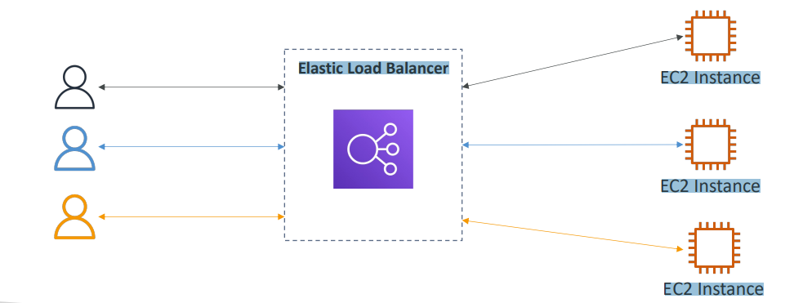

**Use case**

* Spread load across multiple downstream instances
* Expose a single point of access (DNS) to your application
* Seamlessly handle failures of downstream instances
* Do regular health checks for your instances
* Provide SSL termination (HTTPS) for your websites
* Enforce stickiness with cookies
* High availability across zones
* Separate public traffic from private traffic

**Benefits of Elastic Load balancer vs inhouse**

* An Elastic Load Balancer is a managed load balancer

1. AWS guarantees that it will be working
2. AWS takes care of upgrades, maintenance, high availability
3. AWS provides only a few configurations knobs

* It costs less to set up your own load balancer, but it will be a lot more effort on your end
* It is integrated with many AWS offerings / services

1. EC2, EC2 Auto Scaling Groups, Amazon ECS
2. AWS Certificate Manager (ACM), CloudWatch
3. Route 53, AWS WAF, AWS Global Accelerator

**Health Checks**

* Health Checks are crucial for Load Balancers
* They enable the load balancer to know if instances it forwards traffic to are available to reply to requests
* The health check is done on a port, and a route (/health is common)
* If the response is not 200 (OK), then the instance is unhealthy

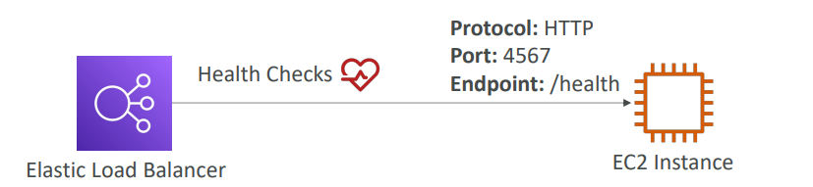

**Types of load balancer on AWS**

AWS has 4 kinds of managed Load Balancers

1. **Classic Load Balancer** (v1 - old generation) – 2009 – CLB: HTTP, HTTPS, TCP, SSL (secure TCP)
2. **Application Load Balancer** (v2 - new generation) – 2016 – ALB: HTTP, HTTPS, WebSocket
3. **Network Load Balancer** (v2 - new generation) – 2017 – NLB: TCP, TLS (secure TCP), UDP
4. **Gateway Load Balancer** – 2020 – GWLB: Operates at layer 3 (Network layer) – IP Protocol

Overall, it is recommended to use the newer generation load balancers as they provide more features. Some load balancers can be set up as internal (private) or external (public) ELBs

**Load Balancers uses Security Group**

So the users can access your load balancer from anywhere using HTTP or HTTPS. And therefore the security group rule is going to look like something like this, where the port range is going to be 80 or 443. And the source is going to be 0.0.0.0/0, which means anywhere.

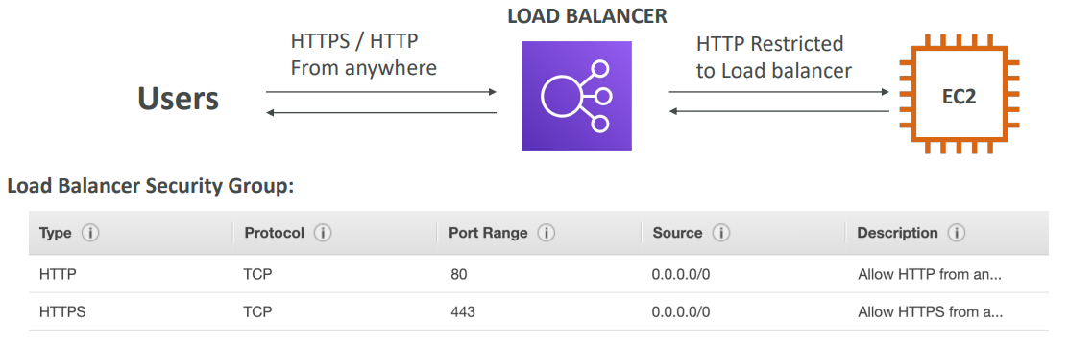

EC2 instances should only allow traffic coming directly from the load balancer. And therefore, the security group rule for your EC2 instances is going to look a little bit different. It's going to allow HTTP traffic on port 80 and the source of it is not going to be an IP range instead is going to be a security group.

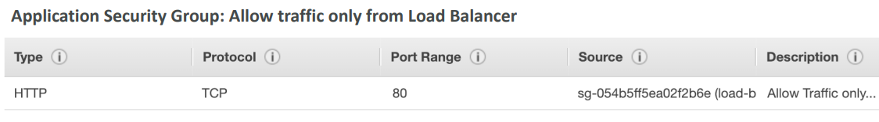

|  |  |  |  |
| --- | --- | --- | --- |
| Classic Load Balancer | Application Load Balancer | Network Load Balancer | Gateway Load Balancer |
|  |  |  |  |
| Choose a Classic Load Balancer when you have an existing application running in the EC2-Classic network. | Choose an Application Load Balancer when you need a flexible feature set for your applications with HTTP and HTTPS traffic. Operating at the request level, Application Load Balancers provide advanced routing and visibility features targeted at application architecture, including microservices and containers. | Choose a Network Load Balancer when you need ultra-high performance, TLS offloading at scale, centralized certificate deployment, support for UDP, and static IP addresses for your applications. Operating at the connection level, Network Load Balancers are capable of handling millions of requests per second securely while maintaining ultra-low latencies. | Choose a Gateway Load Balancer when you need to deploy and manage a fleet of third-party virtual appliances that support GENEVE. These appliances enable you to improve security, compliance, and policy controls. |

## Classic Load Balancers

|  |  |
| --- | --- |
| * Supports TCP (Layer 4), HTTP & HTTPS (Layer 7) * Health checks are TCP or HTTP based * Fixed hostname XXX.region.elb.amazonaws.com |  |

## Application Load Balancer (v2)

* Application load balancers are Layer 7 (HTTP).
* Load balancing to multiple HTTP applications across machines (target groups)
* Load balancing to multiple applications on the same machine (ex: containers)
* Support for HTTP/2 and WebSocket
* Support redirects (from HTTP to HTTPS for example)
* Routing tables for different target groups:

1. Routing based on path in URL (example.com/users & example.com/posts)
2. Routing based on hostname in URL (one.example.com & other.example.com)
3. Routing based on Query String, Headers (example.com/users?id=123&order=false)

* ALB are a great fit for micro services & container-based application (example: Docker & Amazon ECS)
* Has a port mapping feature to redirect to a dynamic port in ECS
* In comparison, we’d need multiple Classic Load Balancer per application

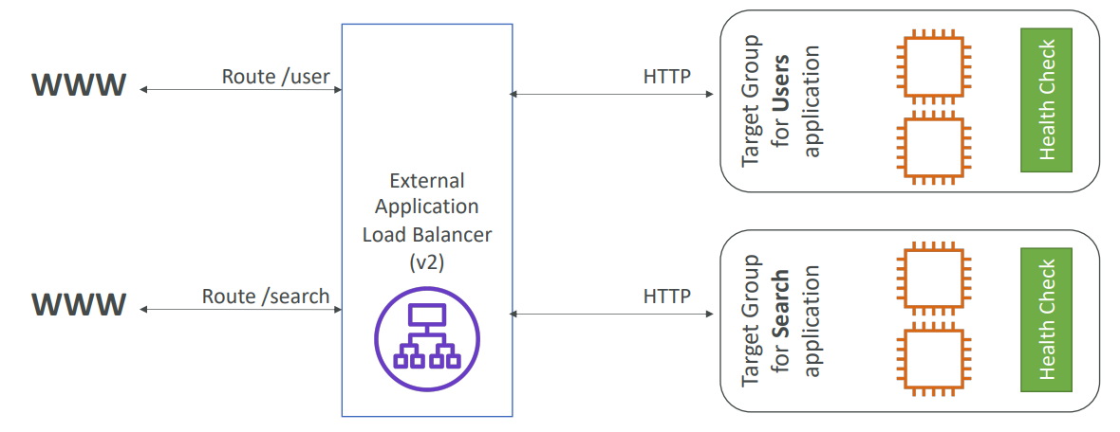

**Target Groups**

* EC2 instances (can be managed by an Auto Scaling Group) – HTTP
* ECS tasks (managed by ECS itself) – HTTP
* Lambda functions – HTTP request is translated into a JSON event
* IP Addresses – must be private IPs
* ALB can route to multiple target groups
* Health checks are at the target group level

**Query Strings/Parameters Routing**

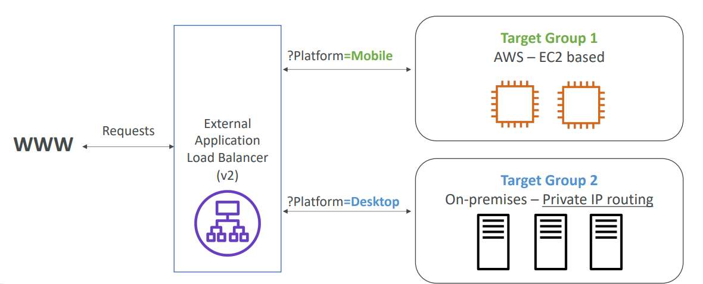

* Fixed hostname (XXX.region.elb.amazonaws.com)
* The application servers don’t see the IP of the client directly

1. The true IP of the client is inserted in the header X-Forwarded-For
2. We can also get Port (X-Forwarded-Port) and proto (X-Forwarded-Proto)

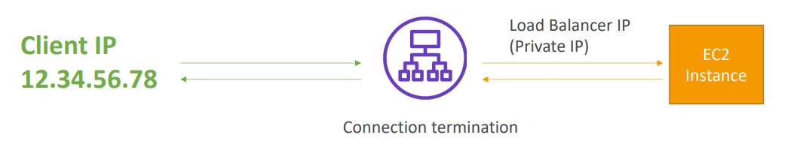

**Hands On**

Let’s say we have 2 EC2 instances now we create ALB

Keep only those regions which have my Ec2

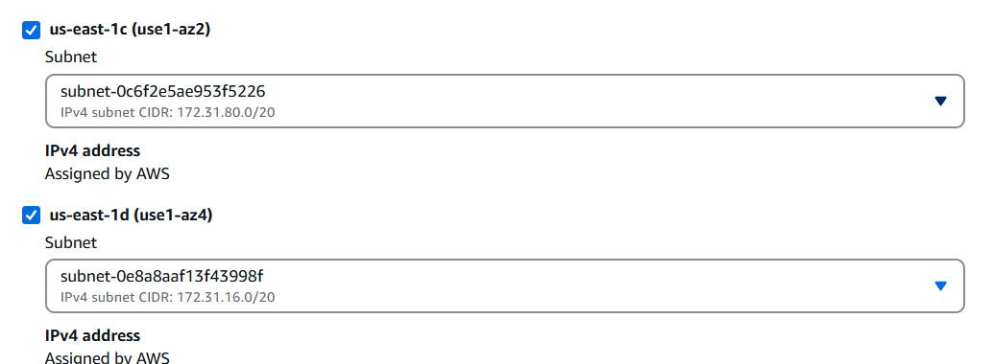

Create SG to allow HTTP from all

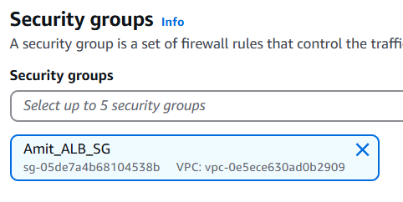

Then we create Target group and assign our EC2 instances as targets

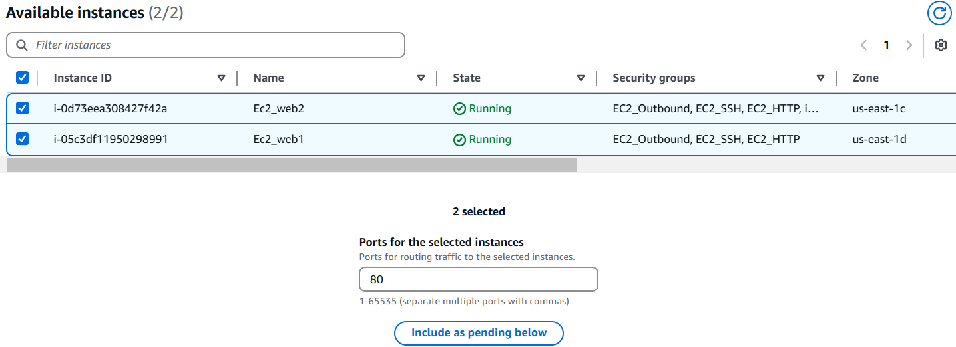

Assigning TG to ALB

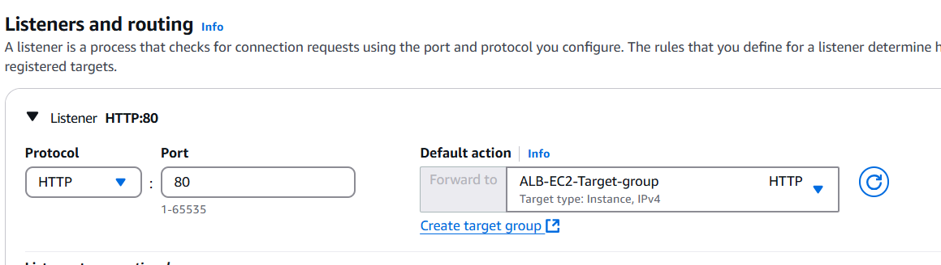

After this we can access our web pages using ALB endpoint

We can also remove the public access SG of EC2 and assign a SG which will allow traffic from SG assigned to ALB. In this SG instead of allowing traffic from any IP will allow traffic from SG assigned to ALB, due to which traffic will be allowed

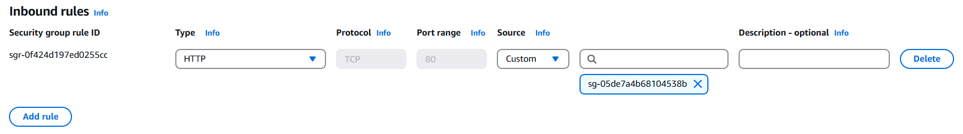

**ALB Listeners**

In ALB we have listeners where we can add rules

## Network Load Balancer (v2)

* Network load balancers (Layer 4) allow to:

1. Forward TCP & UDP traffic to your instances
2. Handle millions of requests per second

* Ultra-low latency
* NLB has one static IP per AZ, and supports assigning Elastic IP (helpful for whitelisting specific IP)
* NLB are used for extreme performance, TCP or UDP traffic
* Not included in the AWS free tier

We create target groups, and then the network balancer will redirect to them.

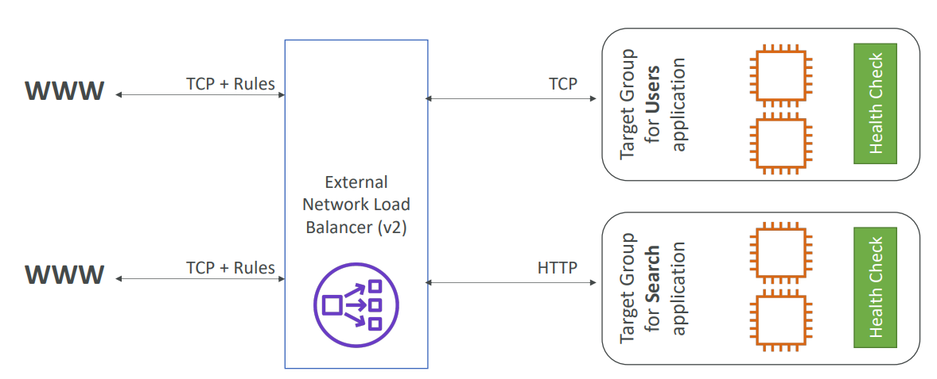

**Target Groups**

* EC2 instances
* IP Addresses – must be private Ips for e.g. private IP of the EC2 instance but also you could use the private IP of a server that you have in your own data center
* Application Load Balancer- We can put NLB in front of ALB thanks to the Network Load Balancer, reason, you would get, the fixed IP addresses from NLB and then, thanks to the ALB , you can get all the rules that you have around handling HTP type of traffic, so it is a valid combination

Health Checks support the TCP, HTTP and HTTPS Protocols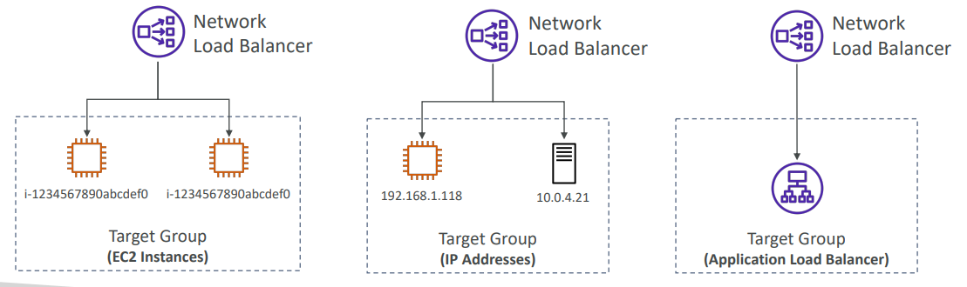

## Gateway Load Balancer

|  |  |
| --- | --- |
| • Deploy, scale, and manage a fleet of 3rd party network virtual appliances in AWS  • Example: Firewalls, Intrusion Detection and Prevention Systems, Deep Packet Inspection Systems, payload manipulation, …  • Operates at Layer 3 (Network Layer) – IP Packets  • Combines the following functions:   1. Transparent Network Gateway – single entry/exit for all traffic 2. Load Balancer – distributes traffic to your virtual appliances   • Uses the GENEVE protocol on port 6081 |  |

**Target Groups**

* EC2 instances
* IP Addresses – must be private Ips

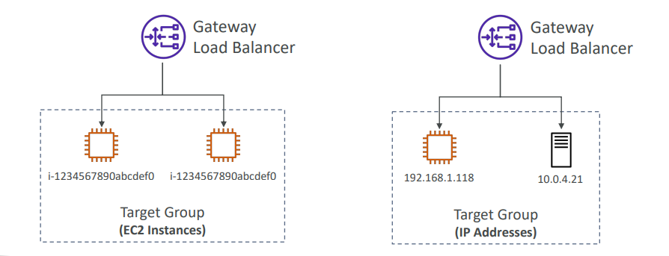

## Sticky Sessions (Session Affinity)

|  |  |
| --- | --- |
| • It is possible to implement stickiness so that the same client is always redirected to the same instance behind a load balancer  • This works for Classic Load Balancer, Application Load Balancer, and Network Load  Balancer  • For both CLB & ALB, the “cookie” used for stickiness has an expiration date you control  • Use case: make sure the user doesn’t lose his session data  • Enabling stickiness may bring imbalance to the load over the backend EC2 instances |  |

**Types of cookies**

1. Application-based Cookies

* Custom cookies
  1. Generated by the target
  2. Can include any custom attributes required by the application
  3. Cookie name must be specified individually for each target group
  4. Don’t use AWSALB, AWSALBAPP, or AWSALBTG (reserved for use by the ELB)
* Application cookies
  1. Generated by the load balancer
  2. Cookie’s name is AWSALBAPP

1. Duration-based Cookies

* Cookie generated by the load balancer
* Cookie name is AWSALB for ALB, AWSELB for CLB

Sticky sessions can be enabled at target group level by editing target group

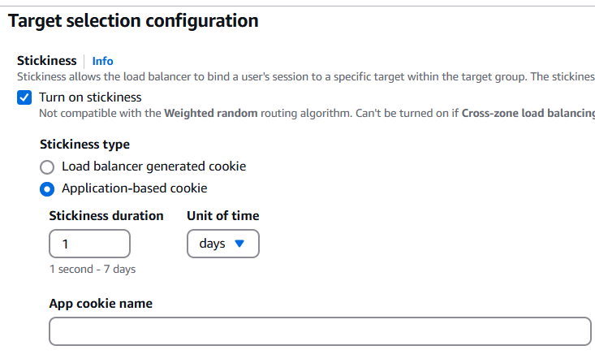

## Cross-Zone Load Balancing

|  |  |
| --- | --- |
| With Cross Zone Load Balancing: each load balancer instance distributes evenly across all registered instances in all AZ | Without Cross Zone Load Balancing: Requests are distributed in the instances of the node of the Elastic Load Balancer |
|  |  |

* Application Load Balancer

1. Enabled by default (can be disabled at the Target Group level)
2. No charges for inter AZ data

* Network Load Balancer & Gateway Load Balancer

1. Disabled by default
2. You pay charges ($) for inter AZ data if enabled

* Classic Load Balancer

1. Disabled by default
2. No charges for inter AZ data if enabled

## SSL/TLS - Basics

* An SSL Certificate allows traffic between your clients and your load balancer to be encrypted in transit (in-flight encryption)
* SSL refers to Secure Sockets Layer, used to encrypt connections
* TLS refers to Transport Layer Security, which is a newer version
* Nowadays, TLS certificates are mainly used, but people still refer as SSL
* Public SSL certificates are issued by Certificate Authorities (CA)
* Comodo, Symantec, GoDaddy, GlobalSign, Digicert, Letsencrypt, etc…
* SSL certificates have an expiration date (you set) and must be renewed

Load Balancer - SSL Certificates

* The load balancer uses an X.509 certificate (SSL/TLS server certificate)
* You can manage certificates using ACM (AWS Certificate Manager)
* You can create upload your own certificates alternatively
* HTTPS listener:

1. You must specify a default certificate
2. You can add an optional list of certs to support multiple domains
3. Clients can use SNI (Server Name Indication) to specify the hostname they reach
4. Ability to specify a security policy to support older versions of SSL / TLS (legacy clients)

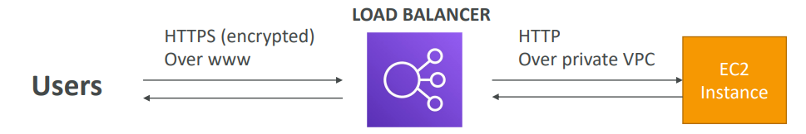

**SSL – Server Name Indication (SNI)**

|  |  |
| --- | --- |
| * SNI solves the problem of loading multiple SSL certificates onto one web server (to serve multiple websites) * It’s a “newer” protocol, and requires the client * to indicate the hostname of the target server in the initial SSL handshake * The server will then find the correct * certificate, or return the default one   Note:   1. Only works for ALB & NLB (newer generation), CloudFront 2. Does not work for CLB (older gen) |  |

**Elastic Load Balancers – SSL Certificates**

* Classic Load Balancer (v1)

1. Support only one SSL certificate
2. Must use multiple CLB for multiple hostnames with multiple SSL certificates

* Application Load Balancer (v2)

1. Supports multiple listeners with multiple SSL certificates
2. Uses Server Name Indication (SNI) to make it work

* Network Load Balancer (v2)

1. Supports multiple listeners with multiple SSL certificates
2. Uses Server Name Indication (SNI) to make it work

**Connection Draining**

|  |  |
| --- | --- |
| * Feature naming  1. Connection Draining – for CLB 2. Deregistration Delay – for ALB & NLB  * The concept is that it will give time to complete “in-flight requests” while the instance is de-registering or unhealthy * And once the instance is drained stop sending new requests to the EC2 instance which is de-registering * Between 1 to 3600 seconds (default: 300 seconds) * Can be disabled (set value to 0) * Set to a low value if your requests are short so that EC2 can be drained quickly and replaced by new EC2 but if requests are long for e.g. uploads etc., then we need to set high so that requests don’t fail , but then it will take time to set up new instances |  |

## Auto Scaling Group

* In real life, the load on your websites and applications can change
* In the cloud, you can create and get rid of servers very quickly
* The goal of an Auto Scaling Group (ASG) is to:

1. Scale out (add EC2 instances) to match an increased load
2. Scale in (remove EC2 instances) to match a decreased load
3. Ensure we have a minimum and a maximum number of EC2 instances running
4. Automatically register new instances to a load balancer
5. Re-create an EC2 instance in case a previous one is terminated (ex: if unhealthy)

* ASG are free (you only pay for the underlying EC2 instances)

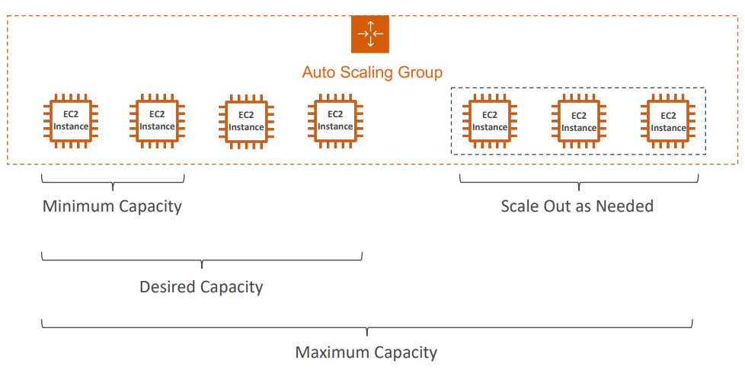

With Load Balancer

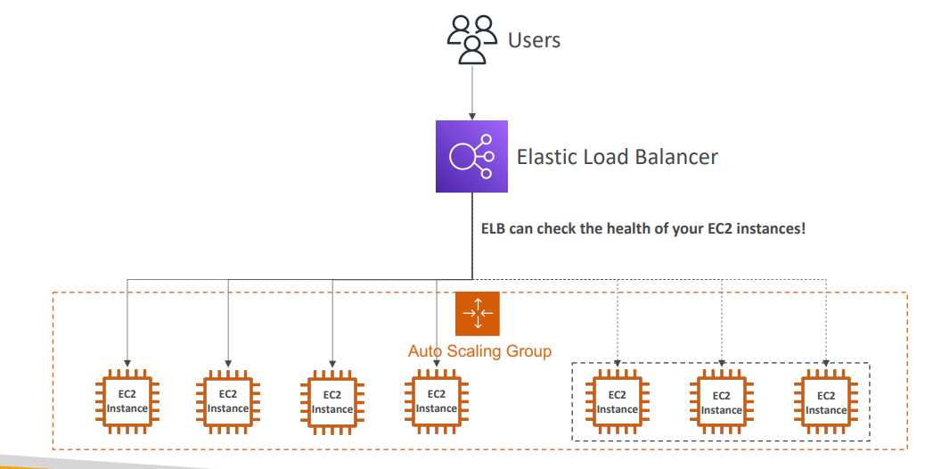

|  |  |
| --- | --- |
| * A Launch Template (older “Launch Configurations” are deprecated)  1. AMI + Instance Type 2. EC2 User Data 3. EBS Volumes 4. Security Groups 5. SSH Key Pair 6. IAM Roles for your EC2 Instances 7. Network + Subnets Information 8. Load Balancer Information  * Min Size / Max Size / Initial Capacity * Scaling Policies |  |

**Auto Scaling - CloudWatch Alarms & Scaling**

* It is possible to scale an ASG based on CloudWatch alarms
* An alarm monitors a metric (such as Average CPU, or a custom metric)
* Metrics such as Average CPU are computed for the overall ASG instances
* Based on the alarm:

1. We can create scale-out policies (increase the number of instances)
2. We can create scale-in policies (decrease the number of instances)

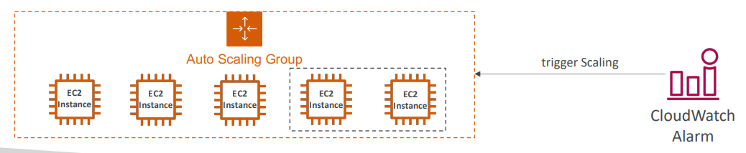

**Auto Scaling Groups – Scaling Policies**

* **Dynamic Scaling**
* Target Tracking Scaling

1. Simple to set-up
2. Example: I want the average ASG CPU to stay at around 40%

* Simple / Step Scaling

1. When a CloudWatch alarm is triggered (example CPU > 70%), then add 2 units
2. When a CloudWatch alarm is triggered (example CPU < 30%), then remove 1

* **Scheduled Scaling**

1. Anticipate scaling based on known usage patterns
2. Example: increase the min capacity to 10 at 5 pm on Fridays

* **Predictive scaling**: continuously forecast load and schedule scaling ahead

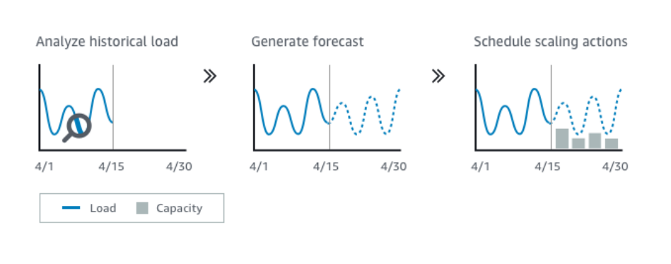

**Good metrics to scale on**

|  |  |
| --- | --- |
| * CPUUtilization: Average CPU utilization across your instances * RequestCountPerTarget: to make sure the number of requests per EC2 instances is stable * Average Network In / Out (if you’re application is network bound) * Any custom metric (that you push using CloudWatch) |  |

**Auto Scaling Groups - Scaling Cooldowns**

|  |  |
| --- | --- |
| • After a scaling activity happens, you are in the cooldown period (default 300 seconds) • During the cooldown period, the ASG will not launch or terminate additional instances (to allow for metrics to stabilize)  • Advice: Use a ready-to-use AMI to reduce configuration time in order to be serving request fasters and reduce the cooldown period |  |

We create Launch template by providing AMI, Security Group, key pair etc.

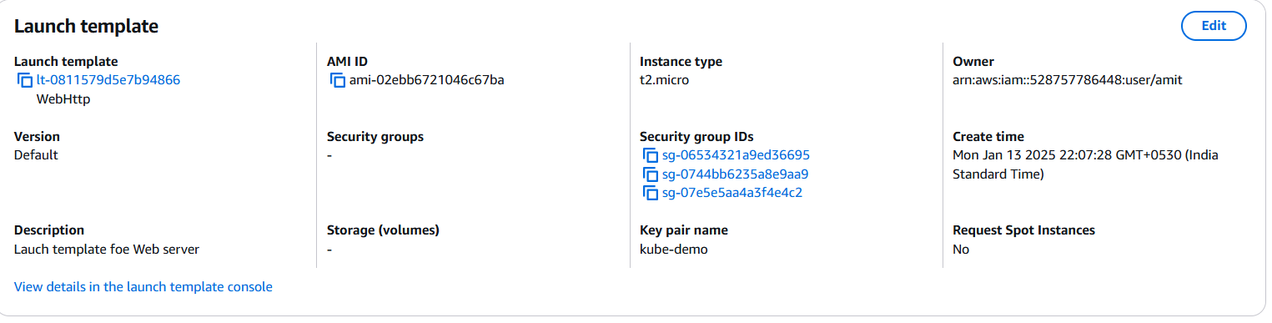

We select Network

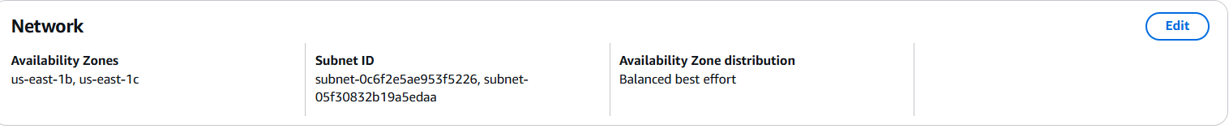

We assign an ALB. We select if we want to monitor the EC2 or the ALB traffic also



Health Checks



And capacity

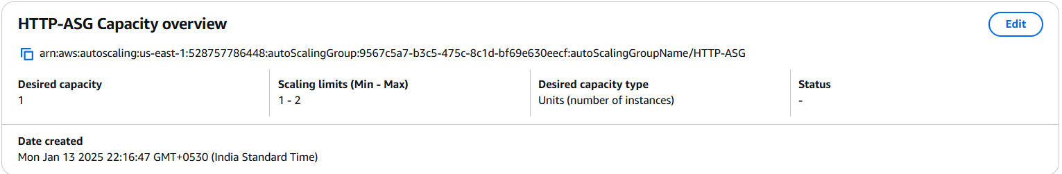

## Questions

Scaling an EC2 instance from r4.large to r4.4xlarge is called .....................

* Horizontal Scaling
* Vertical Scaling

Running an application on an Auto Scaling Group that scales the number of EC2 instances in and out is called .....................

* Horizontal Scaling
* Vertical Scaling

Elastic Load Balancers provide a .......................

* Static IPV4
* Static DNS
* Static IVP6

Only Network Load Balancer provides both static DNS name and static IP. While, Application Load Balancer provides a static DNS name but it does NOT provide a static IP. The reason being that AWS wants your Elastic Load Balancer to be accessible using a static endpoint, even if the underlying infrastructure that AWS manages changes.

You are running a website on 10 EC2 instances fronted by an Elastic Load Balancer. Your users are complaining about the fact that the website always asks them to re-authenticate when they are moving between website pages. You are puzzled because it's working just fine on your machine and in the Dev environment with 1 EC2 instance. What could be the reason?

* Multiple severs
* IP address of EC2 is not visible to client rather than ELB IP is visible
* Sticky session

ELB Sticky Session feature ensures traffic for the same client is always redirected to the same target (e.g., EC2 instance). This helps that the client does not lose his session data.

You are using an Application Load Balancer to distribute traffic to your website hosted on EC2 instances. It turns out that your website only sees traffic coming from private IPv4 addresses which are in fact your Application Load Balancer's IP addresses. What should you do to get the IP address of clients connected to your website?

* Modify your website's frontend so that users send their IP in every request
* Modify your website's backend to get the client IP address from the X-Forwarded-For header
* Modify your website's backend to get the client IP address from the X-Forwarded-Port header
* Modify your website's backend to get the client IP address from the X-Forwarded-Proto header

When using an Application Load Balancer to distribute traffic to your EC2 instances, the IP address you'll receive requests from will be the ALB's private IP addresses. To get the client's IP address, ALB adds an additional header called "X-Forwarded-For" contains the client's IP address.

Top of Form

You hosted an application on a set of EC2 instances fronted by an Elastic Load Balancer. A week later, users begin complaining that sometimes the application just doesn't work. You investigate the issue and found that some EC2 instances crash from time to time. What should you do to protect users from connecting to the EC2 instances that are crashing?

* **Enable ELB Health Checks**
* **Enable ELB Stickiness**
* **Enable SSL Termination**
* **Enable Cross-Zone Load Balancing**

**When you enable ELB Health Checks, your ELB won't send traffic to unhealthy (crashed) EC2 instances.**

Bottom of Form

Top of Form

You are working as a Solutions Architect for a company and you are required to design an architecture for a high-performance, low-latency application that will receive millions of requests per second. Which type of Elastic Load Balancer should you choose?

* **Application Load Balancer**
* **Classic Load Balancer**
* **Network Load Balancer**

Bottom of Form

Network Load Balancer provides the highest performance and lowest latency if your application needs it.

Top of Form

Application Load Balancers support the following protocols, **EXCEPT**:

* **HTTP**
* **HTTPS**
* **TCP**
* **WebSocket**

Application Load Balancers support HTTP, HTTPS and WebSocketBottom of Form

Top of Form

Application Load Balancers can route traffic to different Target Groups based on the following, **EXCEPT**:

* **Client's Location (Geography)**
* **Hostname**
* **Request URL Path**
* **Source IP Address**

ALBs can route traffic to different Target Groups based on URL Path, Hostname, HTTP Headers, and Query Strings.Bottom of Form

Top of Form

Registered targets in a Target Groups for an Application Load Balancer can be one of the following, **EXCEPT**:

* **EC2 Instances**
* **Network Load Balancer**
* **Private IP Addresses**
* **Lambda Functions**

Ans NLB

Top of Form

For compliance purposes, you would like to expose a fixed static IP address to your end-users so that they can write firewall rules that will be stable and approved by regulators. What type of Elastic Load Balancer would you choose?

* **Application Load Balancer with an Elastic IP attached to it**
* **Network Load Balancer**
* **Classic Load Balancer**

Bottom of Form

Network Load Balancer has one static IP address per AZ and you can attach an Elastic IP address to it. Application Load Balancers and Classic Load Balancers have a static DNS name.

Top of Form

You want to create a custom application-based cookie in your Application Load Balancer. Which of the following you can use as a cookie name?

* **AWSALBAPP**
* **APPUSERC**
* **AWSALBTG**
* **AWSALB**

Bottom of Form

The following cookie names are reserved by the ELB (AWSALB, AWSALBAPP, AWSALBTG).

Top of Form

You have a Network Load Balancer that distributes traffic across a set of EC2 instances in us-east-1. You have 2 EC2 instances in us-east-1b AZ and 5 EC2 instances in us-east-1e AZ. You have noticed that the CPU utilization is higher in the EC2 instances in us-east-1b AZ. After more investigation, you noticed that the traffic is equally distributed across the two AZs. How would you solve this problem?

* **Enable Cross-Zone Load Balancing**
* **Enable Sticky Sessions**
* **Enable ELB Health Checks**
* **Enable SSL Termination**

Bottom of Form

When Cross-Zone Load Balancing is enabled, ELB distributes traffic evenly across all registered EC2 instances in all AZs.

Top of Form

Which feature in both Application Load Balancers and Network Load Balancers allows you to load multiple SSL certificates on one listener?

* **TLS Termination**
* **Server Name Indication (SNI)**
* **SSL Security Policies**
* **Host Headers**

Bottom of Form

ANS SNI

Top of Form

You have an Application Load Balancer that is configured to redirect traffic to 3 Target Groups based on the following hostnames: **users.example.com**, **api.external.example.com**, and **checkout.example.com**. You would like to configure HTTPS for each of these hostnames. How do you configure the ALB to make this work?

* **Use an HTTP to HTTPS redirect rule**
* **Use a security group SSL certificate**
* **Use Server Name Indication (SNI)**

Bottom of Form

Server Name Indication (SNI) allows you to expose multiple HTTPS applications each with its own SSL certificate on the same listener. Read more here: https://aws.amazon.com/blogs/aws/new-application-load-balancer-sni/

Top of Form

You have an application hosted on a set of EC2 instances managed by an Auto Scaling Group that you configured both desired and maximum capacity to 3. Also, you have created a CloudWatch Alarm that is configured to scale out your ASG when CPU Utilization reaches 60%. Your application suddenly received huge traffic and is now running at 80% CPU Utilization. What will happen?

* **Nothing**
* **The desired capacity will go up to 4 and the maximum capacity will stay at 3**
* **The desired capacity will go up to 4 and the maximum capacity will stay at 4**

Bottom of Form

The Auto Scaling Group can't go over the maximum capacity (you configured) during scale-out events.

Top of Form

You have an Auto Scaling Group fronted by an Application Load Balancer. You have configured the ASG to use ALB Health Checks, then one EC2 instance has just been reported unhealthy. What will happen to the EC2 instance?

* **The ASG will keep the instance running and re-start the application**
* **The ASG will detach the EC2 instance and leave it running**
* **The ASG will terminate the EC2 instance**

Bottom of Form

You can configure the Auto Scaling Group to determine the EC2 instances' health based on Application Load Balancer Health Checks instead of EC2 Status Checks (default). When an EC2 instance fails the ALB Health Checks, it is marked unhealthy and will be terminated while the ASG launches a new EC2 instance.

Top of Form

Your boss asked you to scale your Auto Scaling Group based on the **number of requests per minute** your application makes to your database. What should you do?

* **Create a CloudWatch custom metric then create a CloudWatch Alarm on this metric to scale your ASG**
* **You politely tell him it's impossible**
* **Enable Detailed Monitoring then create a CloudWatch Alarm to scale your ASG**

Bottom of Form

There's no CloudWatch Metric for "requests per minute" for backend-to-database connections. You need to create a CloudWatch Custom Metric, then create a CloudWatch Alarm.

Top of Form

An application is deployed with an Application Load Balancer and an Auto Scaling Group. Currently, you manually scale the ASG and you would like to define a Scaling Policy that will ensure the average number of connections to your EC2 instances is around 1000. Which Scaling Policy should you use?

* **Simple Scaling Policy**
* **Step Scaling Policy**
* **Target Tracking Policy**
* **Scheduled Scaling Policy**

Bottom of Form

Ans Target

Top of Form

You have an ASG and a Network Load Balancer. The application on your ASG supports the HTTP protocol and is integrated with the Load Balancer health checks. You are currently using the TCP health checks. You would like to migrate to using HTTP health checks, what do you do?

* **Migrate to an Application Load Balancer**
* **Migrate the health check to HTTP**

Bottom of Form

the NLB supports HTTP health checks as well as TCP and HTTPS

Top of Form

You have a website hosted in EC2 instances in an Auto Scaling Group fronted by an Application Load Balancer. Currently, the website is served over HTTP, and you have been tasked to configure it to use HTTPS. You have created a certificate in ACM and attached it to the Application Load Balancer. What you can do to force users to access the website using HTTPS instead of HTTP?

* **Send an email to all customers to use HTTPS instead of HTTP**
* **Configure the Application Load Balancer to redirect HTTP to HTTPS**
* **Configure the DNS record to redirect HTTP to HTTPS**

Bottom of Form

And B

Bottom of Form

# RDS, Aurora & Elastic Cache

**Amazon RDS Overview**

* RDS stands for Relational Database Service
* It’s a managed DB service for DB using SQL as a query language.
* It allows you to create databases in the cloud that are managed by AWS that supports

1. Postgres
2. MySQL
3. MariaDB
4. Oracle
5. Microsoft SQL Server
6. IBM DB2
7. Aurora (AWS Proprietary database)

Ans

**Advantage over using RDS versus deploying DB on EC2**

RDS is a managed service and amazon provides

1. Automated provisioning (DB set up), OS patching
2. Continuous backups and restore to specific timestamp (Point in Time Restore)!
3. Monitoring dashboards
4. Read replicas for improved read performance
5. Multi AZ setup for DR (Disaster Recovery)
6. Maintenance windows for upgrades
7. Scaling capability (vertical and horizontal)
8. Storage backed by EBS

* BUT you can’t SSH into your instances

**RDS Storage Auto Scaling**

|  |  |
| --- | --- |
| * Help you increase storage on your RDS DB instance dynamically * When RDS detects you are running out of free database storage, it scales automatically * Avoid manually scaling your database storage which can be painful * You have to set Maximum Storage Threshold (maximum limit for DB storage) * Automatically modify storage if:  1. Free storage is less than 10% of allocated storage 2. Low storage lasts at least 5 minutes 3. 6 hours have passed since last modification  * Useful for applications with unpredictable workloads   Supports all RDS database engines |  |

## RDS Read Replicas for reading scalability

|  |  |
| --- | --- |
| * RDS supports Up to 15 Read Replicas only for select query * Within AZ, Cross AZ or Cross Region * Replication is ASYNC, so reads are eventually consistent * Replicas can be promoted to their own DB * Applications must update the connection string to leverage read replicas |  |

**RDS Read Replicas – Use Cases**

|  |  |
| --- | --- |
| * You have a production database that is taking on normal load. * You want to run a reporting application to run some analytics * You create a Read Replica to run the new workload there * The production application is unaffected * Read replicas are used for SELECT (=read) only kind of statements (not INSERT, UPDATE, DELETE) |  |

**RDS Read Replicas – Network Cost**

* In AWS there’s a network cost when data goes from one AZ to another
* For RDS Read Replicas within the same region, you don’t pay that fee
* Cross region replicas will have cost

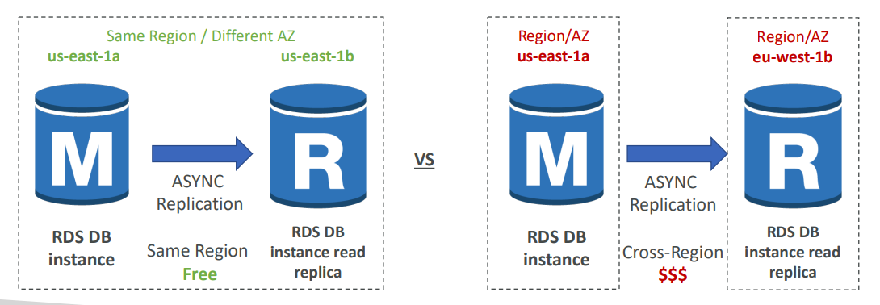

**RDS Multi AZ (Disaster Recovery)**

|  |  |
| --- | --- |
| • SYNC replication every transaction must be synced to be accepted  • One DNS name – automatic app failover to standby  • Increase availability  • Failover in case of loss of AZ, loss of network, instance or storage failure  • Don’t need to do any manual intervention in your apps if it tries to keep on connecting to your database automatically at some point, it will fail over to the standby that will be promoted as the Master,  • Not used for scaling. The standby database is just for standby. No one can read it. No one can write to it; it's just here as a failover in case anything goes on with your Master database. So, quick  • Note: The Read Replicas be set up as Multi AZ for Disaster Recovery (DR) |  |

**RDS – From Single-AZ to Multi-AZ**

|  |  |
| --- | --- |
| • Zero downtime operation (no need to stop the DB) for making it multi-AZ  • Just click on “modify” for the database  • The following happens internally:   1. A snapshot is taken 2. A new DB is restored from the snapshot in a new AZ 3. • Synchronization is established between the two databases |  |

**Hands ON**

Engines supported

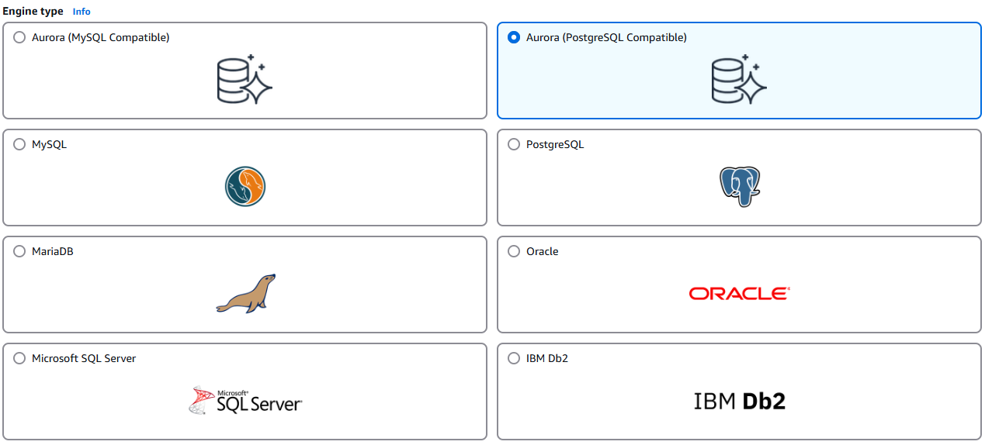

We have templates to meet our use case. In production we have full control

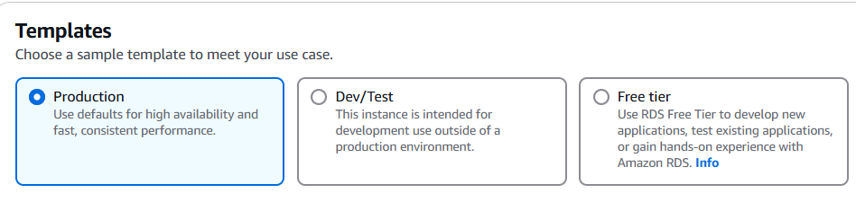

For availability and durability. We have three options. We have Single DB instance, Multi-AZ, or Multi-AZ DB Cluster. Because we want to remain within the free tier, we're going to use Single DB instance.

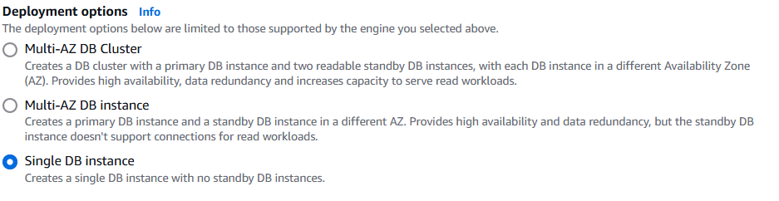

For the instance configuration, this is the size of the underlying EC2 instance. So, in our case, we can have standard classes, memory optimized classes, or burstable classes, and you can choose whatever instance you want amongst each class. But to remain within the free tier, we're going to use burstable classes and we're going to choose db.t3.micro.

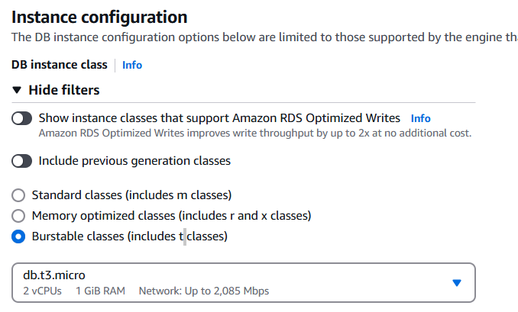

Now for storage type, if you are in production, you're going to use an io1 type of EBS volume. But as we're running within the free tier, I want to use a gp2 type of volume, which is lower performance, and we'll use maybe 10, 20 gigabytes of allocated storage. We can also enable storage autoscaling, which will automatically increase the size of the EBS volume in case we are starting to near a threshold

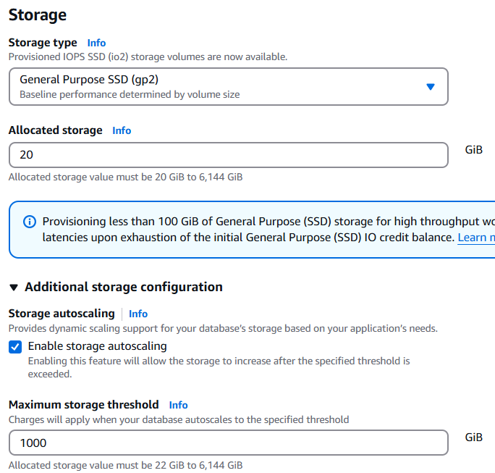

In case you wanted to make sure that there is connectivity between a specified EC2 instance and your RDS database. You would just choose it on this list. And then the configuration in terms of networking would be done automatically so you don't have to handle security groups.

If we are setting connectivity as don’t connect we have to select VPC and select whether or not we want public access to this database

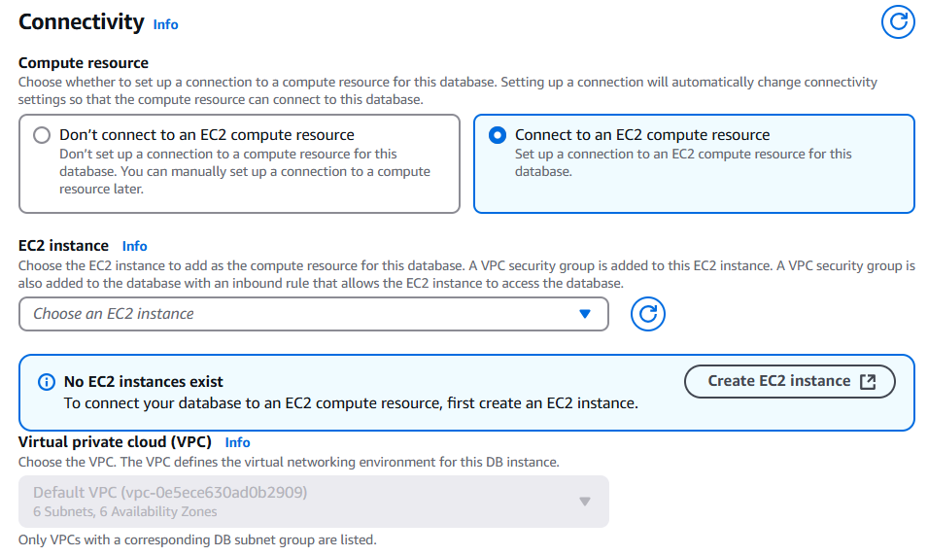

Can control public access

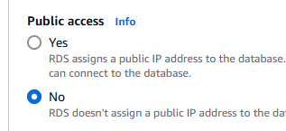

Can set monitoring and backup

**RDS Custom**

With RDS we don't have access to any underlying operating system, or customization, but with RDS Custom we actually do. And RDS Custom is for two database types, it's for Oracle and Microsoft SQL Server

|  |  |
| --- | --- |
| * Managed Oracle and Microsoft SQL Server Database with OS and database customization * RDS: Automates setup, operation, and scaling of database in AWS * Custom: access to the underlying database and OS so you can  1. Configure settings 2. Install patches 3. Enable native features 4. Access the underlying EC2 Instance using SSH or SSM Session Manager  * De-activate Automation Mode to perform your customization, better to take a DB snapshot before * RDS vs. RDS Custom  1. RDS: entire database and the OS to be managed by AWS 2. RDS Custom: full admin access to the underlying OS and the database |  |

## Amazon Aurora

* Aurora is a proprietary technology from AWS (not open sourced)
* Postgres and MySQL are both supported as Aurora DB (that means your drivers will work as if Aurora was a Postgres or MySQL database)
* Aurora is “AWS cloud optimized” and claims 5x performance improvement over MySQL on RDS, over 3x the performance of Postgres on RDS
* Aurora storage automatically grows in increments of 10GB, up to 128 TB. You can start at 10 GB.
* Aurora can have up to 15 replicas and the replication process is faster than MySQL (sub 10 milliseconds replica lag)
* Failover in Aurora is instantaneous. It’s HA (High Availability) native.
* Aurora costs more than RDS (20% more) – but is more efficient

**Aurora High Availability and Read Scaling**

|  |  |
| --- | --- |
| * 6 copies of your data across 3 AZ:  1. 4 copies out of 6 needed for writing 2. 3 copies out of 6 needed for reading 3. Self-healing with peer-to-peer replication  * Storage is striped across 100s of volumes * One Aurora Instance takes writes (master) * Automated failover for master in less than 30 seconds * Master + up to 15 Aurora Read Replicas serve reads * Support for Cross Region Replication |  |

**Aurora DB Cluster**

For Aurora have a shared storage volume which is auto expanding from 10GB to 128GB. Your master is the only thing that will write to your storage. Because the master can change and failover, what Aurora provides you is what's called a writer endpoint. It's a DNS name, a writer endpoint, and it's always pointing to the master. So even if the master fails over, your client still talks to the writer endpoint and is automatically redirected to the right instance.

For Aurora you also have a lot of read replicas. Also, we can have auto scaling on top of these read replicas. You can have one up to 15 read replicas and you can set up auto scaling such as you always have the right number of read replicas. Now, because you have auto scaling, it can be really, hard for your applications to keep track replica end points. There is something called a reader endpoint. It helps with connection load balancing, and it connects automatically to all the read replicas. So anytime the client connects to the reader endpoints it will get connected to one of the read replicas and there will be load balancing done this way. The load balancing happens at the connection level, not the statement level.

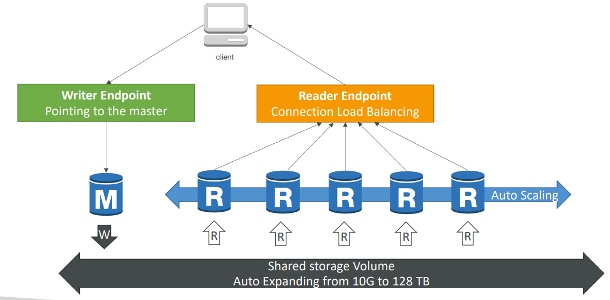

**Features of Aurora**

* Automatic fail-over
* Backup and Recovery
* Isolation and security
* Industry compliance
* Push-button scaling
* Automated Patching with Zero Downtime
* Advanced Monitoring
* Routine Maintenance
* Backtrack: restore data at any point of time without using backups

**Aurora Replicas - Auto Scaling**

Let's say we have a client, and we have three Aurora's instances right now. One will be writing through the writer endpoint and the other two would be reading through the reader endpoint. Okay. Now let's say that we are having many, many requests, read requests on the reader endpoint, and so therefore the Amazon Aurora databases have an increased CPU usage. In that case, we can set up replica auto-scaling, and what this will do is that it will add obviously Amazon Aurora replicas, and then what will happen is that automatically the reader endpoint is going to be extended to cover these new replicas and therefore these new replicas will start receiving some traffic and the reads will be happening in a more distributed fashion, hopefully bringing down the overall CPU usage. So this is replica auto scaling.

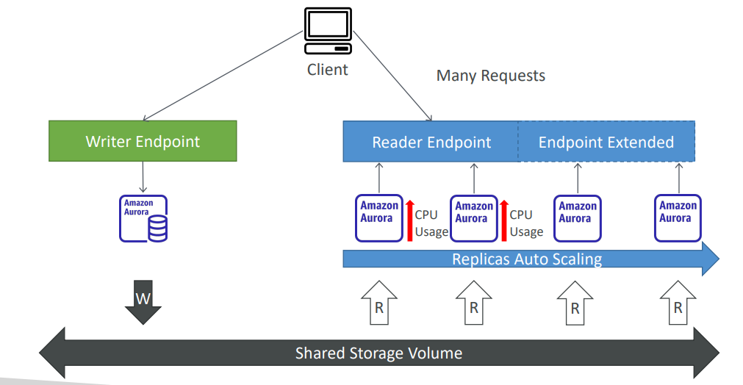

**Aurora – Custom Endpoints**

The second thing is custom endpoints. So, let's say we have the same setup, but this time we have two different kinds of replicas. As you can see, we have some DBR three large and some DBR five two X large. So, some replicas are bigger than others. And the reason you would do this is that you want to define a subset of your Aurora instances as a custom endpoint. Let's say we define a custom endpoint on these two bigger Aurora instances. The reason we would do so is, for example, that we know that these instances are more powerful and therefore they're going to be better to run analytical queries on these specific replicas. So, when you do so, you have a custom endpoint that's defined. And when you have a custom endpoint, generally the reader endpoint itself is not used after defining custom endpoints. It would not disappear, but you would not use it anymore. And what you would do in practice in like practically speaking, is set up many custom endpoints for many different kinds of workloads, therefore allowing you to query only a subsets of your Aurora replicas.

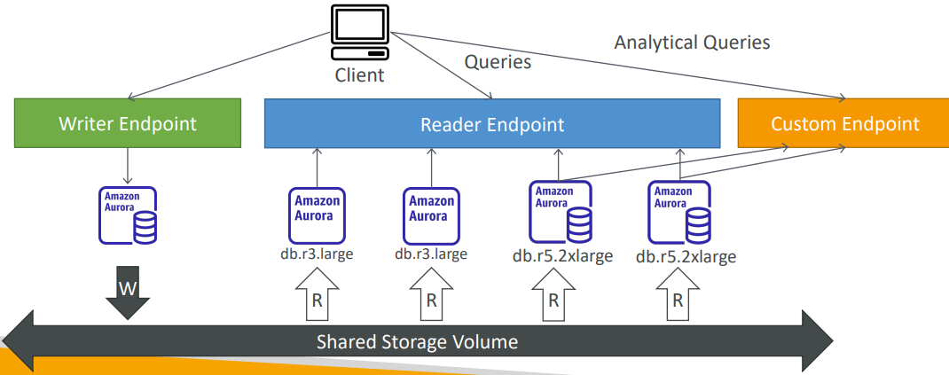

* Define a subset of Aurora Instances as a Custom Endpoint
* Example: Run analytical queries on specific replicas
* The Reader Endpoint is generally not used after defining Custom Endpoints

**Aurora Serverless**

So this is going to give you automated database instantiation and auto-scaling based on actual usage, which is great when you have infrequent, intermittent or unpredictable workloads. And therefore, you don't need to do any capacity planning. You're going to pay per second of each Aurora instance that is being spun up and this can be a lot more cost effective. So how does that work? Well, the client is going to talk to a proxy fleet that is managed by Aurora and in the back end, many Aurora instances will be created based on your workload in a serverless fashion, so you don't have to provision capacity at all in advance.

|  |  |
| --- | --- |
| * Automated database instantiation and auto - scaling based on actual usage * Good for infrequent, intermittent or unpredictable workloads * No capacity planning needed * • Pay per second, can be more cost -effective |  |

**Global Aurora**

In case we have a Aurora cross region read replica it's going to be very helpful for disaster recovery. But instead we can also set up the Aurora global database, which is the recommended way of doing things today. In this case, you have one primary region where all the reading and writes happen, but you can set up up to five secondary read-only regions, where the replication like should be less than one second and up to 16 read replicas per secondary region. And this will help you decrease latency for the read workloads all over the world, but also in case you have a database outage in one region, promoting another region for disaster recovery purposes has an RTO to recover a time objective of less than one minute. So, it takes us in one minute to recover into another region. It takes on average less than one second to replicate data across the region for your Aurora global database.

We have us-east1 as our primary region, which is where the applications do the read and writes, and then we'll set up a secondary region in us-one or some replication happening with a global database of Aurora and the applications that it can do read only from that setup. But in case us-east1 fails, then we can fail over to us-one by promoting it as a read write Aurora cluster.

|  |  |
| --- | --- |
| * Aurora Cross Region Read Replicas:  1. Useful for disaster recovery 2. Simple to put in place   • Aurora Global Database (recommended):  • 1 Primary Region (read / write)  • Up to 5 secondary (read-only) regions, replication lag is less  than 1 second  • Up to 16 Read Replicas per secondary region  • Helps for decreasing latency  • Promoting another region (for disaster recovery) has an RTO  of < 1 minute  • Typical cross-region replication takes less than 1 second |  |

**Aurora Machine Learning**

Aurora also has an integration with machine learning services within AWS. So, the idea with Aurora Machine Learning is that you can have ML based predictions to your applications via the SQL interface. It's a simple, optimized and secure integration between Aurora and different AWS machine learning services. So, two supported services are SageMaker, which allows you to use any kind of machine learning model in the backend or Amazon Comprehend if you want to do sentiment analysis. So in order to use Aurora Machine Learning, you don't have to, you don't need to have machine learning experience. And the use cases for this would be to have fraud detection, ads targeting, sentiment analysis or product recommendation all within Aurora.

So, to give you the architecture idea, Aurora is going to be connected to the machine learning services in AWS. And your application can just run a very simple SQL query. For example, what are the recommended products? Aurora will send some data into the machine learning services such as, for example, the user's profile, the shopping history, et cetera, et cetera. And then the machine learning service will return a prediction directly to Aurora. For example, the user should buy a red shirt and blue pants, and then Aurora can just return the query results to the application all through because of the SQL query, which is very handy.

|  |  |
| --- | --- |
| * Enables you to add ML-based predictions to your applications via SQL * Simple, optimized, and secure integration between Aurora and AWS ML services * Supported services * Amazon SageMaker (use with any ML model) * Amazon Comprehend (for sentiment analysis) * You don’t need to have ML experience * Use cases: fraud detection, ads targeting, sentiment analysis, product recommendations |  |

## Backup

**RDS Backups**

* Automated backups:

1. Daily full backup of the database (during the backup window)
2. Transaction logs are backed-up by RDS every 5 minutes
3. => ability to restore to any point in time (from oldest backup to 5 minutes ago)
4. 1 to 35 days of retention, set 0 to disable automated backups

* Manual DB Snapshots

1. Manually triggered by the user
2. Retention of backup for as long as you want

Trick: in a stopped RDS database, you will still pay for storage. If you plan on stopping it for a long time, you should snapshot & restore instead

**Aurora Backups**

* Automated backups

1. 1 to 35 days (cannot be disabled)
2. point-in-time recovery in that timeframe

* Manual DB Snapshots

1. Manually triggered by the user
2. Retention of backup for as long as you want

**RDS & Aurora Restore options**

* Restoring an RDS / Aurora backup or a snapshot creates a new database
* Restoring MySQL RDS database from S3
  1. Create a backup of your on-premises database
  2. Store it on Amazon S3 (object storage)
  3. Restore the backup file onto a new RDS instance running MySQL
* Restoring MySQL Aurora cluster from S3

1. Create a backup of your on-premises database using the software Percona XtraBackup
2. Store the backup file on Amazon S3
3. Restore the backup file onto a new Aurora cluster running MySQL

**Aurora Database Cloning**

So say you have a production database in Aurora and you want to actually run test on it but you want to copy the data because your test application must be in a staging environment. Well, for this you're just going to clone your production Aurora database. It's going to give you a new database,

* Create a new Aurora DB Cluster from an existing one
* Faster than snapshot & restore
* Uses copy-on-write protocol
* Initially, the new DB cluster uses the same data volume as the original DB cluster (fast and efficient – no copying is needed)
* When updates are made to the new DB cluster data, then additional storage is allocated, and data is copied to be separated
* Very fast & cost-effective
* Useful to create a “staging” database from a “production” database without impacting the production database

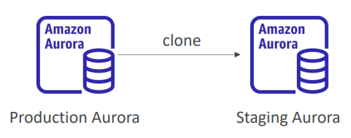

**RDS & Aurora Security**

• At-rest encryption:

1. Database master & replicas encryption using AWS KMS – must be defined as launch time
2. If the master is not encrypted, the read replicas cannot be encrypted
3. To encrypt an un-encrypted database, go through a DB snapshot & restore as encrypted

• In-flight encryption: TLS-ready by default, use the AWS TLS root certificates client-side

• IAM Authentication: IAM roles to connect to your database (instead of username/pw)

• Security Groups: Control Network access to your RDS / Aurora DB

• No SSH available except on RDS Custom

• Audit Logs can be enabled and sent to CloudWatch Logs for longer retention

## Amazon RDS Proxy

we can also deploy a fully managed database proxy for RDS . If you use an As an RDS Proxy, this will allow you, your application, to pool and share the database connections established with the database. So instead of having every single application connect to your RDS database instance, they will be instead connected to the proxy, and the proxy will pool these connections together into less connections to the RDS database instance

If you have a lot of connections into your RDS database instance, and it's going to improve your database efficiency by reducing the stress on database resources, for example, CPU and RAM, and minimize the open connections and the timeouts into your database.

RDS Proxy is fully serverless. It's auto scaling, so you don't need to manage its capacity. And it's highly available. It's across multiple AZ. And therefore, in case, for example, there is a failover that happens on your RDS database instance. For example, it goes from the primary instance to the standby instance, then it will, thanks to the RDS Proxy, reduce the failover time by up to 66%.

|  |  |
| --- | --- |
| • Fully managed database proxy for RDS  • Allows apps to pool and share DB connections established with the database  • Improving database efficiency by reducing the stress on database resources (e.g., CPU, RAM) and minimize open connections (and timeouts)  • Serverless, autoscaling, highly available (multi-AZ)  • Reduced RDS & Aurora failover time by up 66%  • Supports RDS (MySQL, PostgreSQL, MariaDB, MS  SQL Server) and Aurora (MySQL, PostgreSQL)  • No code changes required for most apps just need to connect to RDS Proxy endpoint  • Enforce IAM Authentication for DB, and securely store credentials in AWS Secrets Manager  • RDS Proxy is never publicly accessible (must be accessed from VPC) |  |

One service that is surely going to be very helped by the RDS Proxy is called Lambda functions. And the Lambda functions, they will execute pieces of code. The Lambda functions can multiply, multiply many, many times. And they will appear and disappear very, very fast. And therefore, imagine you have 100 or 1,000 Lambda functions appearing and disappearing just like that, and opening connections into your RDS database instance, they will be a big problem because it will leave open connections and timeouts, and it will be a mess. And therefore, what you do is use the RDS Proxy to pool connections for your Lambda functions, and then the Lambda functions will overload the RDS Proxy, but it's meant to be overload. And the RDS Proxy will pool these connections into less connections to the RDS database instance, thus, solving your problems, okay?

## Amazon ElastiCache

* The same way RDS is to get managed Relational Databases…
* ElastiCache is to get managed Redis or Memcached
* Caches are in-memory databases with high performance, low latency
* Helps reduce load off databases for read intensive workloads
* Help make your application stateless
* AWS takes care of OS maintenance / patching, optimizations, setup, configuration, monitoring, failure recovery and backups
* Using ElastiCache involves heavy application code changes

**ElastiCache Solution Architecture - DB Cache**

|  |  |
| --- | --- |
| • Applications queries ElastiCache, if not available, get from RDS and store in ElastiCache.  • Helps relieve load in RDS  • Cache must have an invalidation strategy to make sure only the most current data is used in there. |  |

**ElastiCache Solution Architecture – User Session Store**

|  |  |
| --- | --- |
| • User logs into any of the application  • The application writes the session data into ElastiCache  • The user hits another instance of our application  • The instance retrieves the data and the user is already logged in |  |

**ElastiCache – Redis vs Memcached**

If we compare Redis and Memcached, so for Redis we have multi-availability zone with auto-failover as a feature, and you can create read replicas to scale the reads and have high availability. You also get data durability using AOF persistence, and you have a backup and restore features on the open-source version of Redis. It also supports sets and sorted sets, which are a very nice way to create leaderboards and provide you with some very nice features in a cache. So, the way I like to think of Redis is a Redis node being replicated into another one to give you an idea of how it works. Of course, Redis is evolving fast, and this may not be general, but this is a simplification. And for Memcached, the idea is that you have multiple nodes set up and they're partitioning your data. That means it's called sharding, so you have multiple nodes together. And there's no high availability, there's no replication. Again, not everything may be true, for example, for the serverless version of Memcached, but I'm just trying to draw a simple image here. So, if you have an issue with Memcached, you may lose your entire cache and you have backup and restore features only for the serverless version of Memcached, not the self-managed version of Memcached on ElastiCache. You also have multi-thread architecture, which may be good for performance. So, the way I like to think of Memcached is they're sharding so you have multiple nodes next to each other, which are partitioning, which are sharing the data, okay?

|  |  |
| --- | --- |
| REDIS  • Multi AZ with Auto-Failover  • Read Replicas to scale reads and have high availability  • Data Durability using AOF persistence  • Backup and restore features  • Supports Sets and Sorted Sets | MEMCACHED  • Multi-node for partitioning of data (sharding)  • No high availability (replication)  • Non persistent  • Backup and restore (Serverless)  • Multi-threaded architecture |

**ElastiCache – Cache Security**

|  |  |
| --- | --- |
| • ElastiCache supports IAM Authentication for Redis  • IAM policies on ElastiCache are only used for AWS API-level security  • Redis AUTH  • You can set a “password/token” when you create a Redis cluster  • This is an extra level of security for your cache (on top of security groups)  • Support SSL in flight encryption  • Memcached  • Supports SASL-based authentication (advanced) |  |

**Patterns for ElastiCache**

|  |  |
| --- | --- |
| • Lazy Loading: all the read data is cached, data can become stale in  cache  • Write Through: Adds or update data in the cache when written to a DB (no stale data)  • Session Store: store temporary session data in a cache (using TTL features)  • Quote: There are only two hard things in Computer Science: cache invalidation and naming things |  |

**ElastiCache – Redis Use Case**

* Gaming Leaderboards are computationally complex
* Redis Sorted guarantees both uniqueness and element ordering
* Each time a new element is added, it’s ranked in real time, then added in correct order

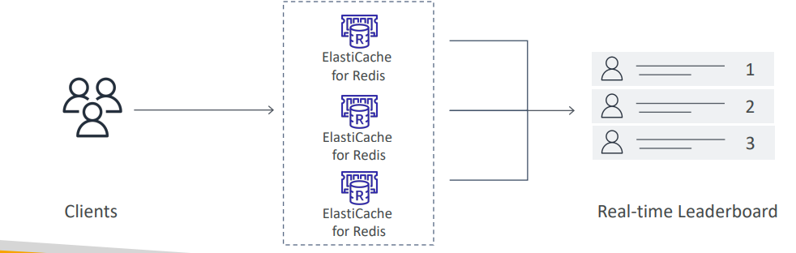

**Handson**

1. Can use Redis, Memcached or Valkey
2. We can use a serverless offering, which is to have a cache automatically scaling to meet your application traffic and no servers to manage. It is way more expensive, but easier to manage. Or we can design our own cache.

We can also create new or restore from existing

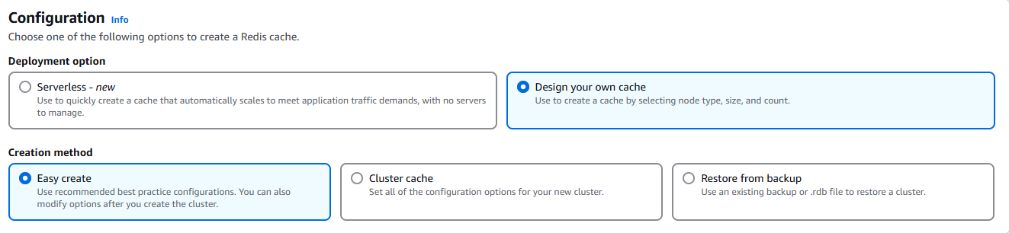

1. Can have single or multiple nodes/shards

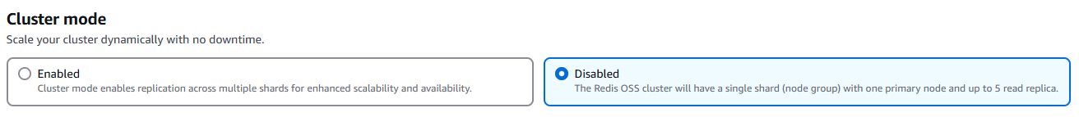

1. Can run AWS or on-premises also, also can enable multi AZ

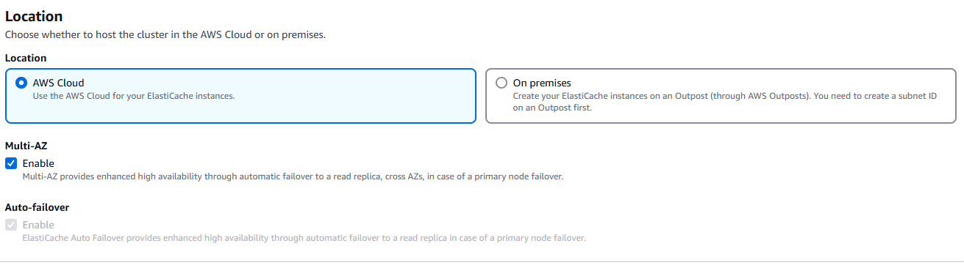

1. We can select instance type where we want to run subnet and AZ

## Questions

Top of Form

Amazon RDS supports the following databases, **EXCEPT**:

* **MongoDB**
* **MySQL**
* **MariaDB**
* **Microsoft SQL Server**

Bottom of Form

Ans RDS supports MySQL, PostgreSQL, MariaDB, Oracle, MS SQL Server, and Amazon Aurora.

Top of Form

You're planning for a new solution that requires a MySQL database that must be available even in case of a disaster in one of the Availability Zones. What should you use?

* **Create Read Replicas**
* **Enable Encryption**
* **Enable Multi-AZ**

Bottom of Form

Ans Multi-AZ helps when you plan a disaster recovery for an entire AZ going down. If you plan against an entire AWS Region going down, you should use backups and replication across AWS Regions.

Top of Form

We have an RDS database that struggles to keep up with the demand of requests from our website. Our million users mostly read news, and we don't post news very often. Which solution is **NOT** adapted to this problem?

* **An ElastiCache Cluster**
* **RDS Multi-AZ**
* **RDS Read Replicas**

Bottom of Form

Ans Be very careful with the way you read questions at the exam. Here, the question is asking which solution is NOT adapted to this problem. ElastiCache and RDS Read Replicas do indeed help with scaling reads.

Top of Form

You have set up read replicas on your RDS database, but users are complaining that upon updating their social media posts, they do not see their updated posts right away. What is a possible cause for this?

* **There must be a bug in your application**
* **Read Replicas have Asynchronous Replication, therefore it's likely your users will only read Eventual Consistency**
* **You should have setup Multi-AZ instead**

Bottom of Form

Ans B

Top of Form

Which RDS **(NOT Aurora)** feature when used does not require you to change the SQL connection string?

* **Multi-AZ**
* **Read Replicas**

Bottom of Form

Top of Form

Which RDS **(NOT Aurora)** feature when used does not require you to change the SQL connection string?

* **Multi-AZ**
* **Read Replicas**

Bottom of Form

Read Replicas add new endpoints with their own DNS name. We need to change our application to reference them individually to balance the read load. Multi-AZ keeps the same connection string regardless of which database is up.

Top of Form

Your application running on a fleet of EC2 instances managed by an Auto Scaling Group behind an Application Load Balancer. Users have to constantly log back in and you don't want to enable Sticky Sessions on your ALB as you fear it will overload some EC2 instances. What should you do?

* **Use your own custom Load Balancer on EC2 instances instead of using ALB**
* **Store session data in RDS**
* **Store session data in ElastiCache**
* **Store session data in a shared EBS volume**

Bottom of Form

Ans Storing Session Data in ElastiCache is a common pattern to ensuring different EC2 instances can retrieve your user's state if needed.

Top of Form

An analytics application is currently performing its queries against your main production RDS database. These queries run at any time of the day and slow down the RDS database which impacts your users' experience. What should you do to improve the users' experience?

* **Setup a Read Replica**
* **Setup Multi-AZ**
* **Run the analytics queries at night**

Bottom of Form

Ans Read Replicas will help as your analytics application can now perform queries against it, and these queries won't impact the main production RDS database.

Top of Form

You would like to ensure you have a replica of your database available in another AWS Region if a disaster happens to your main AWS Region. Which database do you recommend to implement this easily?

* **RDS Read Replicas**
* **RDS Multi-AZ**
* **Aurora Read Replicas**
* **Aurora Global Database**

Bottom of Form

Ans Aurora Global Databases allows you to have an Aurora Replica in another AWS Region, with up to 5 secondary regions.

Top of Form

How can you enhance the security of your ElastiCache Redis Cluster by allowing users to access your ElastiCache Redis Cluster using their IAM Identities (e.g., Users, Roles)?

* **Using Redis Authentication**
* **Using IAM Authentication**
* **Use Security Groups**

Bottom of Form

Ans B

Top of Form

Your company has a production Node.js application that is using RDS MySQL 5.6 as its database. A new application programmed in Java will perform some heavy analytics workload to create a dashboard on a regular hourly basis. What is the most cost-effective solution you can implement to minimize disruption for the main application?

* **Enable Multi-AZ for the RDS database and run the analytics workload on the standby database**
* **Create a Read Replica in a different AZ and run the analytics workload on the replica database**
* **Create a Read Replica in a different AZ and run the analytics workload on the source database**

Bottom of Form

Ans B

Top of Form

You would like to create a disaster recovery strategy for your RDS PostgreSQL database so that in case of a regional outage the database can be quickly made available for both read and write workloads in another AWS Region. The DR database must be highly available. What do you recommend?

* **Create a Read Replica in the same region and enable Multi-AZ on the main database**
* **Create a Read Replica in a different region and enable Multi-AZ on the Read Replica**
* **Create a Read Replica in the same region and enable Multi-AZ on the Read Replica**
* **Enable Multi-Region option on the main database**

Bottom of Form

Ans B

Top of Form

You have migrated the MySQL database from on-premises to RDS. You have a lot of applications and developers interacting with your database. Each developer has an IAM user in the company's AWS account. What is a suitable approach to give access to developers to the MySQL RDS DB instance instead of creating a DB user for each one?

* **By default IAM users have access to your RDS database**
* **Use Amazon Cognito**
* **Enable IAM Database Authentication**

Bottom of Form

Ans C

Top of Form

Which of the following statement is true regarding replication in both RDS Read Replicas and Multi-AZ?

* **Read Replica uses Asynchronous Replication and Multi-AZ uses Asynchronous Replication**
* **Read Replica uses Asynchronous Replication and Multi-AZ uses Synchronous Replication**
* **Read Replica uses Synchronous Replication and Multi-AZ uses Synchronous Replication**
* **Read Replica uses Synchronous Replication and Multi-AZ uses Asynchronous Replication**

Bottom of Form

Ans B

Top of Form

How do you encrypt an unencrypted RDS DB instance?

* **Do it straight from AWS Console, select your RDS DB instance, choose Actions then Encrypt using KMS**
* **Do it straight from AWS Console, after stopping the RDS DB instance**
* **Create a snapshot of the unencrypted RDS DB instance, copy the snapshot and tick "Enable encryption", then restore the RDS DB instance from the encrypted snapshot**

Bottom of Form

Ans C

Top of Form

For your RDS database, you can have up to ............ Read Replicas.

* **5**
* **15**
* **7**

Bottom of Form

And 15

Top of Form

Which RDS database technology does **NOT** support IAM Database Authentication?

* **Oracle**
* **PostgreSQL**
* **MySQL**

Bottom of Form

Ans Oracle

Top of Form

You have an un-encrypted RDS DB instance and you want to create Read Replicas. Can you configure the RDS Read Replicas to be encrypted?

* **No**
* **Yes**

Bottom of Form

Ans You can not create encrypted Read Replicas from an unencrypted RDS DB instance.

Top of Form

An application running in production is using an Aurora Cluster as its database. Your development team would like to run a version of the application in a scaled-down application with the ability to perform some heavy workload on a need-basis. Most of the time, the application will be unused. Your CIO has tasked you with helping the team to achieve this while minimizing costs. What do you suggest?

* **Use an Aurora Global Database**
* **Use an RDS database**
* **Use Aurora Serverless**
* **Run Aurora on EC2, and write a script to shut down the EC2 instance at night**

Bottom of Form

Ans C

Top of Form

How many Aurora Read Replicas can you have in a single Aurora DB Cluster?

* **5**
* **10**
* **15**

Bottom of Form

Ans 15

Top of Form

Amazon Aurora supports both .......................... databases.

* **MySQL and MariaDB**
* **MySQL and PostgreSQL**
* **Oracle and MariaDB**
* **Oracle and MS SQL Server**

Bottom of Form

Ans B

Top of Form

You work as a Solutions Architect for a gaming company. One of the games mandates that players are ranked in real-time based on their score. Your boss asked you to design then implement an effective and highly available solution to create a gaming leaderboard. What should you use?

* **Use RDS for MySQL**
* **Use an Amazon Aurora**
* **Use ElastiCache for Memcached**
* **Use ElastiCache for Redis - Sorted Sets**

Bottom of Form

Ans D

Top of Form

You need full customization of an Oracle Database on AWS. You would like to benefit from using the AWS services. What do you recommend?

* **RDS for Oracle**
* **RDS Custom for Oracle**
* **Deploy Oracle on EC2**

Bottom of Form

Ans B

Top of Form

You need to store long-term backups for your Aurora database for disaster recovery and audit purposes. What do you recommend?

* **Enable Automated Backups**
* **Perform On Demand Backups**
* **Use Aurora Database Cloning**

Bottom of Form

On demand backup

Top of Form

Your development team would like to perform a suite of read and write tests against your production Aurora database because they need access to production data as soon as possible. What do you advise?

* **Create an Aurora Read Replica for them**
* **Do the test against the production database**
* **Make a DB Snapshot and Restore it into a new database**
* **Use the Aurora Cloning feature**

Bottom of Form

Ans D its faster than snapshots

Top of Form

You have 100 EC2 instances connected to your RDS database and you see that upon a maintenance of the database, all your applications take a lot of time to reconnect to RDS, due to poor application logic. How do you improve this?

* **Fix all the applications**
* **Disable Multi-AZ**
* **Enable Multi-AZ**
* **Use an RDS Proxy**

Bottom of Form

This reduces the failover time by up to 66% and keeps connection actives for your applications

# Amazon Route 53

**What is DNS?** Domain Name System which translates the human friendly hostnames into the machine IP addresses

* www.google.com => 172.217.18.36

DNS uses hierarchical naming structure

* .com
* example.com
* www.example.com
* api.example.com

**DNS Terminologies**

* **Domain Registrar**: Amazon Route 53, GoDaddy, - Register domain names
* **DNS Records**: A, AAAA, CNAME, NS, … different types of records
  + NS The NS record is stored by the Top-Level Domain (TLD) server. There are over 1,000 TLD servers. There is one for .com domains, another for .gov domains, and so on.
  + A record is used to point the domain name at one or multiple IP addresses. It has 3 fields name, IP and TTL. The name contains SLD also called Domain name/Host Name/ Alias/DNS entry for e.g. google.com
  + AAAA used for IPV6
  + Canonical Name record (CNAME) tells anyone visiting that subdomain to use the same DNS records as another domain / subdomain. CNAME records must always point to another domain / subdomain, never directly to an IP address. For example, you couldn’t use a CNAME for pbrumby.com. But you could for a subdomain like www.pbrumby.com.
* **Zone File**: contains DNS records to match hostname to IP
* **Name Server** resolves DNS queries (Authoritative or Non-Authoritative)
* **Top Level Domain** (TLD): .com, .us, .in, .gov, .org, …
* **Second Level Domain** (SLD): amazon.com, google.com, …

Protocol <http://api.www.example.com>. . 🡪root

.com 🡪TLD

example.com 🡪SLD also called Domain name/Host Name/ Alias/DNS entry

[www.example.com](http://www.example.com) 🡪 Sub domain

api.www.example.com 🡪 FQDN Fully Qualified Domain Name

**How DNS Works**

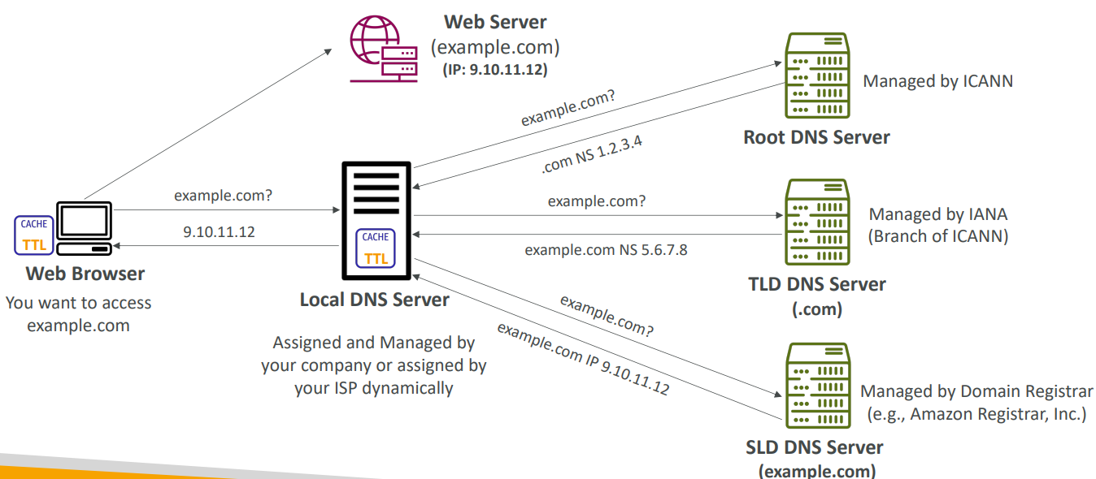

**Amazon Route 53**

|  |  |
| --- | --- |
| * A highly available, scalable, fully managed and Authoritative DNS   + Authoritative = the customer (you) can update the DNS records * Route 53 is also a Domain Registrar i.e. we can register our domain * Ability to check the health of your resources * The only AWS service which provides 100% availability SLA * Why Route 53? 53 is a reference to the traditional DNS port |  |

**Route 53 – Records**

* We can define multiple, DNS record and it defines how you want to route traffic for a domain
* Each record contains:

1. Domain/subdomain Name – e.g., example.com
2. Record Type – e.g., A or AAAA
3. Value – e.g., 12.34.56.78
4. Routing Policy – how Route 53 responds to queries
5. TTL – amount of time the record cached at DNS Resolvers

* Route 53 supports the following DNS record types:

1. (must know) A / AAAA / CNAME / NS
2. (advanced) CAA / DS / MX / NAPTR / PTR / SOA / TXT / SPF / SRV

## Route 53 – Record Types

* A – maps a hostname to IPv4
* AAAA – maps a hostname to IPv6
* CNAME – maps a hostname to another hostname

1. The target is a domain name which must have an A or AAAA record
2. Can’t create a CNAME record for the top node of a DNS namespace (Zone Apex)
3. Example: you can’t create for example.com, but you can create for [www.example.com](http://www.example.com) or api.example.com

* NS – Name Servers for the Hosted Zone

1. Control how traffic is routed for a domain

**Route 53 – Hosted Zones**

A container for records that defines how to route traffic to a domain and its subdomains. Say we have a company with domain or A record example.com we would multiple other URLS for our company like

* api.example.com
* m.example.com
* secured.example.com
* internal.example.com

etc. All these routing can be done by Hosted Zone. It is or 2 types

* Public Hosted Zones – contains records that specify how to route traffic on the Internet (public domain names) application1.mypublicdomain.com. Exposed on the Internet
* Private Hosted Zones – contain records that specify how you route traffic within one or more VPCs (private domain names) application1.company.internal. Not exposed on internet for internal traffic
* You pay $0.50 per month per hosted zone

**Public vs. Private Hosted Zones**

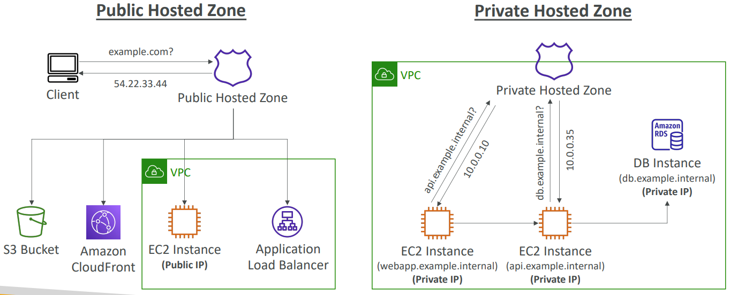

**Route 53 – Records TTL (Time To Live)**

|  |  |
| --- | --- |
| • High TTL – e.g., 24 hr   1. Less traffic on Route 53 2. Possibly outdated records   • Low TTL – e.g., 60 sec.   1. More traffic on Route 53 ($$) 2. Records are outdated for less time 3. Easy to change records   • Except for Alias records, TTL is mandatory for each DNS record |  |

**CNAME vs Alias**

AWS Resources (Load Balancer, CloudFront...) expose an AWS hostname like lb1-1234.us-east-2.elb.amazonaws.com and we want to point to a domain name myapp.mydomain.com. We can do it using

* CNAME:

1. Point a hostname to any other hostname. (app.mydomain.com => blabla.anything.com)
2. ONLY FOR NON-ROOT DOMAIN (aka something.mydomain.com) won’t work for mydomain.com

* Alias:

1. Points a hostname to an AWS Resource (app.mydomain.com => blabla.amazonaws.com)
2. Works for ROOT DOMAIN and NON-ROOT DOMAIN (aka mydomain.com)
3. Free of charge
4. Native health check

**Route 53 – Alias Records**

|  |  |
| --- | --- |
| • Maps a hostname to an AWS resource  • An extension to DNS functionality  • Automatically recognizes changes in the resource’s IP addresses like ALB IP changes  • Unlike CNAME, it can be used for the top node of a DNS namespace (Zone Apex), e.g.: example.com  • Alias Record is always of type A/AAAA for AWS resources (IPv4 / IPv6)  • You can’t set the TTL |  |

**Route 53 – Alias Records Targets**

* Elastic Load Balancers
* CloudFront Distributions
* API Gateway
* Elastic Beanstalk environments
* S3 Websites
* VPC Interface Endpoints
* Global Accelerator accelerator
* Route 53 record in the same hosted zone
* You cannot set an ALIAS record for an EC2 DNS name

## Route 53 – Routing Policies

While creating records we can add weight also

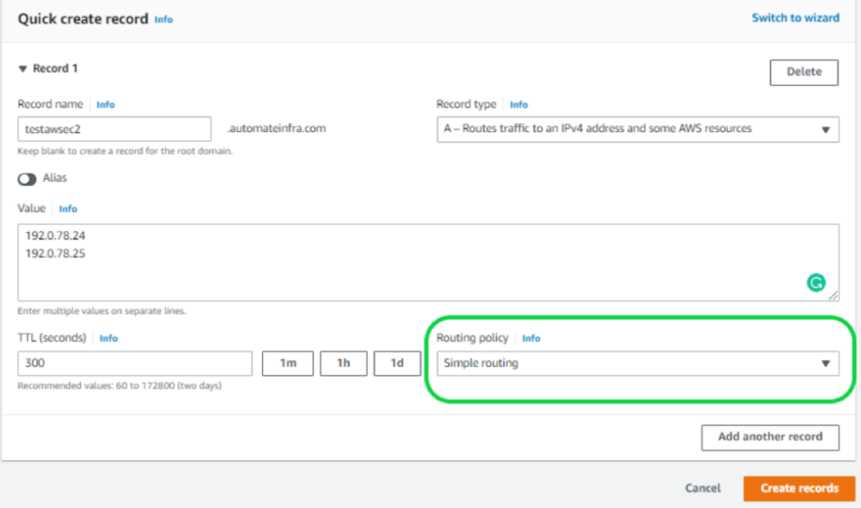

* Define how Route 53 responds to DNS queries
* Don’t get confused by the word “Routing”
  + It’s not the same as Load balancer routing which routes the traffic
  + DNS does not route any traffic, it only responds to the DNS queries
* Route 53 Supports the following Routing Policies

1. Simple
2. Weighted
3. Failover
4. Latency based
5. Geolocation
6. Multi-Value Answer
7. Geoproximity (using Route 53 Traffic Flow feature)

**Routing Policies – Simple**

The clients that will say, hey, I want to go to foo.example.com, and Routes 53 will say, hey, go to this IP address. And this is an A record. So it is possible for us to specify multiple values in the same record. And if so, if multiple values are returned by the DNS, then a random one will be chosen by the clients or client side.

|  |  |
| --- | --- |
| • Typically, route traffic to a single resource  • Can specify multiple values in the same record  • If multiple values are returned, a random one is chosen by the client  • When Alias enabled, specify only one AWS resource  • Can’t be associated with Health Checks |  |

**Routing Policies – Weighted**

|  |  |
| --- | --- |
| • Control the % of the requests that go to each specific resource  • Assign each record a relative weight    Weights don’t need to sum up to 100   * DNS records must have the same name and type * Can be associated with Health Checks * Use cases: load balancing between regions, testing * new application versions… * Assign a weight of 0 to a record to stop * sending traffic to a resource * If all records have weight of 0, then all records * will be returned equally |  |

**Routing Policies – Latency -based**

|  |  |
| --- | --- |
| • Redirect to the resource that has the least latency close to us  • Super helpful when latency for users is a priority  • Latency is based on traffic between users and AWS Regions  • Germany users may be directed to the US (if that’s the lowest latency)  • Can be associated with Health Checks (has a failover capability) |  |

**Route 53 – Health Checks**

|  |  |
| --- | --- |
| * HTTP Health Checks are only for public resources * Health Check => Automated DNS Failover:   + Health checks that monitor an endpoint (application, server, other AWS resource)   + Health checks that monitor other health checks (Calculated Health Checks)   + Health checks that monitor CloudWatch Alarms (full control !!) – e.g., throttles of DynamoDB, alarms on RDS, custom metrics, … (helpful for private resources)   Health Checks are integrated with Cloud watch metrics | Say we have two public Load balancers in different regions for high availability where Route 53 will route to these ALB. With health checks it will will failover if health checks fail. |

**Health Checks – Monitor an Endpoint**

|  |  |
| --- | --- |
| * About 15 global health checkers will check the endpoint health * Can set Healthy/Unhealthy Threshold – 3 (default) * Interval – 30 sec (can set to 10 sec – higher cost) * Supported protocol: HTTP, HTTPS and TCP * If > 18% of health checkers report the endpoint is healthy, Route 53 considers it Healthy. Otherwise, it’s Unhealthy * Ability to choose which locations you want Route 53 to use * Health Checks pass only when the endpoint responds with the 2xx and 3xx status codes * If it is text based response then Health Checks can be set up to pass / fail based on the text in the first 5120 bytes of the response to look for specific text. * Configure your router/firewall to allow incoming requests from Route 53 Health Checkers   [**https://ip-ranges.amazonaws.com/ip-ranges.json**](https://ip-ranges.amazonaws.com/ip-ranges.json) |  |

**Route 53 – Calculated Health Checks**

|  |  |
| --- | --- |
| • Combine the results of multiple Health Checks into a single Health Check  • You can use OR, AND, or NOT  • Can monitor up to 256 Child Health Checks  • Specify how many health checks need to pass to make the parent pass  • Usage: perform maintenance to your website without causing all health checks to fail |  |

**Health Checks – Private Hosted Zones**

|  |  |
| --- | --- |
| * Route 53 health checkers are outside the VPC (private) * They can’t access private endpoints (private VPC or on-premises resource) * You can create a CloudWatch Metric and associate a CloudWatch Alarm, then create a Health Check that checks the alarm itself |  |

**Routing Policies – Failover (Active-Passive)**

In failover policy I set 2 records one active another secondary

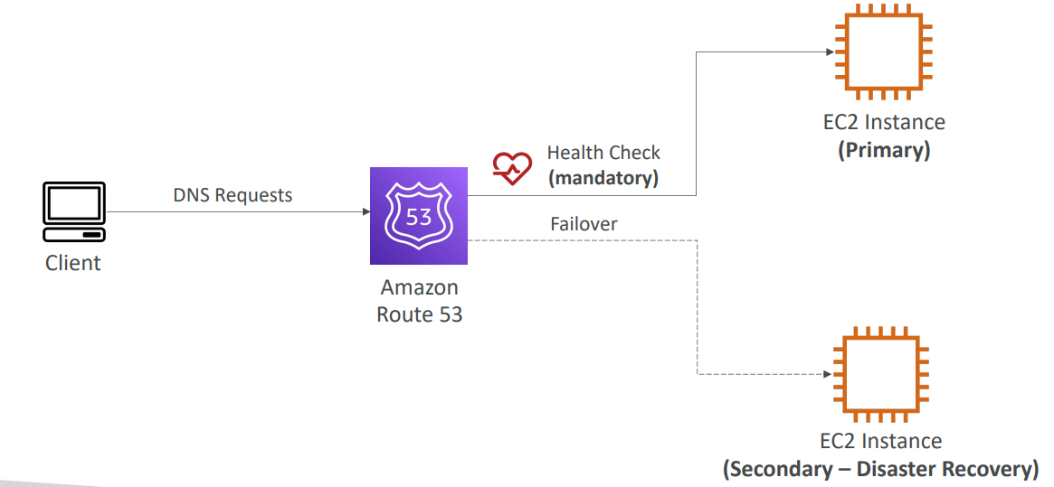

**Routing Policies – Geolocation**

|  |  |
| --- | --- |
| • Different from Latency-based!  • This routing is based on user location  • Specify location by Continent, Country or by US State (if there’s overlapping, most precise location selected)  • Should create a “Default” record (in case there’s no match on location)  • Use cases: website localization, restrict content distribution, load balancing, …  • Can be associated with Health Checks |  |

**Routing Policies – Geoproximity**

* Route traffic to your resources based on the geographic location of users and resources
* Ability to shift more traffic to resources based on the defined bias
* To change the size of the geographic region, specify bias values:

1. To expand (1 to 99) – more traffic to the resource
2. To shrink (-1 to -99) – less traffic to the resource

* Resources can be:

1. AWS resources (specify AWS region)
2. Non-AWS resources (specify Latitude and Longitude)

* You must use Route 53 Traffic Flow to use this feature

Let’s take an example of a resource in us-west-1, and one resource in us-east-1. And the bias is set to zero in both regions. So that means that if you have users all around the US trying to access these resources, there's going to be a line dividing the US is too into two, and users left of that line will go to us-west-1, and user rights of that line will go to us-east-1.

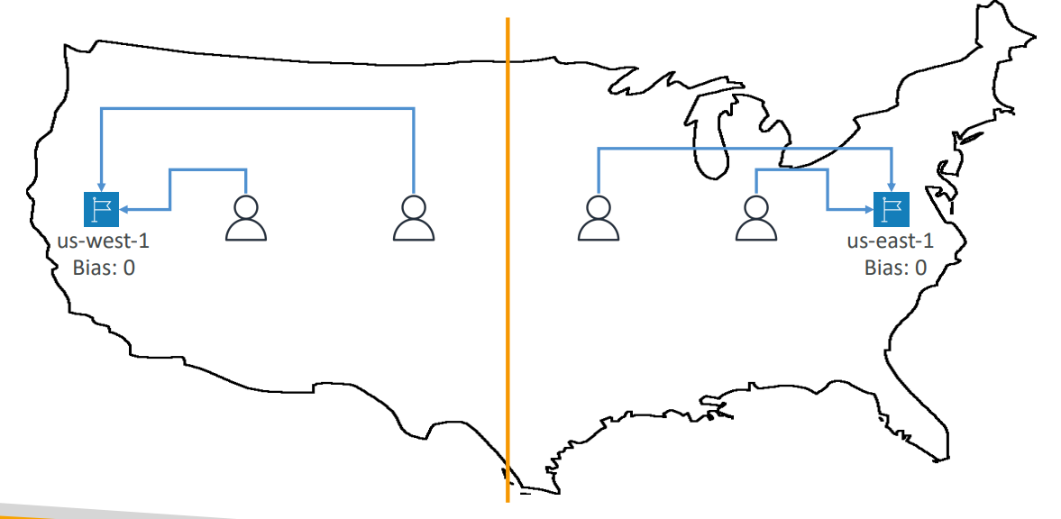

We have us-west-1 and us-east-1, and the bias is set to zero in us-west-1, but we're going to have a positive bias of 50 in us-east-1. And we've seen that the bias make more users and more traffic to that resource.  because of the bias now the quote in quote, dividing line between the first. The two resources is going to be a little bit more to the left because of the higher bias of us-east-1. And so that means is that's the user left of that line can go to us-west-1, but the users right or that one will go to us-east-1

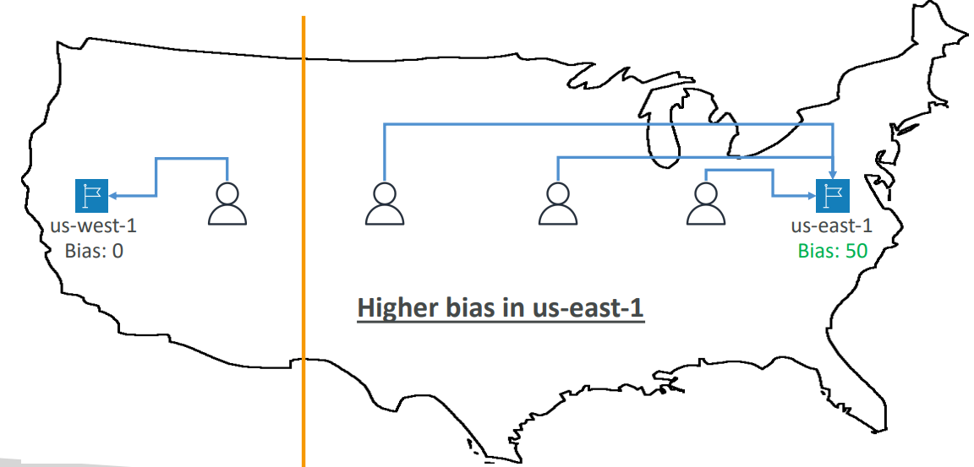

**Routing Policies – IP-based Routing**

|  |  |
| --- | --- |
| * Routing is based on clients’ IP addresses * You provide a list of CIDRs for your clients and the corresponding endpoints/locations (user-IP-to-endpoint mappings) * Use cases: Optimize performance, reduce network costs… * Example: route end users from a particular ISP to a specific endpoint |  |

**Routing Policies – Multi-Value**

* Use when routing traffic to multiple resources
* Route 53 return multiple values/resources
* Can be associated with Health Checks (return only values for healthy resources)
* Up to 8 healthy records are returned for each Multi-Value query
* Multi-Value is not a substitute for having an ELB

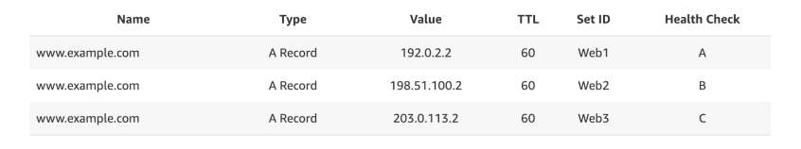

**Domain Registar vs. DNS Service**

* You buy or register your domain name with a Domain Registrar typically by paying annual charges (e.g., GoDaddy, Amazon Registrar Inc., …)
* The Domain Registrar usually provides you with a DNS service to manage your DNS records
* But you can use another DNS service to manage your DNS records
* Example: purchase the domain from GoDaddy and use Route 53 to manage your DNS records

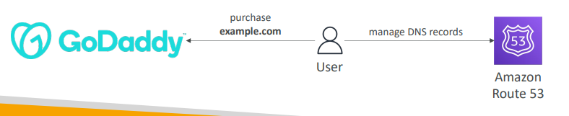

**GoDaddy as Registrar & Route 53 as DNS Service**

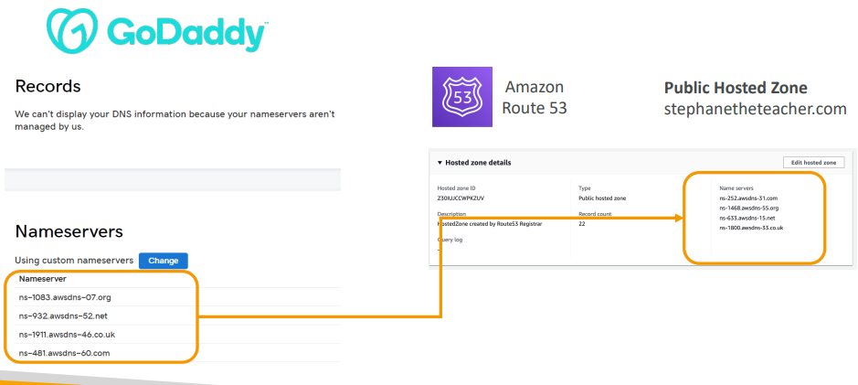

**3rd Party Registrar with Amazon Route 53**

* If you buy your domain on a 3rd party registrar, you can still use Route 53 as the DNS Service provider
  + Create a Hosted Zone in Route 53
  + Update NS Records on 3rd party website to use Route 53 Name Servers
* Domain Registrar != DNS Service
* But every Domain Registrar usually comes with some DNS features

## Questions

Top of Form

You have purchased **mycoolcompany.com** on Amazon Route 53 Registrar and would like the domain to point to your Elastic Load Balancer **my-elb-1234567890.us-west-2.elb.amazonaws.com**. Which Route 53 Record type must you use here?

* **CNAME**
* **Alias**

Bottom of Form

Alias 🡪 You can't create a CNAME record that has the same name as the top node of the DNS namespace (Zone Apex), in our case "mycoolcompany.com."

Top of Form

You have deployed a new Elastic Beanstalk environment and would like to direct 5% of your production traffic to this new environment. This allows you to monitor for CloudWatch metrics and ensuring that there're no bugs exist with your new environment. Which Route 53 Record type allows you to do so?

* **Simple**
* **Weighted**
* **Latency**
* **Failover**

Bottom of Form

Weighted Routing Policy allows you to redirect part of the traffic based on weight (e.g., percentage). It's a common use case to send part of traffic to a new version of your application.

Top of Form

You have updated a Route 53 Record's **myapp.mydomain.com** value to point to a new Elastic Load Balancer, but it looks like users are still redirected to the old ELB. What is a possible cause for this behavior?

* **Because of the Alias record**
* **Because of the CNAME record**
* **Because of the TTL**
* **Because of Route 53 Health Checks**

Bottom of Form

Each DNS record has a TTL (Time To Live) which orders clients for how long to cache these values and not overload the DNS Resolver with DNS requests. The TTL value should be set to strike a balance between how long the value should be cached vs. how many requests should go to the DNS Resolver.

Top of Form

You have an application that's hosted in two different AWS Regions us-west-1 and eu-west-2. You want your users to get the best possible user experience by minimizing the response time from application servers to your users. Which Route 53 Routing Policy should you choose?

* **Multi Value**
* **Weighted**
* **Latency**
* **Geolocation**

Bottom of Form

Latency Routing Policy will evaluate the latency between your users and AWS Regions, and help them get a DNS response that will minimize their latency (e.g. response time)

Top of Form

You have a legal requirement that people in any country, but France should **NOT** be able to access your website. Which Route 53 Routing Policy helps you in achieving this?

* **Latency**
* **Simple**
* **Multi Value**
* **Geolocation**

Geo location

Bottom of Form

Top of Form

You have purchased a domain on **GoDaddy** and would like to use Route 53 as the DNS Service Provider. What should you do to make this work?

* **Request for a domain transfer**
* **Create a Private Hosted Zone and update the 3rd party Registrar NS records**
* **Create a Public Hosted Zone and update the Route 53 NS records**
* **Create a Public Hosted Zone and update the 3rd party Registrar NS records**

Bottom of Form

Public Hosted Zones are meant to be used by people requesting your website through the Internet. Finally, NS records must be updated on the 3rd party Registrar.

Top of Form

Which of the following are **NOT** valid Route 53 Health Checks?

* **Health Check that monitors SQS Queue**
* **Health Check that monitors an Endpoint**
* **Health Check that monitors other Health Checks**
* **Health Check that monitors CloudWatch Alarms**

Health Check that monitors SQS Queue

Bottom of Form

# Classic Solutions Architecture

We’ll see the progression of a Solution’s architect mindset through many sample case studies:

1. WhatIsTheTime.Com
2. MyClothes.Com
3. MyWordPress.Com
4. Instantiating applications quickly
5. Beanstalk

**Stateless Web App: WhatIsTheTime.com**

WhatIsTheTime.com allows people to know what time it is

* We don’t need a database
* We want to start small and can accept downtime
* We want to fully scale vertically and horizontally, no downtime
* Let’s go through the Solutions Architect journey for this app
* Let’s see how we can proceed!

**Stateless web app: What time is it? Starting simple**

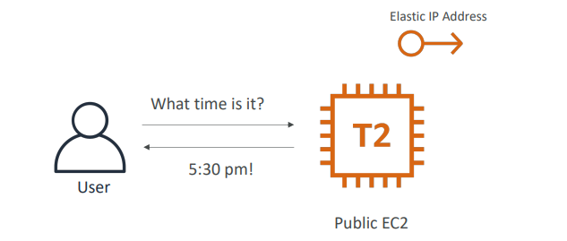

**Stateless web app: What time is it? Scaling vertically**

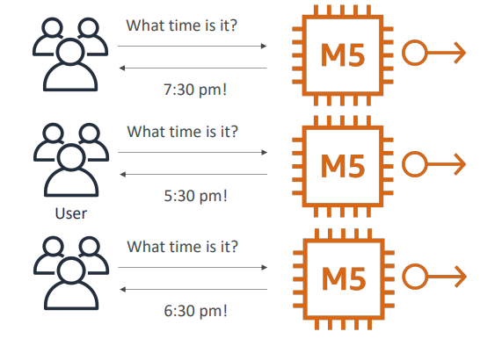

**Stateless web app: What time is it? Scaling horizontally**

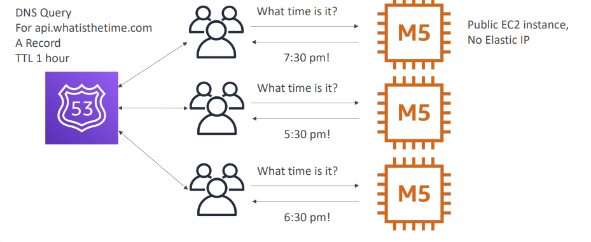

**Stateless web app: What time is it? Scaling horizontally, adding and removing instances**

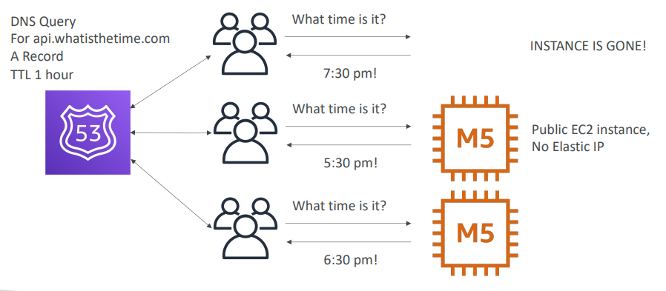

**Stateless web app: What time is it? Scaling horizontally, with a load balancer**

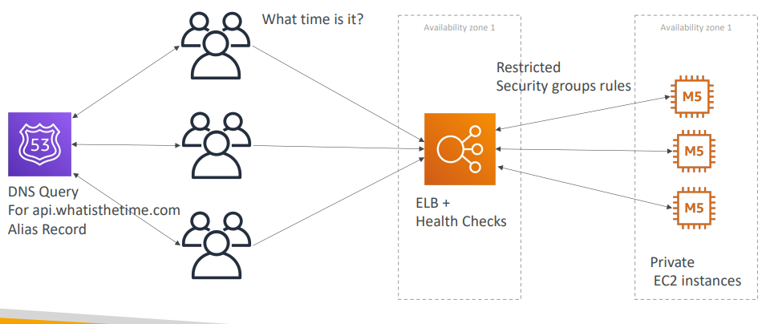

**Stateless web app: What time is it? Scaling horizontally, with an auto-scaling group**

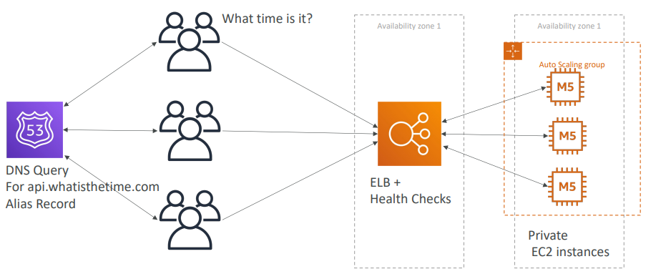

**Stateless web app: What time is it? Making our app multi-AZ**

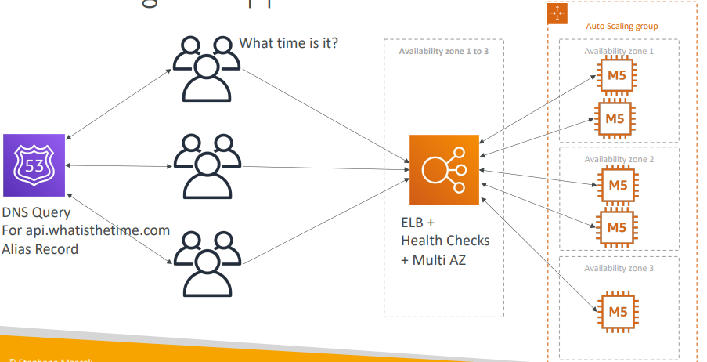

**Minimum 2 AZ => Let’s reserve capacity**

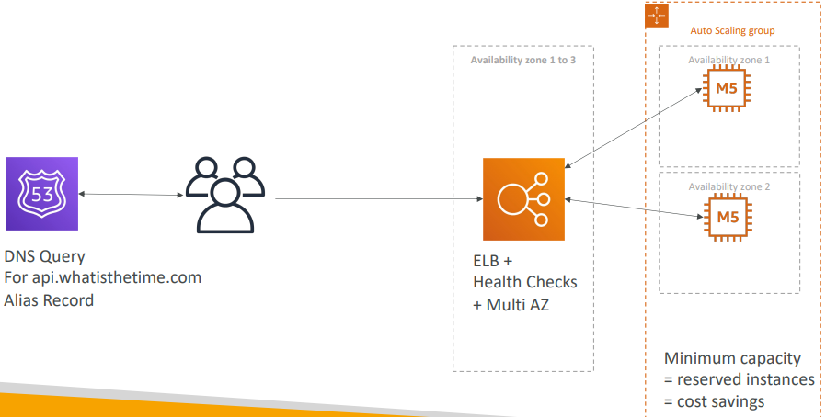

In this lecture we’ve discussed…

* Public vs Private IP and EC2 instances
* Elastic IP vs Route 53 vs Load Balancers
* Route 53 TTL, A records and Alias Records
* Maintaining EC2 instances manually vs Auto Scaling Groups
* Multi AZ to survive disasters
* ELB Health Checks
* Security Group Rules
* Reservation of capacity for costing savings when possible

**Stateful Web App: MyClothes.com**

* MyClothes.com allows people to buy clothes online.
* There’s a shopping cart
* Our website is having hundreds of users at the same time
* We need to scale, maintain horizontal scalability and keep our web application as stateless as possible
* Users should not lose their shopping cart
* Users should have their details (address, etc) in a database
* Let’s see how we can proceed!

**Stateful Web App: MyClothes.com**

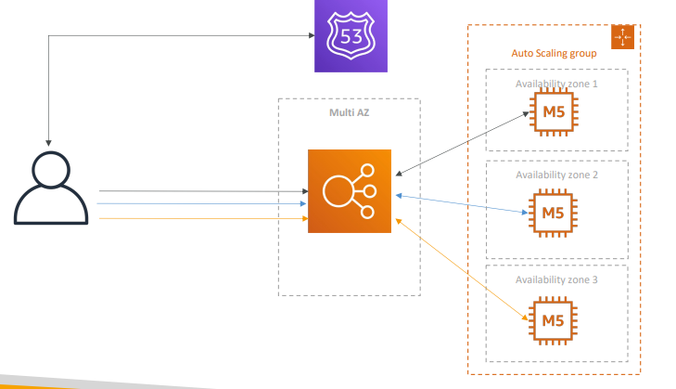

**Stateful Web App: MyClothes.com Introduce Stickiness (Session Affinity)**

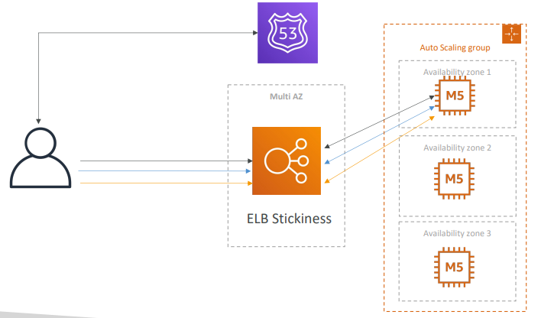

**Stateful Web App: MyClothes.com Introduce User Cookies**

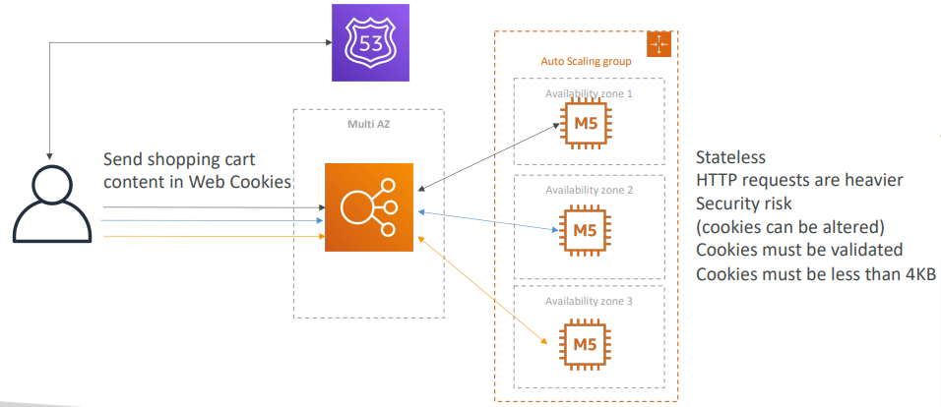

**Stateful Web App: MyClothes.com Introduce Server Session**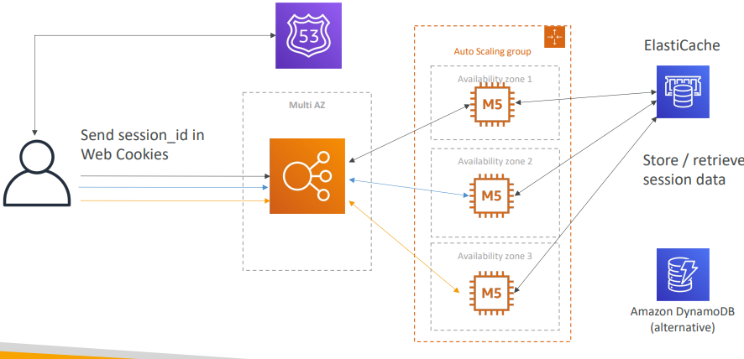

**Stateful Web App: MyClothes.com Storing User Data in a database**

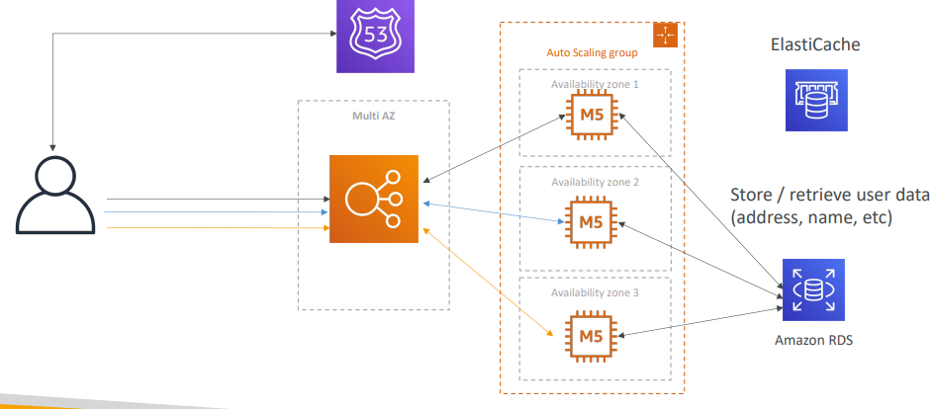

**Stateful Web App: MyClothes.com Scaling Reads**

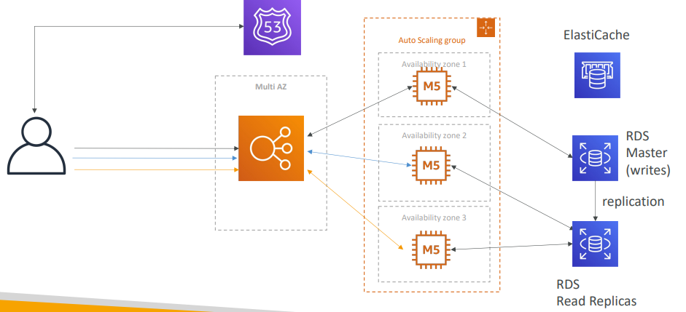

**Stateful Web App: MyClothes.com Scaling Reads (Alternative) – Lazy Loading**

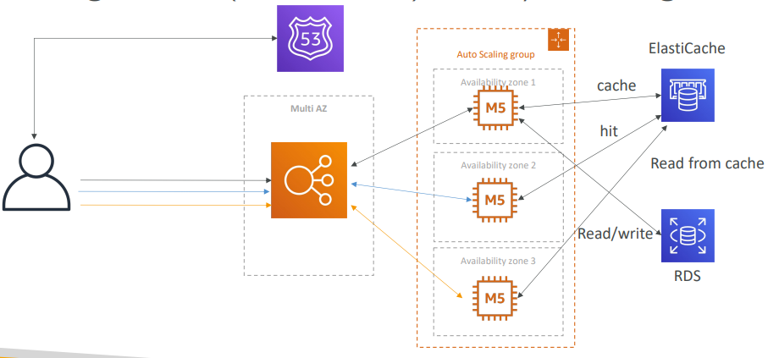

**Stateful Web App: MyClothes.com Multi AZ – Survive disasters**

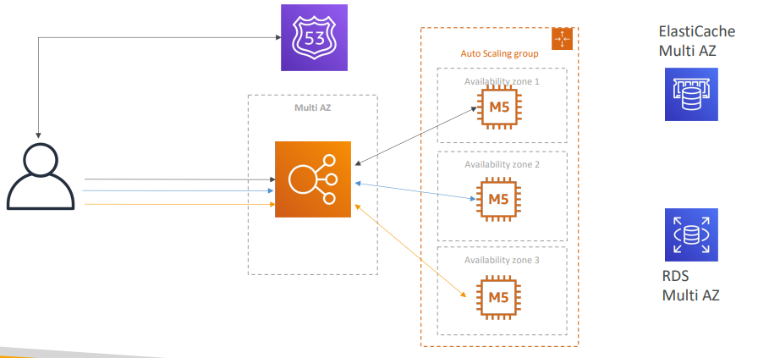

**Stateful Web App: MyClothes.com Security Groups**

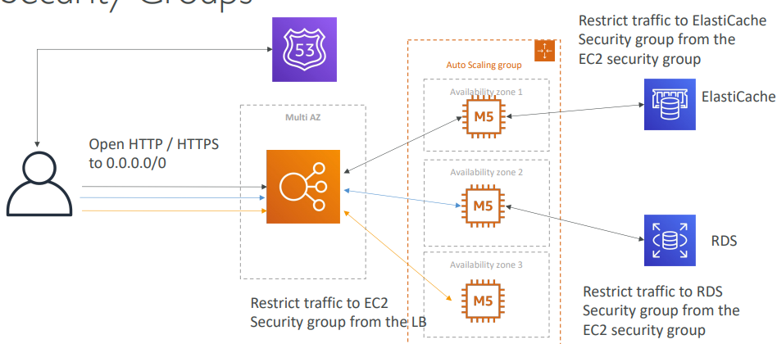

In this lecture we’ve discussed… 3-tier architectures for web applications

* ELB sticky sessions
* Web clients for storing cookies and making our web app stateless
* ElastiCache

1. For storing sessions (alternative: DynamoDB)
2. For caching data from RDS
3. Multi AZ

* RDS

1. For storing user data
2. Read replicas for scaling reads
3. Multi AZ for disaster recovery

* Tight Security with security groups referencing each other

Stateful Web App: MyWordPress.com

* We are trying to create a fully scalable WordPress website
* We want that website to access and correctly display picture uploads
* Our user data, and the blog content should be stored in a MySQL database.
* Let’s see how we can achieve this!

**Stateful Web App: MyWordPress.com RDS layer**

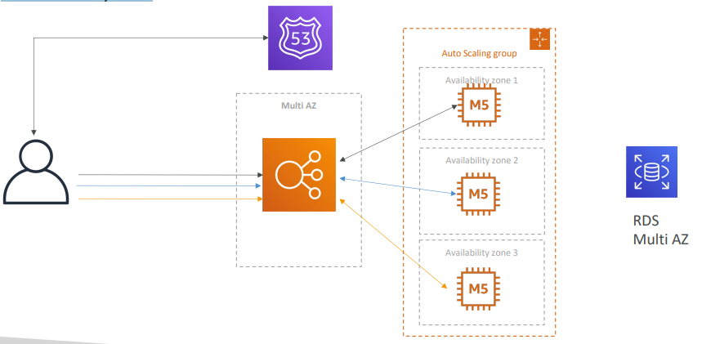

**Stateful Web App: MyWordPress.com Scaling with Aurora: Multi AZ & Read Replicas**

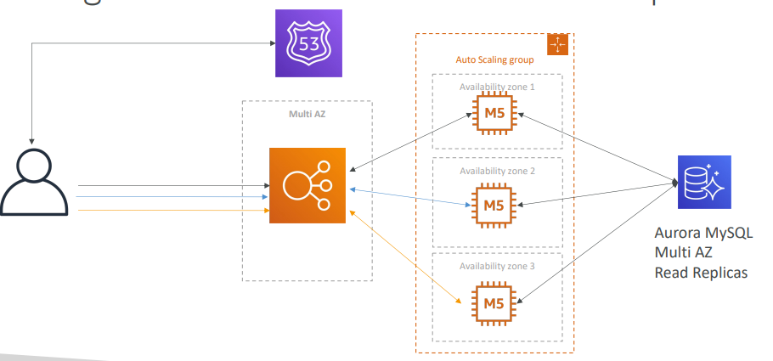

**Stateful Web App: MyWordPress.com Storing images with EBS**

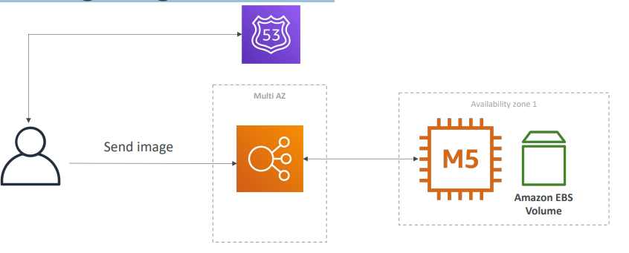

**Stateful Web App: MyWordPress.com Storing images with EBS**

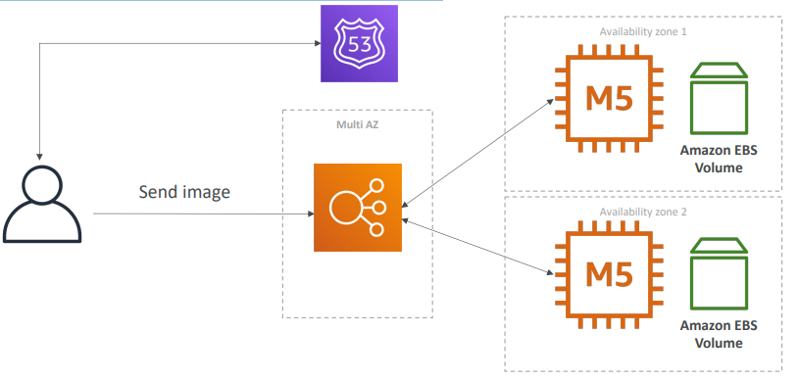

**Stateful Web App: MyWordPress.com Storing images with EFS**

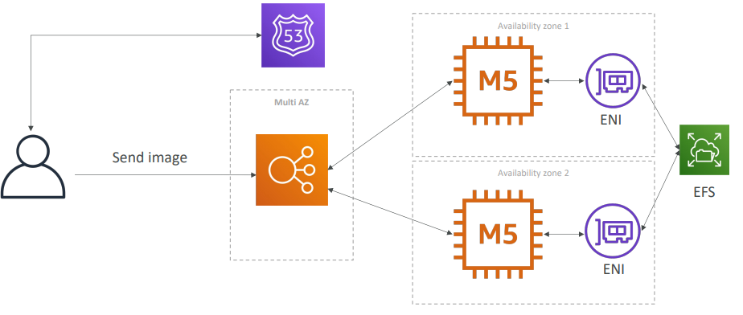

In this lecture we’ve discussed… • Aurora Database to have easy Multi-AZ and Read

* -Replicas
* Storing data in EBS (single instance application)
* Vs Storing data in EFS (distributed application)

Instantiating Applications quickly

* When launching a full stack (EC2, EBS, RDS), it can take time to:

1. Install applications
2. Insert initial (or recovery) data
3. Configure everything
4. Launch the application

* We can take advantage of the cloud to speed that up!

Instantiating Applications quickly

* EC2 Instances:

1. Use a Golden AMI: Install your applications, OS dependencies etc.. beforehand and launch your EC2 instance from the Golden AMI
2. Bootstrap using User Data: For dynamic configuration, use User Data scripts
3. Hybrid: mix Golden AMI and User Data (Elastic Beanstalk)

* RDS Databases:
  + Restore from a snapshot: the database will have schemas and data ready!
* EBS Volumes:
  + Restore from a snapshot: the disk will already be formatted and have data

**Typical architecture: Web App 3-tier**

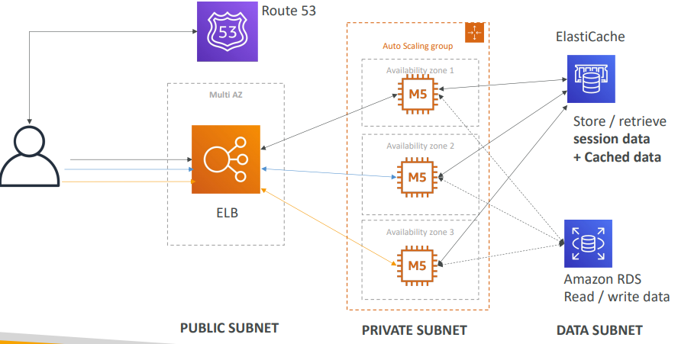

Developer problems on AWS

1. Managing infrastructure
2. Deploying Code
3. Configuring all the databases, load balancers, etc
4. Scaling concerns
5. Most web apps have the same architecture (ALB + ASG)
6. All the developers want is for their code to run!
7. Possibly, consistently across different applications and environments

**Elastic Beanstalk – Overview**

* Elastic Beanstalk is a developer centric view of deploying an application on AWS
* It uses all the component’s we’ve seen before: EC2, ASG, ELB, RDS, …
* Managed service

1. Automatically handles capacity provisioning, load balancing, scaling, application health monitoring, instance configuration, …
2. Just the application code is the responsibility of the developer

* We still have full control over the configuration
* Beanstalk is free but you pay for the underlying instances

Elastic Beanstalk – Components

* Application: collection of Elastic Beanstalk components (environments, versions, configurations, …)
* Application Version: an iteration of your application code
* Environment

1. Collection of AWS resources running an application version (only one application version at a time)
2. Tiers: Web Server Environment Tier & Worker Environment Tier
3. You can create multiple environments (dev, test, prod, …)

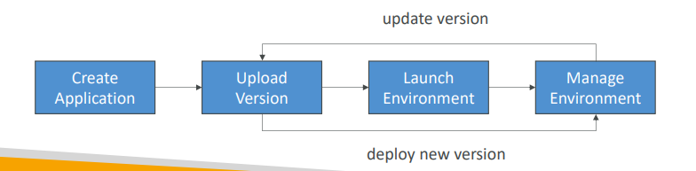

Elastic Beanstalk – Supported Platforms

* Go
* Java SE
* Java with Tomcat
* .NET Core on Linux
* .NET on Windows Server
* Node.js
* PHP
* Python
* Ruby
* Packer Builder
* Single Container Docker
* Multi-container Docker
* Preconfigured Docker

**Web Server Tier vs. Worker Tier**

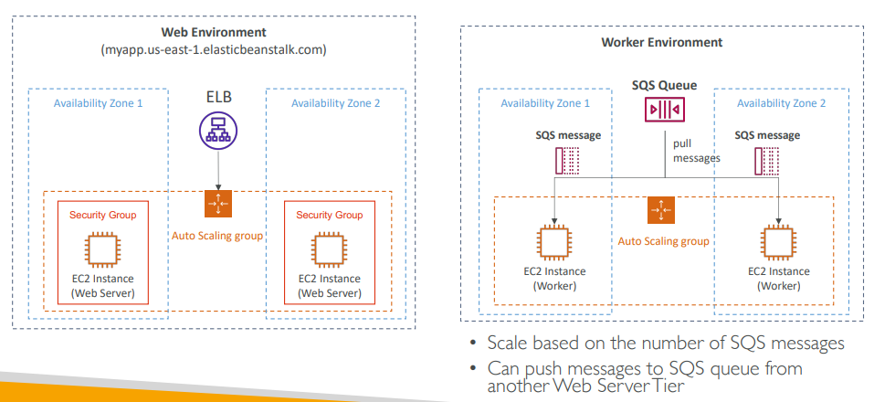

**Elastic Beanstalk Deployment Modes**

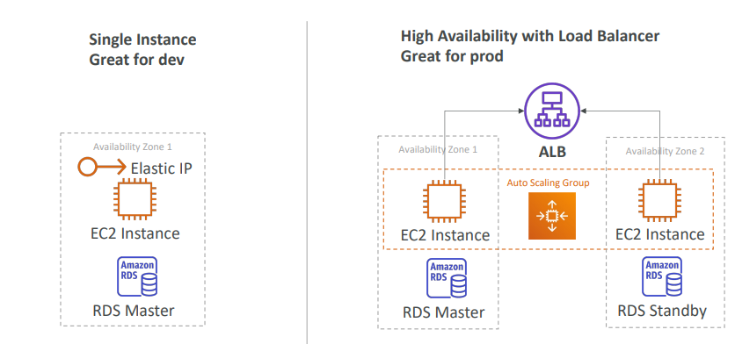

# Amazon S3

* Amazon S3 is one of the main building blocks of AWS
* It’s advertised as ”infinitely scaling” storage
* Many websites use Amazon S3 as a backbone e.g. Nasdaq stores 7 years of data on S3 glacier, Sysco runs data analytics on data on S3
* Many AWS services use Amazon S3 as an integration as well

**Amazon S3 Use cases**

* Backup and storage
* Disaster Recovery
* Archive
* Hybrid Cloud storage
* Application hosting
* Media hosting
* Data lakes & big data analytics
* Software delivery
* Static website

**Amazon S3 - Buckets**

* Amazon S3 allows people to store objects (files) in “buckets” (directories)
* Buckets must have a globally unique name (across all regions all accounts)
* Buckets are defined at the region level
* S3 looks like a global service but buckets are created in a region
* Naming convention

1. No uppercase, No underscore
2. 3-63 characters long
3. Not an IP
4. Must start with lowercase letter or number
5. Must NOT start with the prefix xn--
6. Must NOT end with the suffix -s3alias

**Amazon S3 – Objects**

|  |  |
| --- | --- |
| * Objects (files) have a Key * The key is the FULL path:  1. s3://my-bucket/my_file.txt 2. s3://my-bucket/my_folder1/another_folder/my_file.txt  * The key is composed of prefix + object name   + s3://my-bucket/my_folder1/another_folder/my_file.txt * There’s no concept of “directories” within buckets * (although the UI will trick you to think otherwise) * Just keys with very long names that contain slashes (“/”) |  |

* Object values are the content of the body:

1. Max. Object Size is 5TB (5000GB)
2. If uploading more than 5GB, must use “multi-part upload”

* Objects can also have metadata (list of text key / value pairs – system or user metadata)
* Ther are also tags (Unicode key / value pair – up to 10) – useful for security / lifecycle
* Can also have Version ID (if versioning is enabled)

## Amazon S3 – Security

* User-Based
  + IAM Policies – which API calls should be allowed for a specific user from IAM
* Resource-Based
  + Bucket Policies – bucket wide rules from the S3 console - allows cross account
  + Object Access Control List (ACL) – finer grain (can be disabled)
  + Bucket Access Control List (ACL) – less common (can be disabled)
* Note: an IAM principal can access an S3 object if
  + The user IAM permissions ALLOW it OR the resource policy ALLOWS it
  + AND there’s no explicit DENY
* Encryption: encrypted objects in Amazon S3 using encryption keys

**S3 Bucket Policies**

|  |  |
| --- | --- |
| * JSON based policies which contains   + Resources: buckets and objects where policy will apply. In the example it will apply to all objects in bucket, since * is used   + Effect: Allow / Deny   + Actions: Set of API where policy will impact . In the example it will impact get Objects API   + Principal: The account or user to apply the policy to * Use case example for S3 bucket for policy:   + Grant public access to the bucket   + Force objects to be encrypted at upload   + Grant access to another account (Cross Account) |  |

**Example: Public Access - Use Bucket Policy**

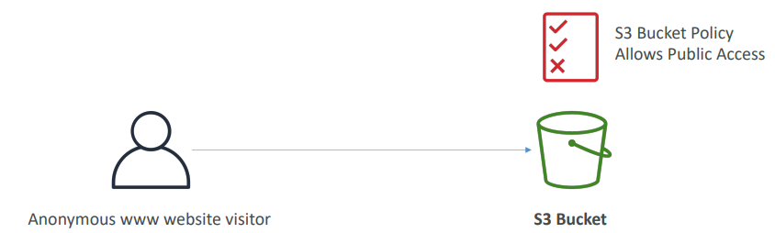

First, we have to enable public access for bucket like from console. This but this is risky as it will make all objects public

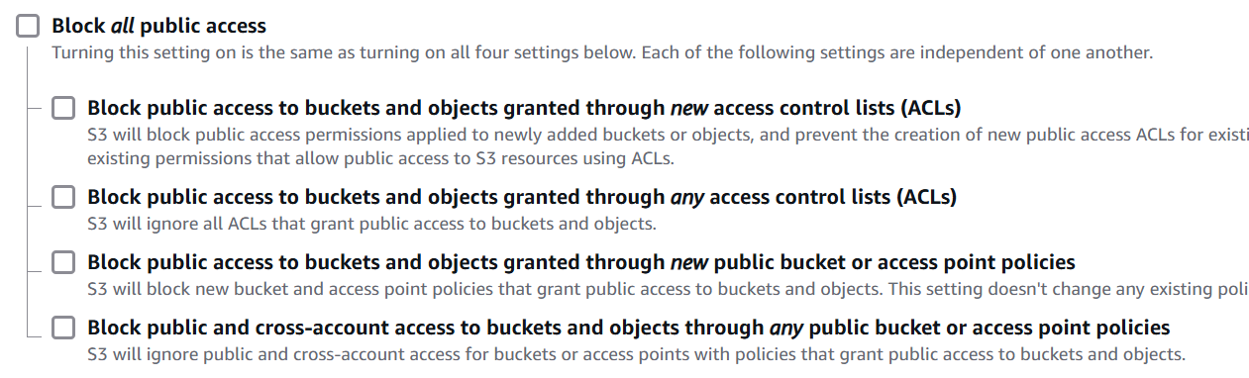

* These settings were created to prevent company data leaks
* If you know your bucket should never be public, leave these on
* Can be set at the account level

Next, we must add bucket policy we can go to Bucket 🡪 Permission and add policy. We can use policy generators URL 🡪 <https://awspolicygen.s3.amazonaws.com/policygen.html>



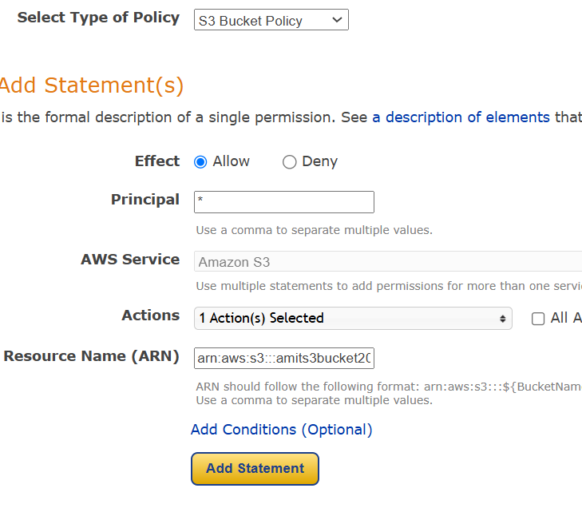

In Arn we have to provide bucket ARN and it has to be followed by star so that policy is applied to all objects in the bucket

arn:aws:s3:::amits3bucket2025/*

Next we have to generate policy from policy generators and apply in Bucket policy and now we can access the file using public URL

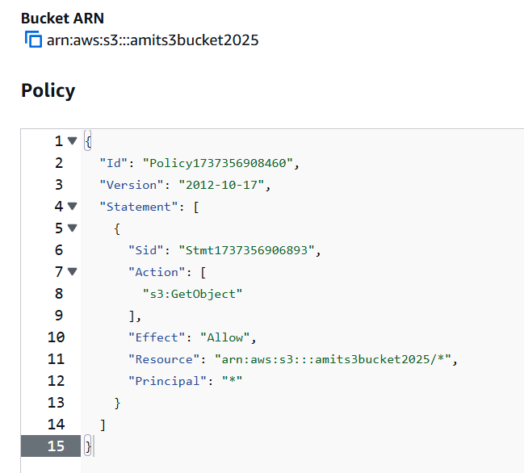



**Example: User Access to S3 – IAM permissions**

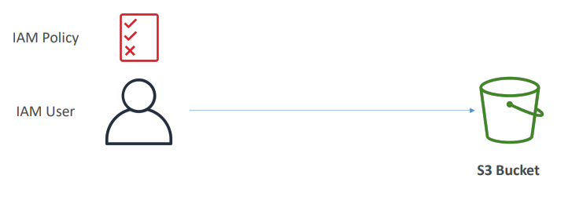

**Example: EC2 instance access - Use IAM Roles**

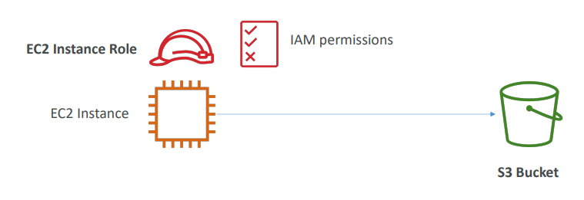

**Advanced: Cross-Account Access – Use Bucket Policy**

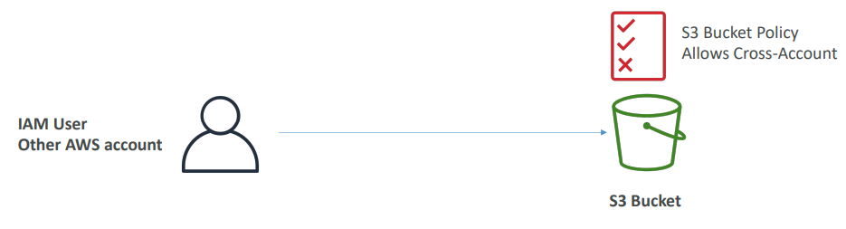

## Amazon S3 – Static Website Hosting

|  |  |
| --- | --- |
| * S3 can host static websites and have them accessible on the Internet * The website URL will be (depending on the region) * http://bucket-name.s3-website-aws-region.amazonaws.com * OR * http://bucket-name.s3-website.aws-region.amazonaws.com * If you get a 403 Forbidden error, make sure the bucket * policy allows public reads! |  |

Go to bucket settings at the end there will a section for Static website hosting we can enable it and provide a index.html for the code. Once we enable it in the same section we can find the website URL

## Amazon S3 -Versioning

|  |  |
| --- | --- |
| * You can version your files in Amazon S3 * It is enabled at the bucket level * Same key(file name with path) overwrite will change the “version”: 1, 2, 3…. * It is best practice to version your buckets  1. Protect against unintended deletes (ability to restore a version) 2. Easy roll back to previous version  * Notes:  1. Any file that is not versioned prior to enabling versioning will have version “null” 2. Suspending versioning does not delete the previous versions |  |

After we enable versions there is a toggle called show versions, we can turn on that to see the versions. For the files added before enabling versioning it will be null.

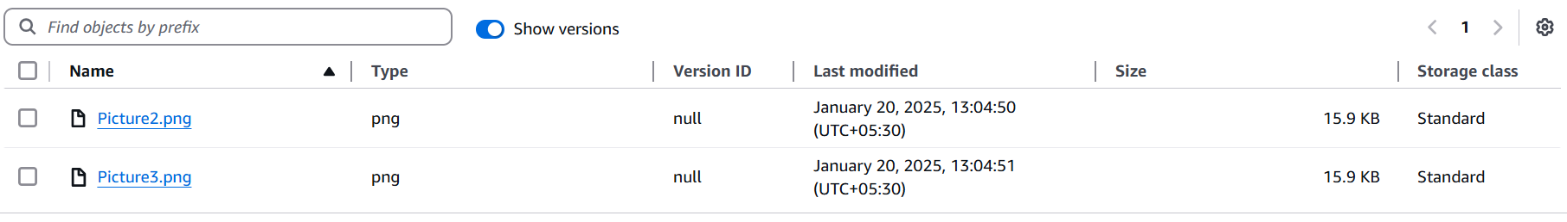

But any change we do after enabling versioning we can see the versions and if we delete the newer version, the older version will be restored

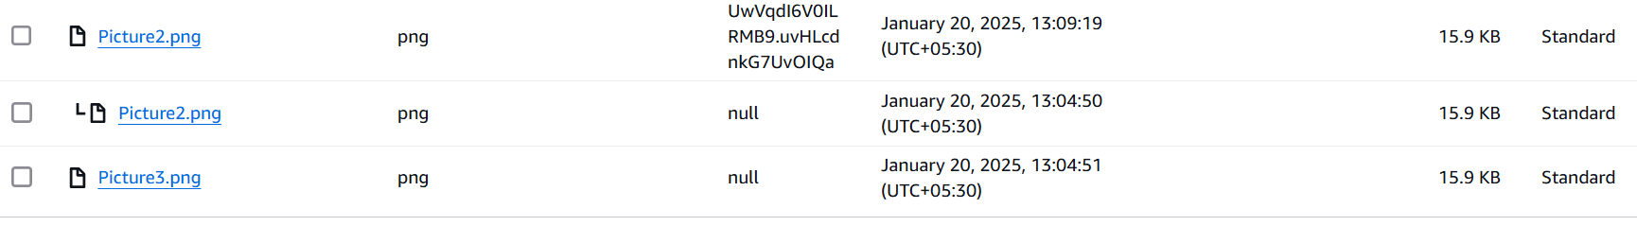

If we remove the version and just delete the file, it will not delete the file but add a delete marker. If we delete the version with delete marker it will restore the file.

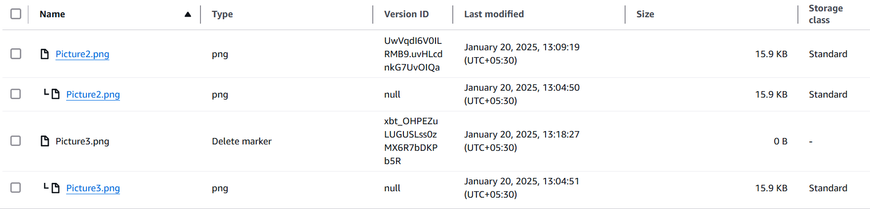

## Replication

**Amazon S3 – Replication (CRR & SRR)**

|  |  |
| --- | --- |
| * To enable versioning must enable Versioning in source and destination buckets * Cross-Region Replication (CRR) * Same-Region Replication (SRR) * Buckets can be in different AWS accounts * Copying is asynchronous * Must give proper IAM permissions to S3 * Use cases: * CRR – compliance, lower latency access, replication across accounts * SRR – log aggregation, live replication between production and test accounts |  |

**Amazon S3 – Replication (Notes)**

* After you enable Replication, only new objects are replicated
* Optionally, you can replicate existing objects using S3 Batch Replication
  + Replicates existing objects and objects that failed replication
* For DELETE operations
  + Can replicate delete markers from source to target (optional setting) i.e. versions get copied
  + Deletions with a version ID are not replicated (to avoid malicious deletes) i.e. when we delete the actual file or its versions delete won’t happen in replica.
* There is no “chaining” of replication
  + If bucket 1 has replication into bucket 2, which has replication into bucket 3
  + Then objects created in bucket 1 are not replicated to bucket 3

Replication is under management section 🡪 replication rules

## S3 Storage Classes

* Amazon S3 Standard - General Purpose
* Amazon S3 Standard-Infrequent Access (IA)
* Amazon S3 One Zone-Infrequent Access
* Amazon S3 Glacier Instant Retrieval
* Amazon S3 Glacier Flexible Retrieval
* Amazon S3 Glacier Deep Archive
* Amazon S3 Intelligent Tiering
* Can move between classes manually or using S3 Lifecycle configurations

Durability:

1. High durability (99.999999999%, 11 9’s) of objects across multiple AZ
2. If you store 10,000,000 objects with Amazon S3, you can on average expect to incur a loss of a single object once every 10,000 years
3. Same for all storage classes

* Availability:

1. Measures how readily available a service is
2. Varies depending on storage class
3. Example: S3 standard has 99.99% availability = not available 53 minutes a year

**S3 Standard – General Purpose**

* 99.99% Availability
* Used for frequently accessed data
* Low latency and high throughput
* Sustain 2 concurrent facility failures
* Use Cases: Big Data analytics, mobile & gaming applications, content distribution…

**S3 Storage Classes – Infrequent Access**

* For data that is less frequently accessed, but requires rapid access when needed
* Lower cost than S3 Standard, cost on retrieval
* Amazon S3 Standard-Infrequent Access (S3 Standard-IA)

1. 99.9% Availability
2. Use cases: Disaster Recovery, backups

* Amazon S3 One Zone-Infrequent Access (S3 One Zone-IA)

1. High durability (99.999999999%) in a single AZ; data lost when AZ is destroyed
2. 99.5% Availability
3. Use Cases: Storing secondary backup copies of on-premises data, or data you can recreate

**Amazon S3 Glacier Storage Classes**

* Low-cost object storage meant for archiving / backup
* Pricing: price for storage + object retrieval cost
* Amazon S3 Glacier Instant Retrieval

1. Millisecond retrieval, great for data accessed once a quarter
2. Minimum storage duration of 90 days

* Amazon S3 Glacier Flexible Retrieval (formerly Amazon S3 Glacier):

1. Expedited (1 to 5 minutes), Standard (3 to 5 hours), Bulk (5 to 12 hours) – free
2. Minimum storage duration of 90 days

* Amazon S3 Glacier Deep Archive – for long term storage:

1. Standard (12 hours), Bulk (48 hours)
2. Minimum storage duration of 180 days

**S3 Intelligent-Tiering**

* Small monthly monitoring and auto-tiering fee
* Moves objects automatically between Access Tiers based on usage
* There are no retrieval charges in S3 Intelligent-Tiering
* Frequent Access tier (automatic): default tier
* Infrequent Access tier (automatic): objects not accessed for 30 days
* Archive Instant Access tier (automatic): objects not accessed for 90 days
* Archive Access tier (optional): configurable from 90 days to 700+ days
* Deep Archive Access tier (optional): config. from 180 days to 700+ days

We can go to files and change the storage tier of the file, going to properties 🡪 storage class of the file.

At bucket level we can do this using lifecycle rules. Bucket we want to change 🡪 management

**S3 Storage Classes Comparison**

[**https://aws.amazon.com/s3/storage-classes/**](https://aws.amazon.com/s3/storage-classes/)

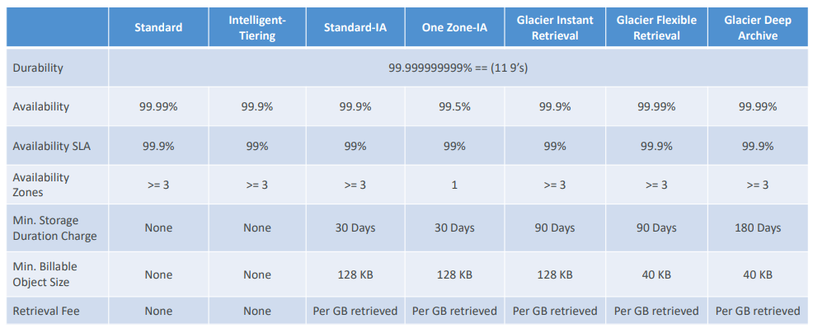

**S3 Storage Classes – Price Comparison Example: us-east-1**

[**https://aws.amazon.com/s3/pricing/**](https://aws.amazon.com/s3/pricing/)

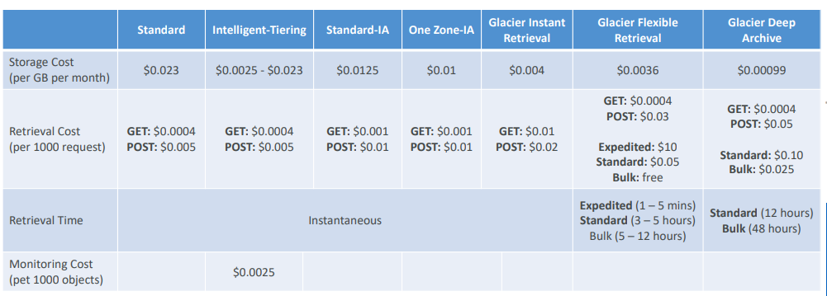

**Questions**

**Top of Form**

**You're getting errors while trying to create a new S3 bucket named "dev". You're using a new AWS Account with no S3 buckets created before. And you double-checked and found that you have the correct IAM permissions to create S3 Buckets. What is a possible cause for this?**

* **Only AWS account root user can create S3 Buckets**
* **S3 bucket names must be globally unique and "dev" is already taken**

**Bottom of Form**

Ans B

**Top of Form**

**You have enabled versioning in your S3 bucket which already contains a lot of files. Which version will the existing files have?**

* **1**
* **0**
* **-1**
* **null**

**Bottom of Form**

Ans null

**Imp Top of Form**

**You have updated an S3 bucket policy to allow IAM users to read/write files in the S3 bucket, but one of the users complain that he can't perform a PutObject API call. What is a possible cause for this?**

* **The S3 bucket policy must be wrong**
* **The user is lacking permissions**
* **The IAM user must have an explicit DENY in the attached IAM Policy**
* **You need to contact AWS Support to lift this limit**

**Bottom of Form**

Even if the user doesn't have permissions, in the question the S3 bucket is explicitly allowing the user and that's enough from a permission's perspective so the answer is

Explicit DENY in an IAM Policy will take precedence over an S3 bucket policy.

**Top of Form**

**You want the content of an S3 bucket to be fully available in different AWS Regions. That will help your team perform data analysis at the lowest latency and cost possible. What S3 feature should you use?**

* **Amazon CloudFront Distributions**
* **S3 Versioning**
* **S3 Static Website Hosting**
* **S3 Replication**

**Bottom of Form**

S3 Replication allows you to replicate data from an S3 bucket to another in the same/different AWS Region.

**Top of Form**

**You have 3 S3 buckets. One source bucket A, and two destination buckets B and C in different AWS Regions. You want to replicate objects from bucket A to both bucket B and C. How would you achieve this?**

* **Configure replication from bucket A to bucket B, then from bucket A to bucket C**
* **Configure replication from bucket A to bucket B, then from bucket B to bucket C**
* **Configure replication from bucket A to bucket C, then from bucket C to bucket B**

**Bottom of Form**

Ans A

**Top of Form**

**Which of the following is NOT a Glacier Deep Archive retrieval mode?**

* **Expedited (1 - 5 minutes)**
* **Standard (12 hours)**
* **Bulk (48 hours)**

**Bottom of Form**

Ans A

**Top of Form**

**Which of the following is NOT a Glacier Flexible retrieval mode?**

* **Instant (10 seconds)**
* **Expedited (1 - 5 minutes)**
* **Standard (3 - 5 hours)**
* **Bulk (5 - 12 hours)**

**Bottom of Form**

Ans A

# Amazon S3 – Advanced

## Moving between Storage Classes

|  |  |
| --- | --- |
| * You can transition objects between storage classes * For infrequently accessed object, move them to Standard IA * For archive objects that you don’t need fast access to, move them to Glacier or Glacier Deep Archive * Moving objects can be automated using a Lifecycle Rules |  |

**Amazon S3 – Lifecycle Rules**

Life cycle rules made of multiple items like

* Transition Actions – configure objects to transition to another storage class
  + Move objects to Standard IA class 60 days after creation
  + Move to Glacier for archiving after 6 months
* Expiration actions – configure objects to expire (delete) after some time
  + Access log files can be set to delete after 365 days
  + Can be used to delete old versions of files (if versioning is enabled)
  + Can be used to delete incomplete multi-Part uploads
* Rules can be created for a certain prefix (example: s3://mybucket/mp3/*)
* Rules can be created for certain objects Tags (example: Department: Finance)

**Amazon S3 – Lifecycle Rules (Scenario 1)**

Your application on EC2 creates images thumbnails after profile photos are uploaded to Amazon S3. These thumbnails can be easily recreated and only need to be kept for 60 days. The source images should be able to be immediately retrieved for these 60 days, and afterwards, the user can wait up to 6 hours. How would you design this?

* S3 source images can be on Standard, with a lifecycle configuration to transition them to Glacier after 60 days
* S3 thumbnails can be on One-Zone IA, with a lifecycle configuration to expire them (delete them) after 60 days

**Amazon S3 – Lifecycle Rules (Scenario 2)**

A rule in your company states that you should be able to recover your deleted S3 objects immediately for 30 days, although this may happen rarely. After this time, and for up to 365 days, deleted objects should be recoverable within 48 hours.

* Enable S3 Versioning to have object versions, so that “deleted objects” are in fact hidden by a “delete marker” and can be recovered
* Transition the “noncurrent versions” of the object to Standard IA
* Transition afterwards the “noncurrent versions” to Glacier Deep Archive

**Amazon S3 Analytics – Storage Class Analysis**

|  |  |
| --- | --- |
| * Help you decide when to transition objects to the right storage class * Recommendations for Standard and Standard IA   + Does NOT work for One-Zone IA or Glacier * Report is updated daily * 24 to 48 hours to start seeing data analysis   Good first step to put together Lifecycle Rules (or improve them)! |  |

We can select the rules we want and then we have to add the rule

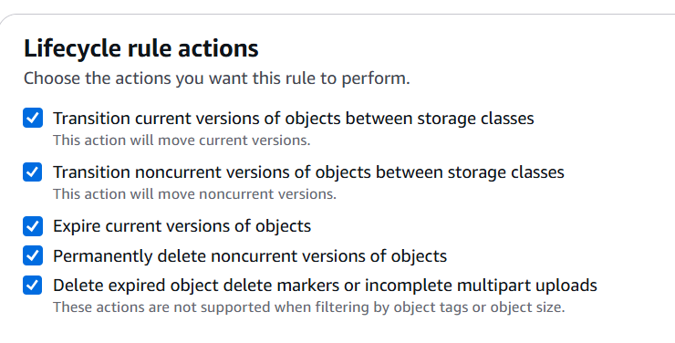

Transition of current objects Transition of non current version

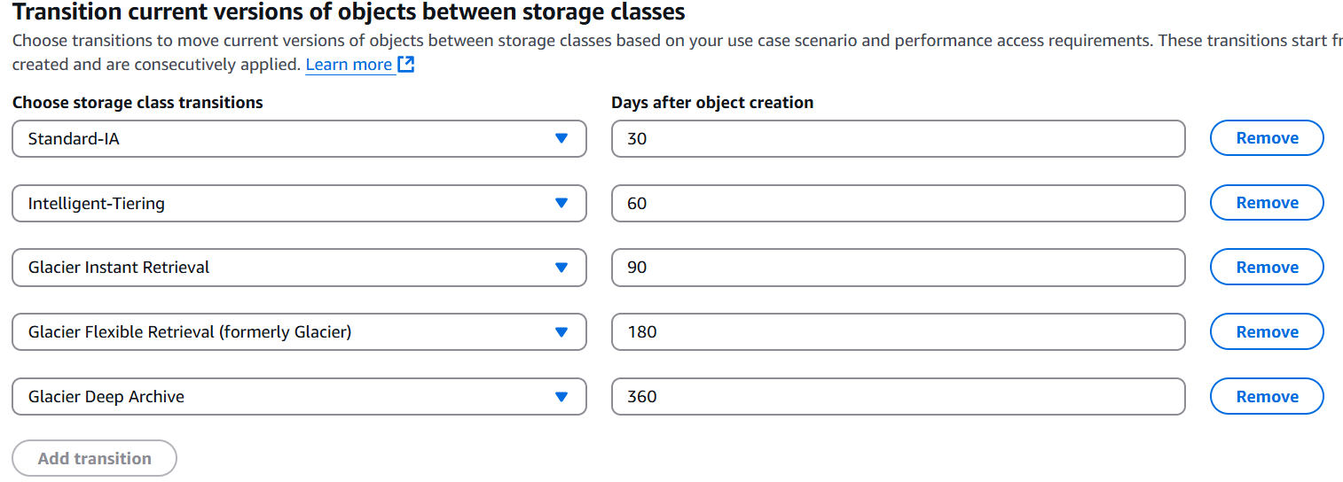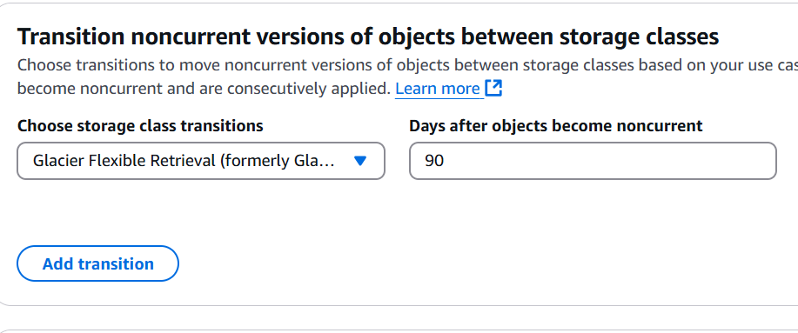

Expire current versions Permanently delete noncurrent versions

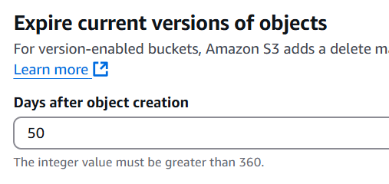 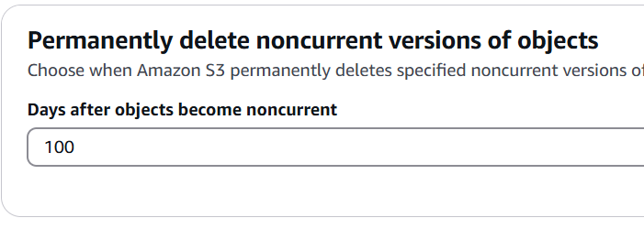

Then we can see the summary below

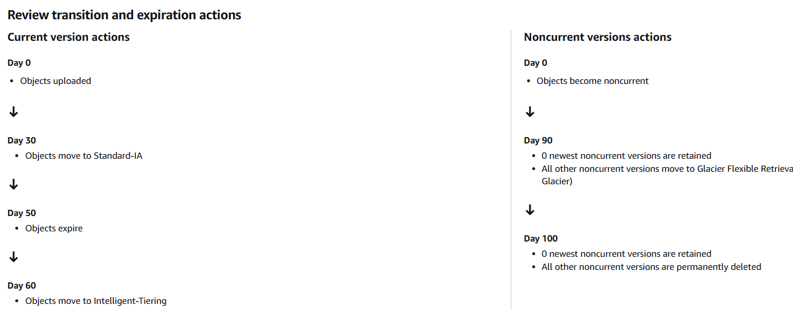

**S3 – Requester Pays**

|  |  |
| --- | --- |
| * In general, bucket owners pay for all Amazon S3 storage and data transfer costs associated with their bucket * With Requester Pays buckets, the requester instead of the bucket owner pays the cost of the request and the data download from the bucket * Helpful when you want to share large datasets with other accounts * The requester must be authenticated in AWS (cannot be anonymous) |  |

S3 Event Notifications

|  |  |
| --- | --- |
| * S3:ObjectCreated, S3:ObjectRemoved,   S3:ObjectRestore, S3:Replication…   * Object name filtering possible (*.jpg) * Use case: generate thumbnails of images uploaded to S3 * Can create as many “S3 events” as desired * S3 event notifications typically deliver events in seconds but can sometimes take a minute or longer |  |

**S3 Event Notifications – IAM Permissions**

For the Event Notifications to work, we need to have IAM permissions. So, the S3 service is sending data into an SNS topic. To make this possible, we need to attach what's called an SNS resource access policy. This is a IAM policy you attach to the SNS topic, and this will allow the S3 bucket to send messages directly into the SNS topic. Similarly, if we use SQS, we create an SQS resource access policy, which authorizes the S3 service to send data into our SQS queue.

So here we don't use IAM roles for Amazon S3. Instead, we define resource access policies on the SNS topic, on the SQS queue, or on the Lambda function.

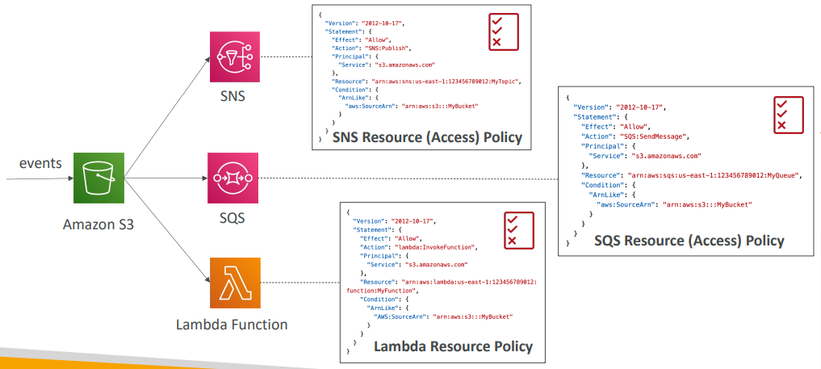

**S3 Event Notifications with Amazon EventBridge**

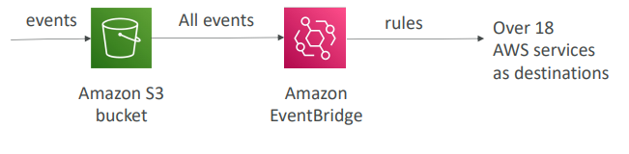

* Advanced filtering options with JSON rules (metadata, object size, name...)
* Multiple Destinations – ex Step Functions, Kinesis Streams / Firehose…
* EventBridge Capabilities – Archive, Replay Events, Reliable delivery

We can enable notification from bucker properties. We can create on the type of events like object creation, update , delete etc.

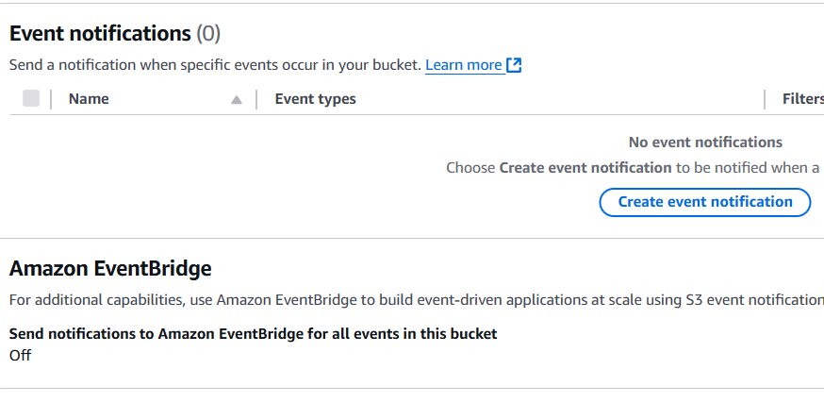

**S3 – Baseline Performance**

* Amazon S3 automatically scales to high request rates, latency 100-200 milli seconds to get first byte out of S3
* Your application can achieve at least 3,500 PUT/COPY/POST/DELETE or 5,500 GET/HEAD requests per second per prefix in a bucket.
* There are no limits to the number of prefixes in a bucket.
* Example (object path => prefix): prefix example

1. bucket/folder1/sub1/file => /folder1/sub1/
2. bucket/folder1/sub2/file => /folder1/sub2/
3. bucket/1/file => /1/
4. bucket/2/file => /2/

* If you spread reads across all four prefixes evenly, you can achieve 22,000 requests per second for GET and HEAD

**S3 Performance optimization**

|  |  |
| --- | --- |
| Multi-Part upload:  • recommended for files > 100MB, must use for files > 5GB  • multiplarts help parallelize uploads (speed up transfers) | S3 Transfer Acceleration   * Increase transfer speed by transferring files to an AWS edge location which will forward the data to the S3 bucket in the target region * Compatible with multi-part upload |

**S3 Performance – get operations**

S3 Byte-Range Fetches – getting files in byte ranges

|  |  |
| --- | --- |
| • Parallelize GETs by requesting specific byte ranges  • Better resilience in case of failures only small parts are retried in case of failures  Can be used to speed up downloads by parallel get | Can be used to retrieve only partial data (for example the header of a file) |

**S3 Batch Operations**

|  |  |
| --- | --- |
| • Allows to perform bulk operations on existing S3 objects with a single request, example:   1. Modify object metadata & properties of many S3 objects 2. Copy objects between S3 buckets 3. Encrypt un-encrypted objects 4. Modify ACLs, tags 5. Restore objects from S3 Glacier 6. Invoke Lambda function to perform custom action on each object   • A job consists of a   * list of objects, * the action to perform, * optional parameters   • S3 Batch Operations manages retries, tracks progress, sends completion notifications, generate reports …  • how to generate a list to pass to S3 Batch? Well, we can use S3 Inventory  to get your object list in an S3 bucket. And then you use Athena to query that list and filter the objects you want to pass to the S3 batch service.  So, using S3 Inventory and then Athena, we get a filtered list of objects that we want to include in our batch operation. We pass it to batch operation,  plus, whatever operation we want to do, as well as some parameters. And then the S3 Batch will do its thing and process the objects. |  |

**S3 – Storage Lens**

* Understand, analyze, and optimize storage across entire AWS Organization
* Discover anomalies, identify cost efficiencies, and apply data protection best practices across entire AWS Organization (30 days usage & activity metrics)
* Aggregate data for Organization, specific accounts, regions, buckets, or prefixes
* Default dashboard or create your own dashboards
* Can be configured to export metrics daily to an S3 bucket (CSV, Parquet)

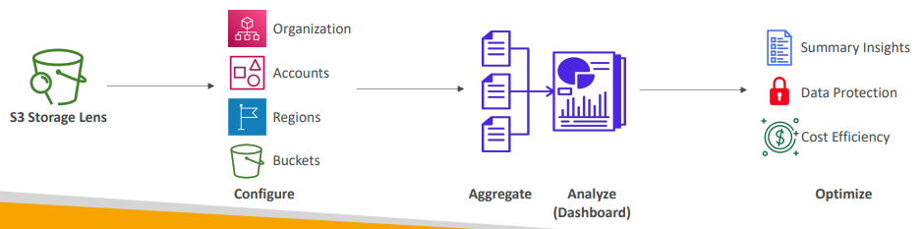

**Storage Lens – Default Dashboard**

* Visualize summarized insights and trends for both free and advanced metrics
* Default dashboard shows Multi-Region and Multi-Account data
* Preconfigured by Amazon S3
* Can’t be deleted, but can be disabled

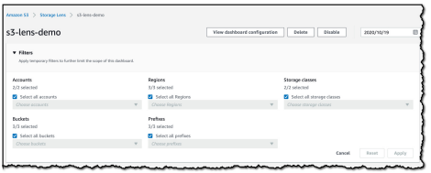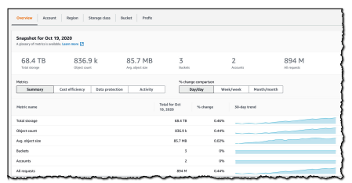

<https://aws.amazon.com/blogs/aws/s3-storage-lens/> <https://aws.amazon.com/blogs/aws/s3-storage-lens/>

**Storage Lens – Metrics**

* Summary Metrics
  + General insights about your S3 storage
  + Storage Bytes, Object Count…
  + Use cases: identify the fastest growing (or not used) buckets and prefixes
* Cost-Optimization Metrics
  + Provide insights to manage and optimize your storage costs
  + NonCurrentVersionStorageBytes, IncompleteMultipartUploadStorageBytes…
  + Use cases: identify buckets with incomplete multipart uploaded older than 7 days, Identify which objects could be transitioned to lower-cost storage class

**Storage Lens – Metrics**

* Data-Protection Metrics
  + Provide insights for data protection features
  + VersioningEnabledBucketCount, MFADeleteEnabledBucketCount, SSEKMSEnabledBucketCount, CrossRegionReplicationRuleCount…
  + Use cases: identify buckets that aren’t following data-protection best practices
* Access-management Metrics
  + Provide insights for S3 Object Ownership
  + ObjectOwnershipBucketOwnerEnforcedBucketCount…
  + Use cases: identify which Object Ownership settings your buckets use
* Event Metrics
  + Provide insights for S3 Event Notifications
  + EventNotificationEnabledBucketCount (identify which buckets have S3 Event Notifications configured)
* Performance Metrics
  + Provide insights for S3 Transfer Acceleration
  + TransferAccelerationEnabledBucketCount (identify which buckets have S3 Transfer Acceleration enabled)
* Activity Metrics
  + Provide insights about how your storage is requested
  + AllRequests, GetRequests, PutRequests, ListRequests, BytesDownloaded…
* Detailed Status Code Metrics
  + Provide insights for HTTP status codes
  + 200OKStatusCount, 403ForbiddenErrorCount, 404NotFoundErrorCount

**Storage Lens– Free vs . Paid**

|  |  |
| --- | --- |
| * Free Metrics   + Automatically available for all customers   + Contains around 28 usage metrics   + Data is available for queries for 14 days * Advanced Metrics and Recommendations   + Additional paid metrics and features   + Advanced Metrics – Activity, Advanced Cost Optimization, Advanced Data Protection, Status Code   + CloudWatch Publishing – Access metrics in CloudWatch without additional charges   + Prefix Aggregation – Collect metrics at the prefix level   + Data is available for queries for 15 months |  |

## Questions

**Top of Form**

**How can you be notified when there's an object uploaded to your S3 bucket?**

* **S3 Select**
* **S3 Access Logs**
* **S3 Event Notifications**
* **S3 Analytics**

Ans CBottom of Form

**Top of Form**

**You have an S3 bucket that has S3 Versioning enabled. This S3 bucket has a lot of objects, and you would like to remove old object versions to reduce costs. What's the best approach to automate the deletion of these old object versions?**

* **S3 Lifecycle Rules - Transition Actions**
* **S3 Lifecycle Rules - Expiration Actions**
* **S3 Access Logs**

Ans B**Bottom of Form**

**Top of Form**

**How can you automate the transition of S3 objects between their different tiers?**

* **AWS Lambda**
* **CloudWatch Events**
* **S3 Lifecycle Rules**

Ans C**Bottom of Form**

**Top of Form**

**While you're uploading large files to an S3 bucket using Multi-part Upload, there are a lot of unfinished parts stored in the S3 bucket due to network issues. You are not using these unfinished parts and they cost you money. What is the best approach to remove these unfinished parts?**

* **Use AWS Lambda to loop on each old/unfinished part and delete them**
* **Request AWS Support to help you delete old/unfinished parts**
* **Use an S3 Lifecycle Policy to automate old/unfinished parts deletion**

Ans C**Bottom of Form**

**Top of Form**

**You are looking to get recommendations for S3 Lifecycle Rules. How can you analyze the optimal number of days to move objects between different storage tiers?**

* **S3 Inventory**
* **S3 Analytics**
* **S3 Lifecycle Rules Advisor**

Ans B**Bottom of Form**

**Top of Form**

**You are looking to build an index of your files in S3, using Amazon RDS PostgreSQL. To build this index, it is necessary to read the first 250 bytes of each object in S3, which contains some metadata about the content of the file itself. There are over 100,000 files in your S3 bucket, amounting to 50 TB of data. How can you build this index efficiently?**

* **Use the RDS Import feature to load the data from S3 to PostgreSQL, and run a SQL query to build the index**
* **Create an application that will traverse the S3 bucket, read all the files one by one, extract the first 250 bytes, and store that information in RDS**
* **Create an application that will traverse the S3 bucket, issue a Byte Range Fetch for the first 250 bytes, and store that information in RDS**
* **Create an application that will traverse the S3 bucket, use S3 Select to get the first 250 bytes, and store that information in RDS**

Ans C Ans AnsC**Bottom of Form**

**Top of Form**

**You have a large dataset stored on-premises that you want to upload to the S3 bucket. The dataset is divided into 10 GB files. You have good bandwidth but your Internet connection isn't stable. What is the best way to upload this dataset to S3 and ensure that the process is fast and avoid any problems with the Internet connection?**

* **Use Multi-part Upload Only**
* **Use S3 Select & Use S3 Transfer Acceleration**
* **Use S3 Multi-part Upload & S3 Transfer Acceleration**

Ans c

**Top of Form**

**A company is preparing for compliance and regulatory review on its infrastructure on AWS. Currently, they have their files stored on S3 buckets encrypted using S3 Default Encryption, which must be encrypted using KMS as required for compliance and regulatory review. Which S3 feature allows them to encrypt all files in their S3 buckets in the most efficient and cost-effective way?**

* **S3 Access Points**
* **S3 Cross-Region Replication**
* **S3 Batch Operations**
* **S3 Lifecycle Rules**

**Bottom of Form**

Ans C

**Top of Form**

**You have a 25 GB file that you're trying to upload to S3 but you're getting errors. What is a possible solution for this?**

* **The file size limit on S3 is 5 GB**
* **Update your bucket policy to allow the larger file**
* **Use Multi-Part upload when uploading files larger than 5GB**
* **Encrypt the file**

**Bottom of Form**

Ans Multi-Part Upload is recommended as soon as the file is over 100 MB. And mandatory for file greater than 5 GB

**Bottom of Form**

# Amazon S3 – Security

You can encrypt objects in S3 buckets using one of 4 methods

1. Server-Side Encryption (SSE)
   1. Server-Side Encryption with Amazon S3-Managed Keys (SSE-S3) – Enabled by Default
      1. Encrypts S3 objects using keys handled, managed, and owned by AWS
   2. Server-Side Encryption with KMS Keys stored in AWS KMS (SSE-KMS)
      1. Leverage AWS Key Management Service (AWS KMS) to manage encryption keys
   3. Server-Side Encryption with Customer-Provided Keys (SSE-C)
      1. When you want to manage your own encryption keys
2. Client-Side Encryption

It’s important to understand which ones are for which situation for the exam

**Amazon S3 Encryption**– SSE-S3

* Encryption using keys handled, managed, and owned by AWS
* Object is encrypted server-side
* The Encryption type is AES-256
* Must set header "x-amz-server-side-encryption": "AES256"
* Enabled by default for new buckets & new objects

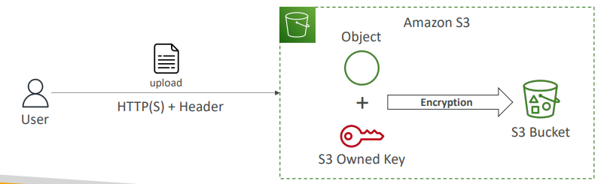

**Amazon S3 Encryption – SSE-KMS**

* Encryption using keys handled and managed by AWS KMS (Key Management Service)
* KMS advantages: user control + audit key usage using CloudTrail
* Object is encrypted server side
* Must set header "x-amz-server-side-encryption": "aws:kms"

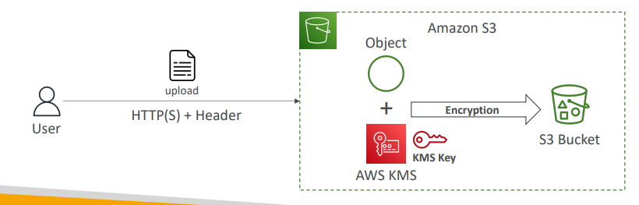

**SSE-KMS Limitation**

|  |  |
| --- | --- |
| • If you use SSE-KMS, you may be impacted by the KMS limits  • When you upload, it calls the GenerateDataKey KMS API  • When you download, it calls the Decrypt KMS API  • Count towards the KMS quota per second (5500, 10000, 30000 req/s based on region)  • You can request a quota increase using the Service Quotas Console |  |

**Amazon S3 Encryption – SSE-C**

* Server-Side Encryption using keys fully managed by the customer outside of AWS
* Amazon S3 does NOT store the encryption key you provide
* HTTPS must be used
* Encryption key must provided in HTTP headers, for every HTTP request made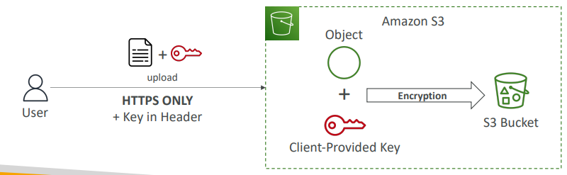

**Amazon S3 Encryption – Client-Side Encryption**

* Use client libraries such as Amazon S3 Client-Side Encryption Library
* Clients must encrypt data themselves before sending to Amazon S3
* Clients must decrypt data themselves when retrieving from Amazon S3
* Customer fully manages the keys and encryption cycle

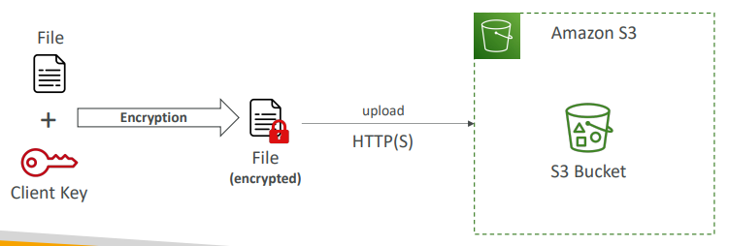

**Amazon S3 – Encryption in transit (SSL/TLS)**

* Encryption in flight is also called SSL/TLS
* Amazon S3 exposes two endpoints:

1. HTTP Endpoint – non encrypted
2. HTTPS Endpoint – encryption in flight

* HTTPS is recommended
* HTTPS is mandatory for SSE-C
* Most clients would use the HTTPS endpoint by default

**Amazon S3 – Force Encryption in Transit aws:SecureTransport**

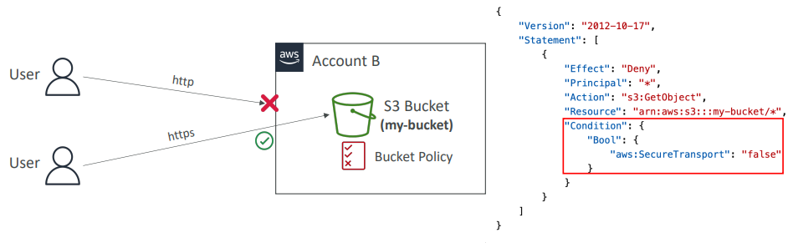

**Amazon S3 – Default Encryption vs. Bucket Policies**

* SSE-S3 encryption is automatically applied to new objects stored in S3 bucket
* Optionally, you can “force encryption” using a bucket policy and refuse any API call to PUT an S3 object without encryption headers (SSE-KMS or SSE-C)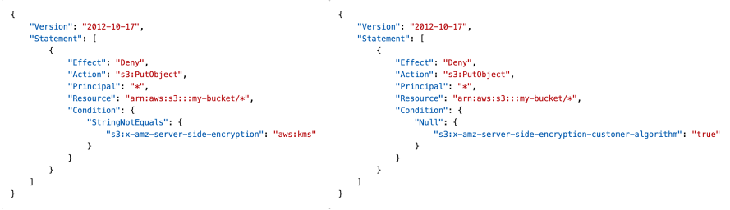

Note: Bucket Policies are evaluated before “Default Encryption”

**What is CORS?**

* Cross-Origin Resource Sharing (CORS)
* Origin = scheme (protocol) + host (domain) + port
  + example: https://www.example.com (implied port is 443 for HTTPS, 80 for HTTP)
* Web Browser based mechanism to allow requests to other origins while visiting the main origin
* Same origin: http://example.com/app1 & http://example.com/app2
* Different origins: http://www.example.com & http://other.example.com
* The requests won’t be fulfilled unless the other origin allows for the requests, using CORS Headers (example: Access-Control-Allow-Origin)

**What is CORS?**

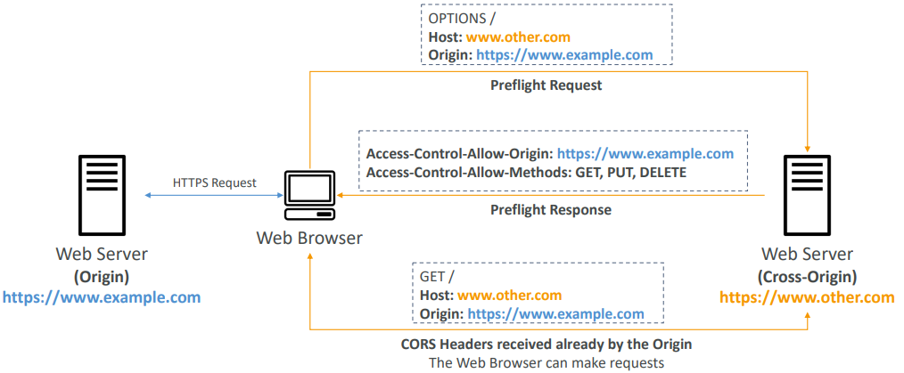

**Amazon S3 – CORS**

* If a client makes a cross-origin request on our S3 bucket, we need to enable the correct CORS headers
* It’s a popular exam question
* You can allow for a specific origin or for * (all origins)

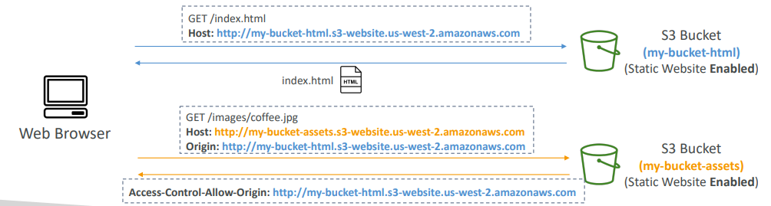

**Amazon S3 – MFA Delete**

* MFA (Multi-Factor Authentication) – force users to generate a code on a device (usually a mobile phone or hardware) before doing important operations on S3
* MFA will be required to:

1. Permanently delete an object version
2. Suspend Versioning on the bucket

* MFA won’t be required to:

1. Enable Versioning
2. List deleted versions

* To use MFA Delete, Versioning must be enabled on the bucket
* Only the bucket owner (root account) can enable/disable MFA Delete

**S3 Access Logs**

|  |  |
| --- | --- |
| * For audit purpose, you may want to log all access to S3 buckets * Any request made to S3, from any account, authorized or denied, will be logged into another S3 bucket * That data can be analyzed using data analysis tools… * The target logging bucket must be in the same AWS region * The log format is at:   <https://docs.aws.amazon.com/AmazonS3/latest/dev/LogFormat.html> |  |

**S3 Access Logs: Warning**

* Do not set your logging bucket to be the monitored bucket
* It will create a logging loop, and your bucket will grow exponentially

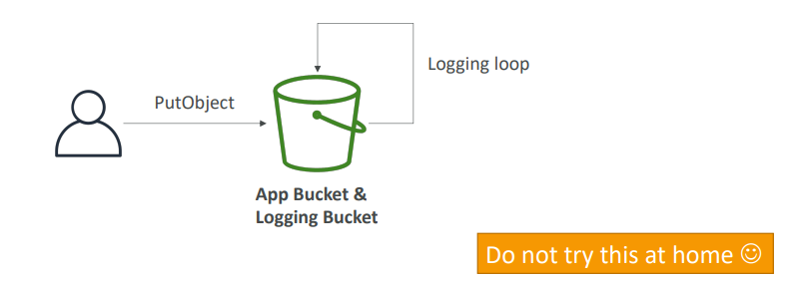

**Amazon S3 – Pre-Signed URLs**

* Generate pre-signed URLs using the S3 Console, AWS CLI or SDK
* URL Expiration

1. S3 Console – 1 min up to 720 mins (12 hours)
2. AWS CLI – configure expiration with --expires-in parameter in seconds (default 3600 secs, max. 604800 secs ~ 168 hours)

* Users given a pre-signed URL inherit the permissions of the user that generated the URL for GET / PUT
* Examples:
* Allow only logged-in users to download a premium video from your S3 bucket
* Allow an ever-changing list of users to download files by generating URLs dynamically
* Allow temporarily a user to upload a file to a precise location in your S3 BUCKET

**S3 Glacier Vault Lock**

|  |  |
| --- | --- |
| * Adopt a WORM (Write Once Read Many) model * Create a Vault Lock Policy * Lock the policy for future edits (can no longer be changed or deleted) * Helpful for compliance and data retention |  |

**S3 Object Lock (versioning must be enabled)**

* Adopt a WORM (Write Once Read Many) model
* Block an object version deletion for a specified amount of time
* **Retention mode - Compliance:**
  + Object versions can't be overwritten or deleted by any user, including the root user
  + Objects retention modes can't be changed, and retention periods can't be shortened
* **Retention mode - Governance:**
  + Most users can't overwrite or delete an object version or alter its lock settings
  + Some users have special permissions to change the retention or delete the object
* **Retention Period:** protect the object for a fixed period, it can be extended
* **Legal Hold:**
  + protect the object indefinitely, independent from retention period
  + can be freely placed and removed using the s3:PutObjectLegalHold IAM permission

**S3 – Access Points**

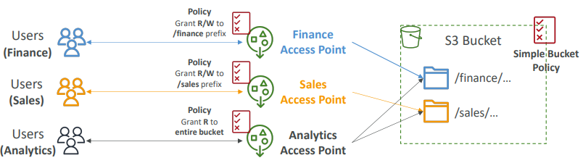

* Access Points simplify security management for S3 Buckets
* Each Access Point has:
  + its own DNS name (Internet Origin or VPC Origin)
  + an access point policy (similar to bucket policy) – manage security at scale

**S3 – Access Points –VPC Origin**

|  |  |
| --- | --- |
| We can define the access point to be accessible only from within the VPC  • You must create a VPC Endpoint to access the Access Point (Gateway or Interface Endpoint)  • The VPC Endpoint Policy must allow access to the target bucket and Access Point |  |

**S3 Object Lambda**

|  |  |
| --- | --- |
| • Use AWS Lambda Functions to change the object before it is retrieved by the caller application  • Only one S3 bucket is needed, on top of which we create S3 Access Point and S3 Object Lambda Access Points.  • Use Cases:   1. Redacting personally identifiable information for analytics or non- production environments. 2. Converting across data formats, such as converting XML to JSON. 3. • Resizing and watermarking images on the fly using caller-specific details, such as the user who requested the object. |  |

# CloudFront & Global Accelerator

|  |  |
| --- | --- |
| • Content Delivery Network (CDN)  • Improves read performance, content is cached at the edge  • Improves users experience  • 216 Point of Presence globally (edge locations)  • DDoS protection (because worldwide), integration with Shield, AWS Web Application Firewall |  |

**CloudFront – Origins**

* S3 bucket
  + For distributing files and caching them at the edge
  + Enhanced security with CloudFront Origin Access Control (OAC)
  + OAC is replacing Origin Access Identity (OAI)
  + CloudFront can be used as an ingress (to upload files to S3)
* Custom Origin (HTTP)
  + Application Load Balancer
  + EC2 instance
  + S3 website (must first enable the bucket as a static S3 website)
  + Any HTTP backend you want

**CloudFront at a high level**

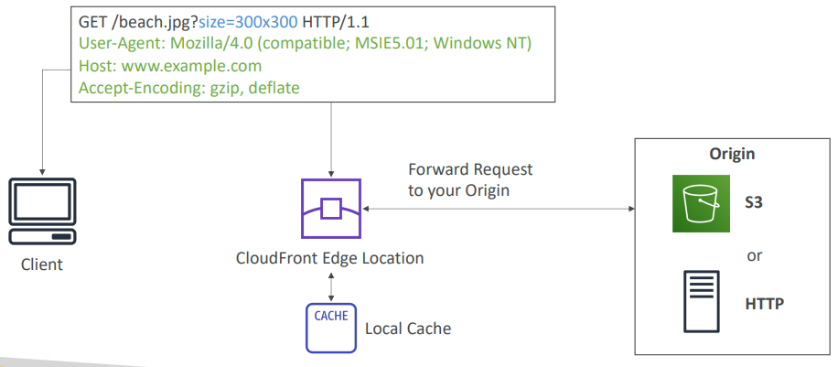

**CloudFront – S3 as an Origin**

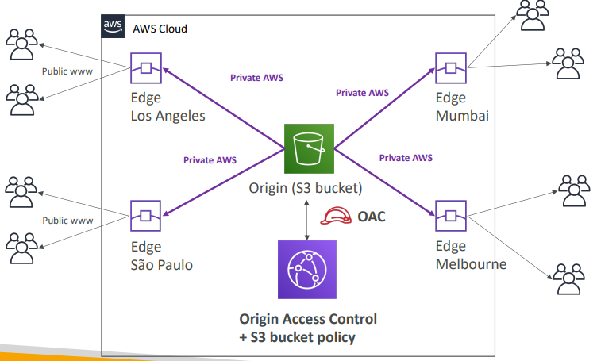

**CloudFront vs S3 Cross Region Replication**

* CloudFront:
  + Global Edge network
  + Files are cached for a TTL (maybe a day)
  + Great for static content that must be available everywhere
* S3 Cross Region Replication:
  + Must be setup for each region you want replication to happen
  + Files are updated in near real-time
  + Read only
  + Great for dynamic content that needs to be available at low-latency in few regions

**CloudFront – ALB or EC2 as an origin**

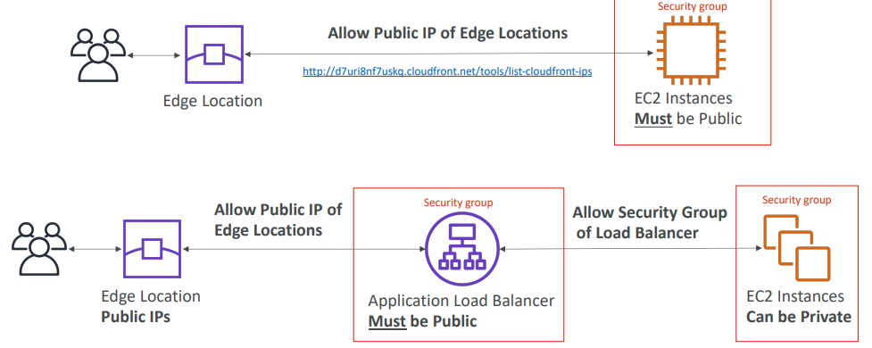

**CloudFront Geo Restriction**

* You can restrict who can access your distribution
  + Allowlist: Allow your users to access your content only if they're in one of the countries on a list of approved countries.
  + Blocklist: Prevent your users from accessing your content if they're in one of the countries on a list of banned countries.
* The “country” is determined using a 3rd party Geo-IP database
* Use case: Copyright Laws to control access to content

**CloudFront - Pricing**

* CloudFront Edge locations are all around the world
* The cost of data out per edge location varies

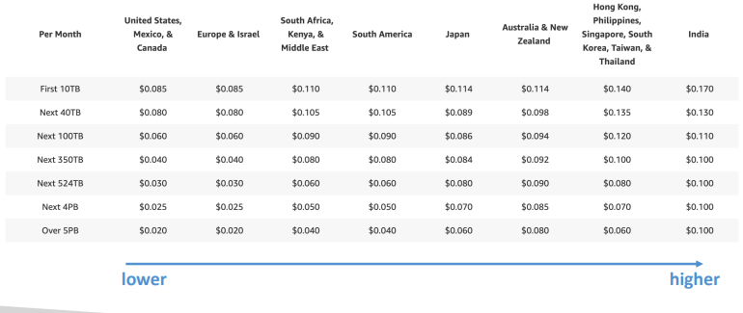

**CloudFront – Price Classes**

* You can reduce the number of edge locations for cost reduction
* Three price classes:
  + Price Class All: all regions – best performance
  + Price Class 200: most regions, but excludes the most expensive regions
  + Price Class 100: only the least expensive regions

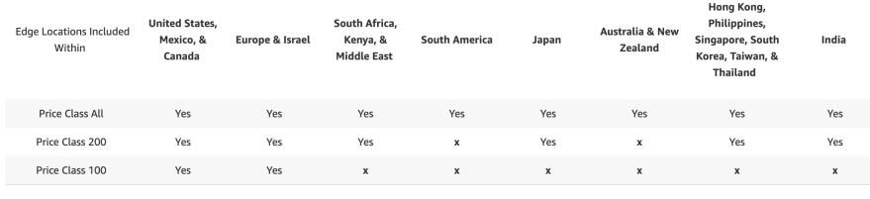

**CloudFront - Price Class**

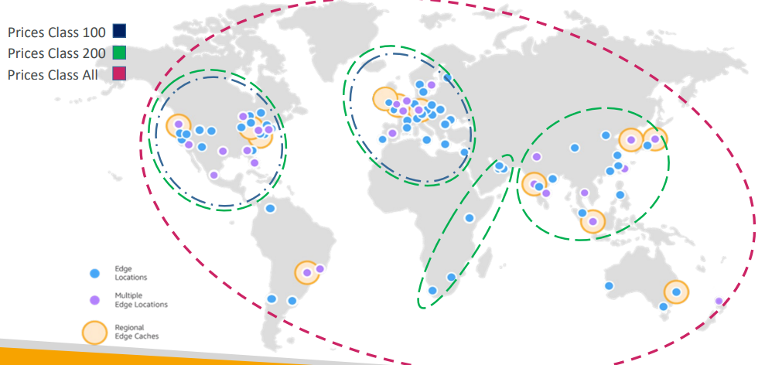

**CloudFront – Cache Invalidations**

|  |  |
| --- | --- |
| • In case you update the back-end origin, CloudFront doesn’t know about it and will only get the refreshed content after the TTL has expired  • However, you can force an entire or partial cache refresh (thus bypassing the TTL) by performing a CloudFront Invalidation  • You can invalidate all files (*) or a special path (/images/*) |  |

**Global users for our application**

|  |  |
| --- | --- |
| * You have deployed an application and have global users who want to access it directly. * They go over the public internet, which can add a lot of latency due to many hops * We wish to go as fast as possible through AWS network to minimize latency |  |

**Unicast IP vs Anycast IP**

|  |  |
| --- | --- |
| • Unicast IP: one server holds one IP address  • Anycast IP: all servers hold the same IP address and the client is routed to the nearest one |  |

**AWS Global Accelerator**

|  |  |
| --- | --- |
| • Leverage the AWS internal network to route to your application  • 2 Anycast IP are created for your application  • The Anycast IP send traffic directly to Edge Locations  • The Edge locations send the traffic to your application |  |

* Works with Elastic IP, EC2 instances, ALB, NLB, public or private
* Consistent Performance
  1. Intelligent routing to lowest latency and fast regional failover
  2. No issue with client cache (because the IP doesn’t change)
  3. Internal AWS network
* Health Checks
  1. Global Accelerator performs a health check of your applications
  2. Helps make your application global (failover less than 1 minute for unhealthy)
  3. Great for disaster recovery (thanks to the health checks)
* Security
  1. only 2 external IP need to be whitelisted
  2. DDoS protection thanks to AWS Shield

**AWS Global Accelerator vs CloudFront**

* They both use the AWS global network and its edge locations around the world
* Both services integrate with AWS Shield for DDoS protection.
* CloudFront
  1. Improves performance for both cacheable content (such as images and videos)
  2. Dynamic content (such as API acceleration and dynamic site delivery)
  3. Content is served at the edge
* Global Accelerator
* Improves performance for a wide range of applications over TCP or UDP
* Proxying packets at the edge to applications running in one or more AWS Regions.
* Good fit for non-HTTP use cases, such as gaming (UDP), IoT (MQTT), or Voice over IP
* Good for HTTP use cases that require static IP addresses
* Good for HTTP use cases that required deterministic, fast regional failover

# AWS Storage Extras

AWS Snow Family

• Highly-secure, portable devices to collect and process data at the edge, and migrate data into and out of AWS

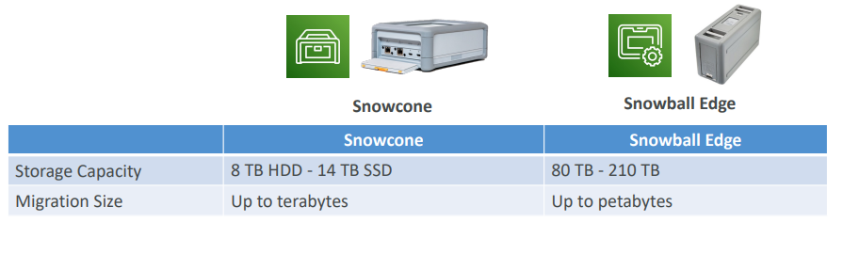

**Data Migrations with AWS Snow Family**

|  |  |
| --- | --- |
| Challenges:   * Limited connectivity * Limited bandwidth * High network cost * Shared bandwidth (can’t maximize the line) * Connection stability |  |

AWS Snow Family: offline devices to perform data migrations If it takes more than a week to transfer over the network, use Snowball devices!

* Direct upload to S3:

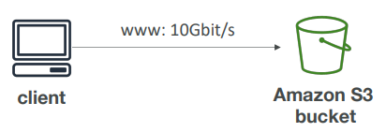

* With Snow Family:

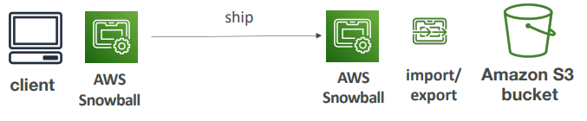

**Snow Family – Usage Process**

1. Request Snowball devices from the AWS console for delivery

2. Install the snowball client / AWS OpsHub on your servers

3. Connect the snowball to your servers and copy files using the client

4. Ship back the device when you’re done (goes to the right AWS facility)

5. Data will be loaded into an S3 bucket

6. Snowball is completely wiped

**What is Edge Computing?**

• Process data while it’s being created on an edge location

• A truck on the road, a ship on the sea, a mining station underground...



• These locations may have limited internet and no access to computing power

• We setup a Snowball Edge / Snowcone device to do edge computing

• Snowcone: 2 CPUs, 4 GB of memory, wired or wireless access

• Snowball Edge Compute Optimized (dedicated for that use case) & Storage Optimized

• Run EC2 Instances or Lambda functions at the edge

• Use cases: preprocess data, machine learning, transcoding media

**Solution Architecture: Snowball into Glacier**

• Snowball cannot import to Glacier directly

• You must use Amazon S3 first, in combination with an S3 lifecycle policy

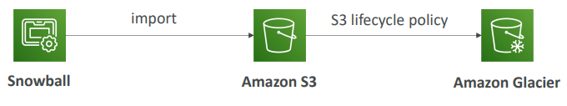

**Amazon FSx – Overview**

* Launch 3rd party high-performance file systems on AWS
* Fully managed service

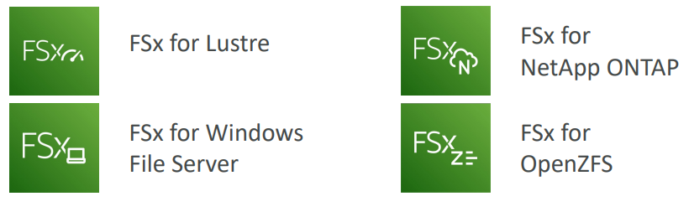

**Amazon FSx for Windows (File Server)**

* FSx for Windows is a fully managed Windows file system share drive
* Supports SMB protocol & Windows NTFS
* Microsoft Active Directory integration, ACLs, user quotas
* Can be mounted on Linux EC2 instances
* Supports Microsoft's Distributed File System (DFS) Namespaces (group files across multiple FS)
* Scale up to 10s of GB/s, millions of IOPS, 100s PB of data
* Storage Options:
  + SSD – latency sensitive workloads (databases, media processing, data analytics, …)
  + HDD – broad spectrum of workloads (home directory, CMS, …)
* Can be accessed from your on-premises infrastructure (VPN or Direct Connect)
* Can be configured to be Multi-AZ (high availability)
* Data is backed up daily to S3

**Amazon FSx for Lustre**

* Lustre is a type of parallel distributed file system, for large-scale computing
* The name Lustre is derived from “Linux” and “cluster
* Machine Learning, High Performance Computing (HPC)
* Video Processing, Financial Modeling, Electronic Design Automation
* Scales up to 100s GB/s, millions of IOPS, sub-ms latencies
* Storage Options:
  + SSD – low-latency, IOPS intensive workloads, small & random file operations
  + HDD – throughput-intensive workloads, large & sequential file operations
* Seamless integration with S3
  + Can “read S3” as a file system (through FSx)
  + Can write the output of the computations back to S3 (through FSx)
* Can be used from on-premises servers (VPN or Direct Connect)

**FSx Lustre - File System Deployment Options**

|  |  |
| --- | --- |
| * Scratch File System   + Temporary storage   + Data is not replicated (doesn’t persist if file server fails)   + High burst (6x faster, 200MBps per TiB)   + Usage: short-term processing, optimize costs * Persistent File System   + Long-term storage   + Data is replicated within same AZ   + Replace failed files within minutes   + Usage: long-term processing, sensitive data |  |

**Amazon FSx for NetApp ONTAP**

|  |  |
| --- | --- |
| * Managed NetApp ONTAP on AWS * File System compatible with NFS, SMB, iSCSI protocol * Move workloads running on ONTAP or NAS to AWS * Works with:   + Linux   + Windows   + MacOS   + VMware Cloud on AWS   + Amazon Workspaces & AppStream 2.0   + Amazon EC2, ECS and EKS * Storage shrinks or grows automatically * Snapshots, replication, low-cost, compression and data de-duplication * Point-in-time instantaneous cloning (helpful for testing new workloads) |  |

**Amazon FSx for OpenZFS**

|  |  |
| --- | --- |
| * Managed OpenZFS file system on AWS * File System compatible with NFS (v3, v4, v4.1, v4.2) * Move workloads running on ZFS to AWS * Works with:   + Linux   + Windows   + MacOS   + VMware Cloud on AWS   + Amazon Workspaces & AppStream 2.0   + Amazon EC2, ECS and EKS * Up to 1,000,000 IOPS with < 0.5ms latency * Snapshots, compression and low-cost * Point-in-time instantaneous cloning (helpful for testing new workloads) |  |

**Hybrid Cloud for Storage**

* AWS is pushing for ”hybrid cloud”
* Part of your infrastructure is on the cloud
* Part of your infrastructure is on-premises
* This can be due to
* Long cloud migrations
* Security requirements
* Compliance requirements
* IT strategy
* S3 is a proprietary storage technology (unlike EFS / NFS), so how do
* you expose the S3 data on-premises?
* AWS Storage Gateway!

**AWS Storage Cloud Native Options**

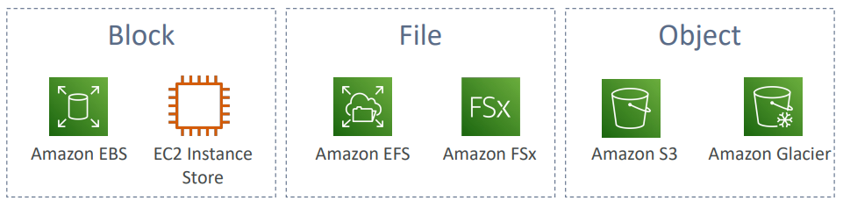

**AWS Storage Gateway**

|  |  |
| --- | --- |
| * Bridge between on-premises data and cloud data * Use cases: * disaster recovery * backup & restore * tiered storage * on-premises cache & low-latency files access * Types of Storage Gateway: * S3 File Gateway * FSx File Gateway * Volume Gateway * Tape Gateway |  |

**Amazon S3 File Gateway**

* Configured S3 buckets are accessible using the NFS and SMB protocol
* Most recently used data is cached in the file gateway
* Supports S3 Standard, S3 Standard IA, S3 One Zone A, S3 Intelligent Tiering
* Transition to S3 Glacier using a Lifecycle Policy
* Bucket access using IAM roles for each File Gateway
* SMB Protocol has integration with Active Directory (AD) for user authentication

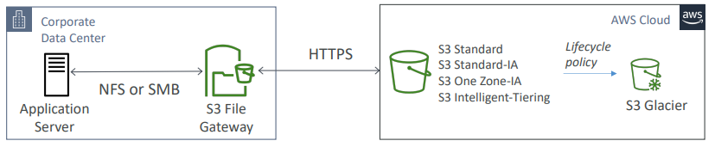

**Amazon FSx File Gateway**

* Native access to Amazon FSx for Windows File Server
* Local cache for frequently accessed data
* Windows native compatibility (SMB, NTFS, Active Directory...)
* Useful for group file shares and home directories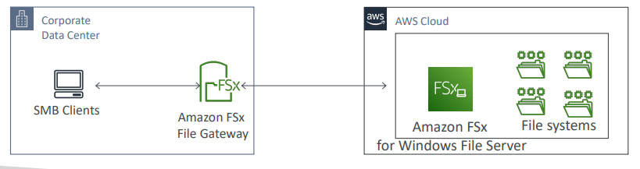

**Volume Gateway**

* Block storage using iSCSI protocol backed by S3
* Backed by EBS snapshots which can help restore on-premises volumes!
* Cached volumes: low latency access to most recent data
* Stored volumes: entire dataset is on premise, scheduled backups to S3

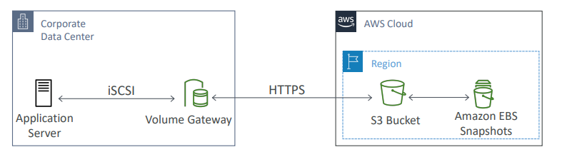

**Tape Gateway**

* Some companies have backup processes using physical tapes (!)
* With Tape Gateway, companies use the same processes but, in the cloud
* Virtual Tape Library (VTL) backed by Amazon S3 and Glacier
* Back up data using existing tape-based processes (and iSCSI interface)
* Works with leading backup software vendors

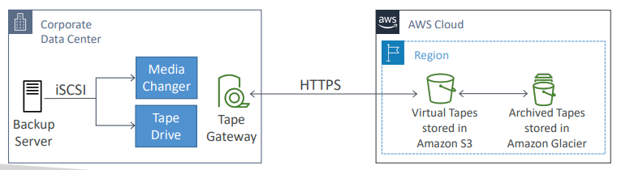

**Storage Gateway – Hardware appliance**

|  |  |
| --- | --- |
| * Using Storage Gateway means you need on-premises virtualization * Otherwise, you can use a Storage Gateway Hardware Appliance * You can buy it on amazon.com * Works with File Gateway, Volume Gateway, Tape Gateway * Has the required CPU, memory, network, SSD cache resources * Helpful for daily NFS backups in small data centers |  |

**AWS Storage Gateway**

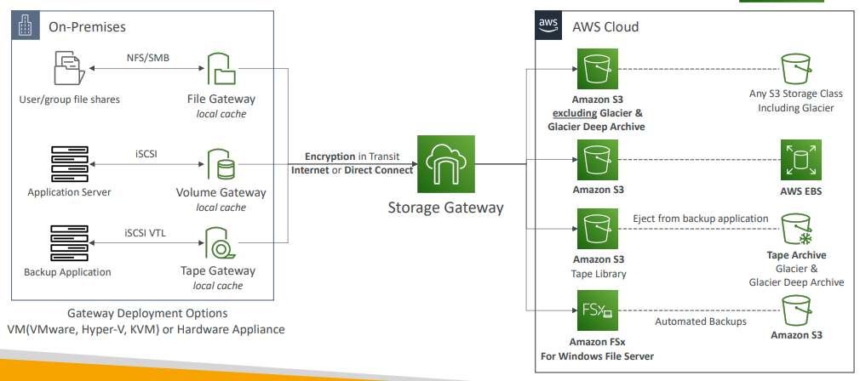

**AWS Transfer Family**

* A fully-managed service for file transfers into and out of Amazon S3 or Amazon EFS using the FTP protocol
* Supported Protocols
* AWS Transfer for FTP (File Transfer Protocol (FTP))
* AWS Transfer for FTPS (File Transfer Protocol over SSL (FTPS))
* AWS Transfer for SFTP (Secure File Transfer Protocol (SFTP))
* Managed infrastructure, Scalable, Reliable, Highly Available (multi-AZ)
* Pay per provisioned endpoint per hour + data transfers in GB
* Store and manage users’ credentials within the service
* Integrate with existing authentication systems (Microsoft Active Directory,
* LDAP, Okta, Amazon Cognito, custom)
* Usage: sharing files, public datasets, CRM, ERP, …

**AWS Transfer Family**

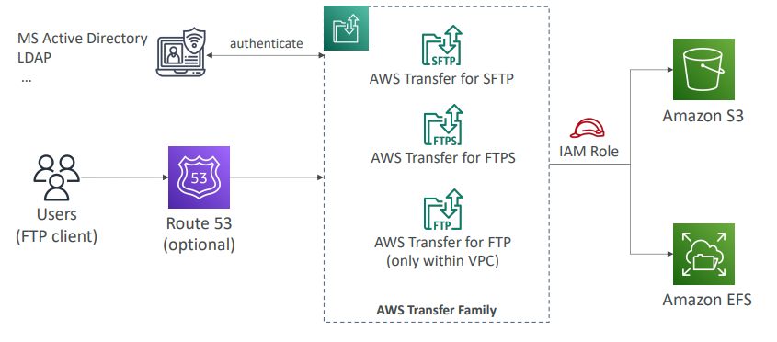

**AWS DataSync**

* Move large amount of data to and from
  + On-premises / other cloud to AWS (NFS, SMB, HDFS, S3 API…) – needs agent
  + AWS to AWS (different storage services) – no agent needed
* Can synchronize to:
  + Amazon S3 (any storage classes – including Glacier)
  + Amazon EFS
  + Amazon FSx (Windows, Lustre, NetApp, OpenZFS...)
* Replication tasks can be scheduled hourly, daily, weekly
* File permissions and metadata are preserved (NFS POSIX, SMB…)
* One agent task can use 10 Gbps, can setup a bandwidth limit

**AWS DataSync NFS / SMB to AWS (S3, EFS, FSx…)**

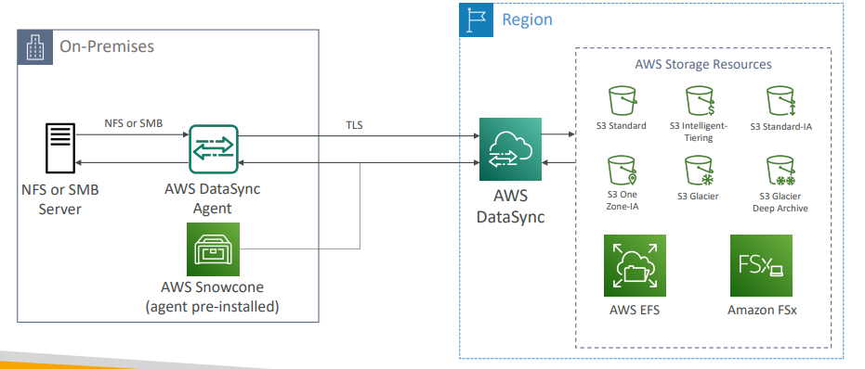

**AWS DataSync Transfer between AWS storage services**

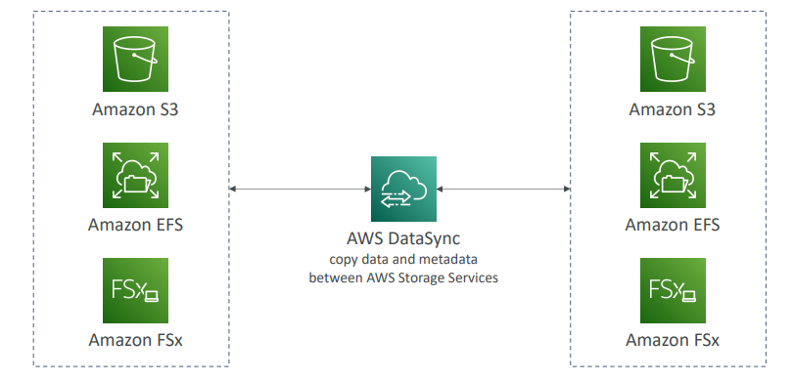

**Storage Comparison**

* S3: Object Storage
* S3 Glacier: Object Archival
* EBS volumes: Network storage for one EC2 instance at a time
* Instance Storage: Physical storage for your EC2 instance (high IOPS)
* EFS: Network File System for Linux instances, POSIX filesystem
* FSx for Windows: Network File System for Windows servers
* FSx for Lustre: High Performance Computing Linux file system
* FSx for NetApp ONTAP: High OS Compatibility
* FSx for OpenZFS: Managed ZFS file system
* Storage Gateway: S3 & FSx File Gateway, Volume Gateway (cache & stored), Tape Gateway
* Transfer Family: FTP, FTPS, SFTP interface on top of Amazon S3 or Amazon EFS
* DataSync: Schedule data sync from on-premises to AWS, or AWS to AWS
* Snowcone / Snowball / Snowmobile: to move large amount of data to the cloud, physically
* Database: for specific workloads, usually with indexing and querying

# AWS Integration & Messaging

* When we start deploying multiple applications, they will inevitably need to communicate with one another
* There are two patterns of application communication

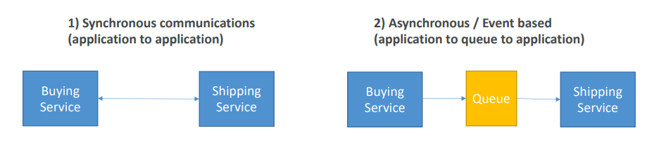

Section Introduction

* Synchronous between applications can be problematic if there are sudden spikes of traffic
* What if you need to suddenly encode 1000 videos but usually it’s 10?
* In that case, it’s better to decouple your applications,
* using SQS: queue model
* using SNS: pub/sub model
* using Kinesis: real-time streaming model
* These services can scale independently from our application!

**Amazon SQS What’s a queue?**

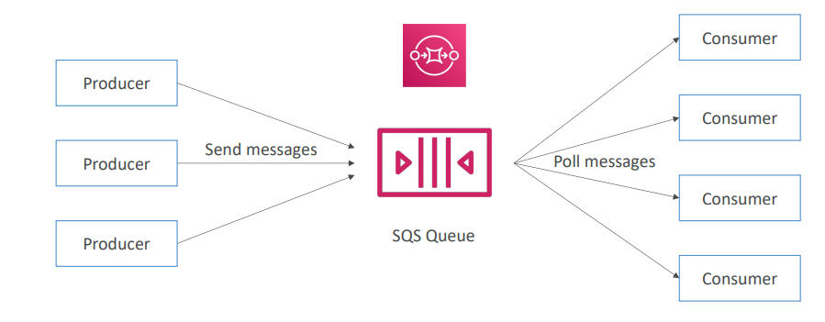

Amazon SQS – Standard Queue

* Oldest offering (over 10 years old)
* Fully managed service, used to decouple applications
* Attributes:
  + Unlimited throughput, unlimited number of messages in queue
  + Default retention of messages: 4 days, maximum of 14 days
  + Low latency (<10 ms on publish and receive)
  + Limitation of 256KB per message sent
* Can have duplicate messages (at least once delivery, occasionally)
* Can have out of order messages (best effort ordering)

SQS – Producing Messages

* Produced to SQS using the SDK (SendMessage API)
* The message is persisted in SQS until a consumer deletes it
* Message retention: default 4 days, up to 14 days
* Example: send an order to be processed
  + Order id
  + Customer id
  + Any attributes you want
* SQS standard: unlimited throughput

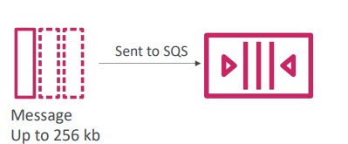

**SQS – Consuming Messages**

* Consumers (running on EC2 instances, servers, or AWS Lambda)…
* Poll SQS for messages (receive up to 10 messages at a time)
* Process the messages (example: insert the message into an RDS database)
* Delete the messages using the DeleteMessage AP

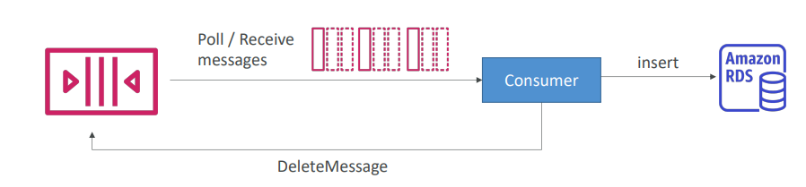

**SQS – Multiple EC2 Instances Consumers**

|  |  |
| --- | --- |
| • Consumers receive and process messages in parallel  • At least once delivery  • Best-effort message ordering  • Consumers delete messages after processing them  • We can scale consumers horizontally to improve throughput of processing |  |

**SQS with Auto Scaling Group (ASG)**

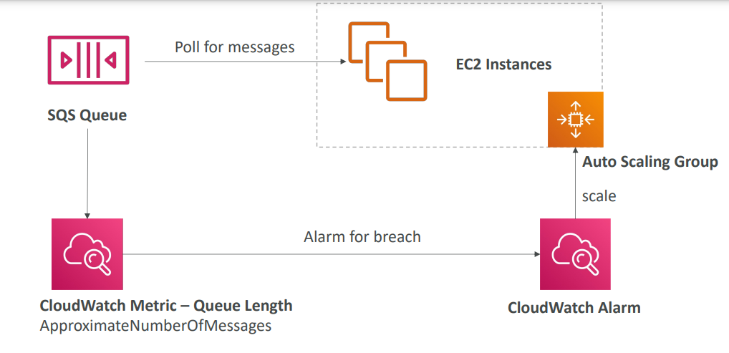

**SQS to decouple between application tiers**

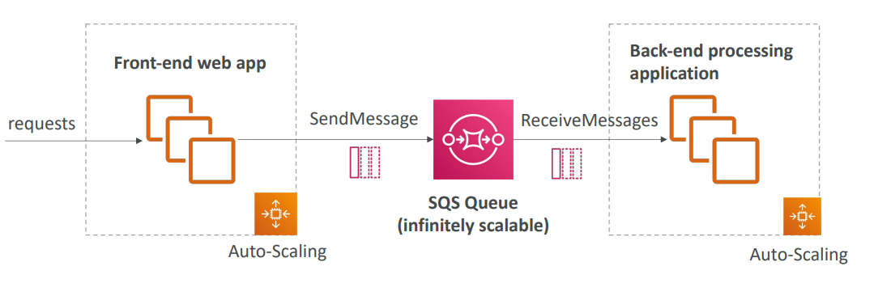

**Amazon SQS – Security**

* Encryption:
  + In-flight encryption using HTTPS API
  + At-rest encryption using KMS keys
  + Client-side encryption if the client wants to perform encryption/decryption itself
* Access Controls: IAM policies to regulate access to the SQS API
* SQS Access Policies (similar to S3 bucket policies)
  + Useful for cross-account access to SQS queues
  + Useful for allowing other services (SNS, S3…) to write to an SQS queue

**SQS – Message Visibility Timeout**

* After a message is polled by a consumer, it becomes invisible to other consumers
* By default, the “message visibility timeout” is 30 seconds
* That means the message has 30 seconds to be processed
* After the message visibility timeout is over, the message is “visible” in SQS

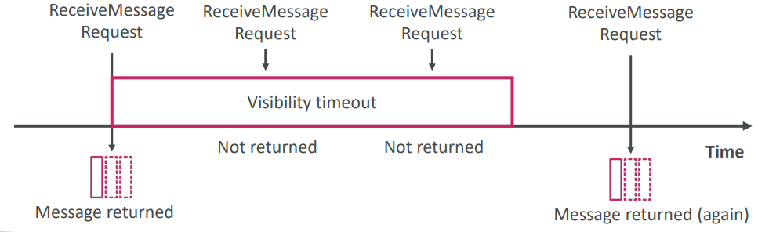

**SQS – Message Visibility Timeout**

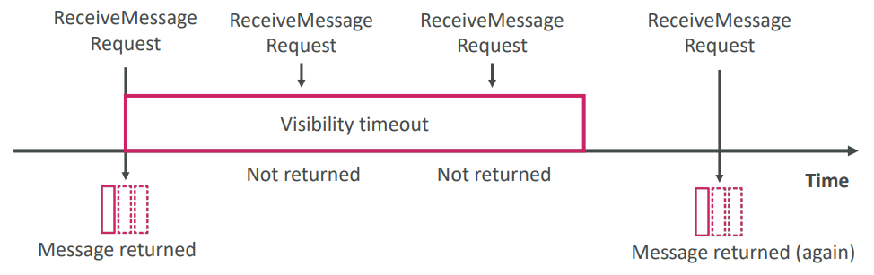

* If a message is not processed within the visibility timeout, it will be processed twice
* A consumer could call the ChangeMessageVisibility API to get more time
* If visibility timeout is high (hours), and consumer crashes, re-processing will take time
* If visibility timeout is too low (seconds), we may get duplicates

**Amazon SQS - Long Polling**

|  |  |
| --- | --- |
| * When a consumer requests messages from the queue, it can optionally “wait” for messages to arrive if there are none in the queue * This is called Long Polling * LongPolling decreases the number of API calls made to SQS while increasing the efficiency and reducing latency of your application * The wait time can be between 1 sec to 20 sec (20 sec preferable) * Long Polling is preferable to Short Polling * Long polling can be enabled at the queue level or at the API level using WaitTimeSeconds |  |

**Amazon SQS – FIFO Queue**

* FIFO = First In First Out (ordering of messages in the queue)

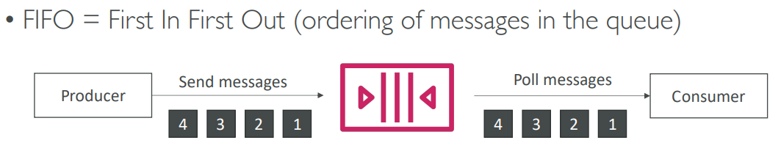

* Limited throughput: 300 msg/s without batching, 3000 msg/s with
* Exactly-once send capability (by removing duplicates)
* Messages are processed in order by the consumer

**SQS with Auto Scaling Group (ASG)**

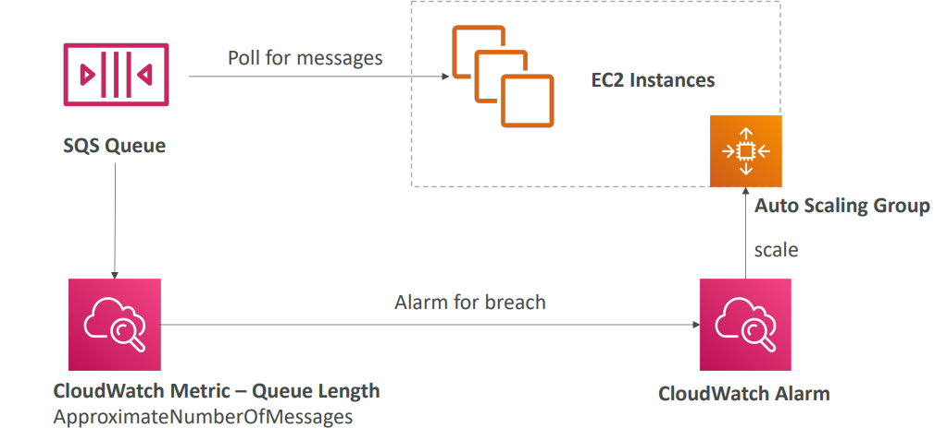

If the load is too big, some transactions may be lost

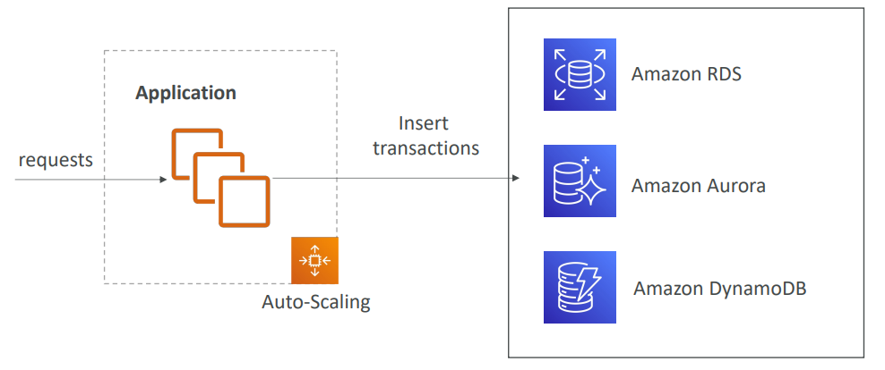

**SQS as a buffer to database writes**

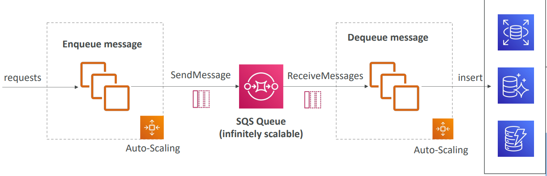

**SQS to decouple between application tiers**

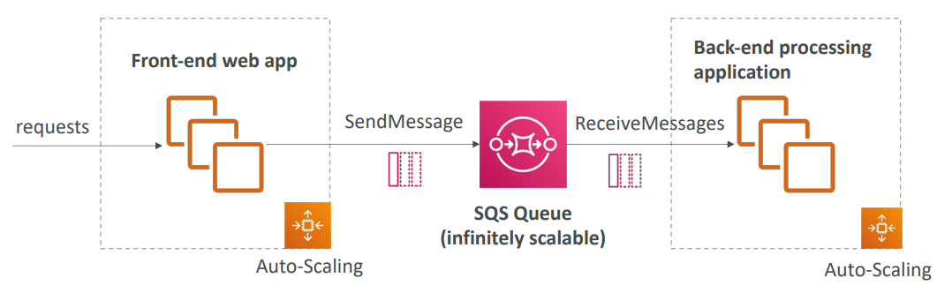

**Amazon SNS**

• What if you want to send one message to many receivers?

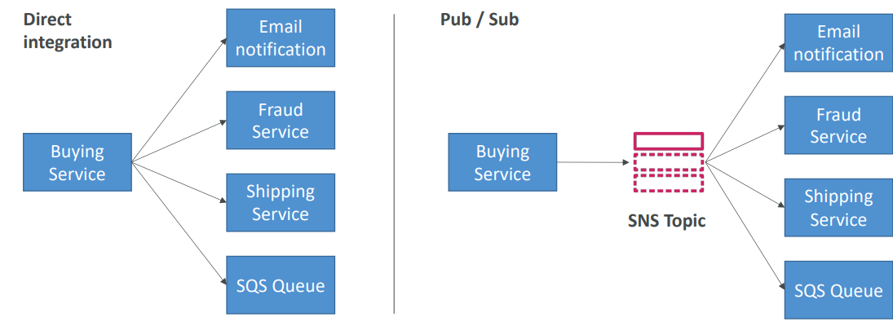

**Amazon SNS**

* The “event producer” only sends message to one SNS topic
* As many “event receivers” (subscriptions) as we want to listen to the SNS topic notifications
* Each subscriber to the topic will get all the messages (note: new feature to filter messages)
* Up to 12,500,000 subscriptions per topic
* 100,000 topics limit

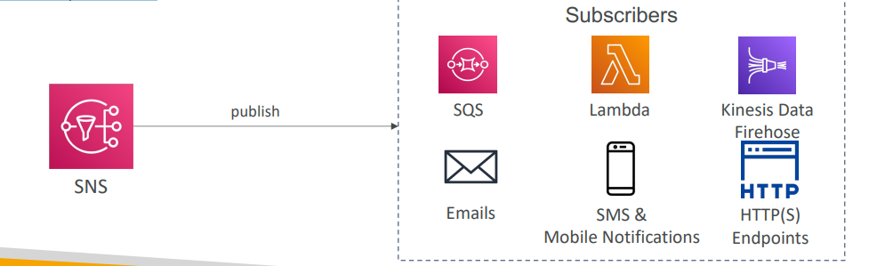

**SNS integrates with a lot of AWS services**

Many AWS services can send data directly to SNS for notifications

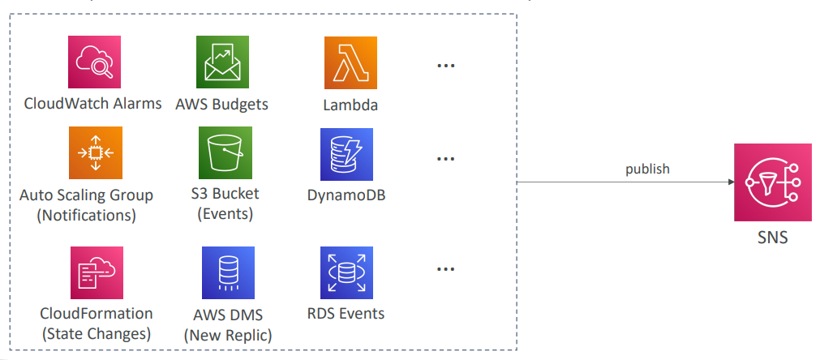

**Amazon SNS – How to publish**

Topic Publish (using the SDK)

* Create a topic
* Create a subscription (or many)
* Publish to the topic

Direct Publish (for mobile apps SDK)

* Create a platform application
* Create a platform endpoint
* Publish to the platform endpoint
* Works with Google GCM, Apple APNS, Amazon ADM

**Amazon SNS – Security**

* Encryption:
  + In-flight encryption using HTTPS API
  + At-rest encryption using KMS keys
  + Client-side encryption if the client wants to perform encryption/decryption itself
* Access Controls: IAM policies to regulate access to the SNS API
* SNS Access Policies (similar to S3 bucket policies)
  + Useful for cross-account access to SNS topics
  + Useful for allowing other services ( S3…) to write to an SNS topic

**SNS + SQS: Fan Out**

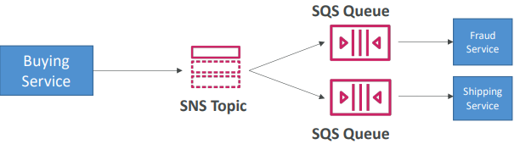

* Push once in SNS, receive in all SQS queues that are subscribers
* Fully decoupled, no data loss
* SQS allows for: data persistence, delayed processing and retries of work
* Ability to add more SQS subscribers over time
* Make sure your SQS queue access policy allows for SNS to write
* Cross-Region Delivery: works with SQS Queues in other regions

**Application: S3 Events to multiple queues**

* For the same combination of: event type (e.g. object create) and prefix (e.g. images/) you can only have one S3 Event rule
* If you want to send the same S3 event to many SQS queues, use fan-out

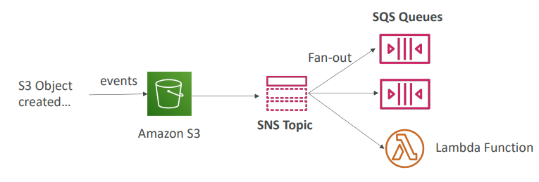

**Application: SNS to Amazon S3 through Kinesis Data Firehose**

SNS can send to Kinesis and therefore we can have the following solutions architecture:

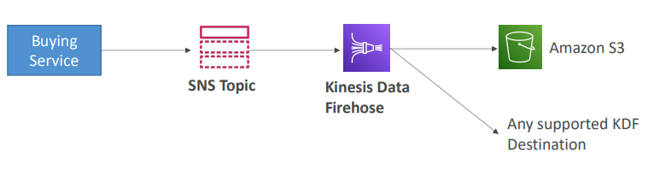

**Amazon SNS – FIFO Topic**

* FIFO = First In First Out (ordering of messages in the topic)

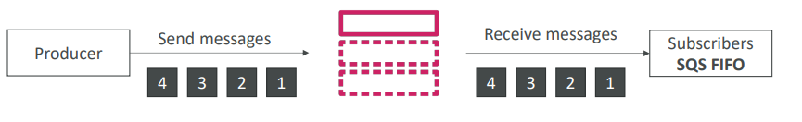

* Similar features as SQS FIFO:
* Ordering by Message Group ID (all messages in the same group are ordered)
* Deduplication using a Deduplication ID or Content Based Deduplication
* Can have SQS Standard and FIFO queues as subscribers
* Limited throughput (same throughput as SQS FIFO)

**SNS FIFO + SQS FIFO: Fan Out**

In case you need fan out + ordering + deduplication

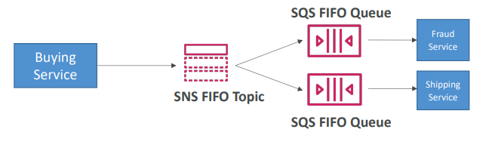

**SNS – Message Filtering**

* JSON policy used to filter messages sent to SNS topic’s subscriptions
* If a subscription doesn’t have a filter policy, it receives every message

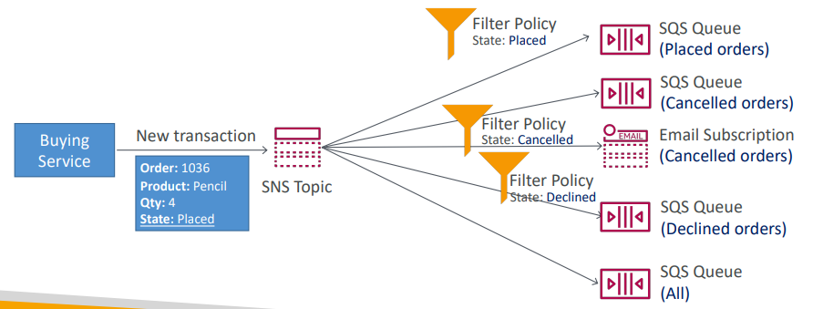

**Kinesis Overview**

* Makes it easy to collect, process, and analyze streaming data in real-time
* Ingest real-time data such as: Application logs, Metrics, Website clickstreams, IoT telemetry data…



* Kinesis Data Streams: capture, process, and store data streams
* Kinesis Data Firehose: load data streams into AWS data stores
* Kinesis Data Analytics: analyze data streams with SQL or Apache Flink
* Kinesis Video Streams: capture, process, and store video streams

**Kinesis Data Streams**

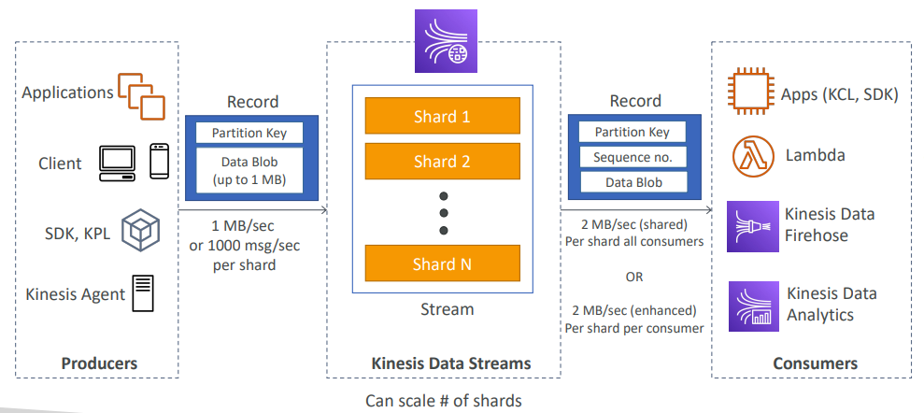

**Kinesis Data Streams**

* Retention between 1 day to 365 days
* Ability to reprocess (replay) data
* Once data is inserted in Kinesis, it can’t be deleted (immutability)
* Data that shares the same partition goes to the same shard (ordering)
* Producers: AWS SDK, Kinesis Producer Library (KPL), Kinesis Agent
* Consumers:
  + Write your own: Kinesis Client Library (KCL), AWS SDK
  + Managed: AWS Lambda, Kinesis Data Firehose, Kinesis Data Analytics,

**Kinesis Data Streams – Capacity Modes**

* Provisioned mode:
  + You choose the number of shards provisioned, scale manually or using API
  + Each shard gets 1MB/s in (or 1000 records per second)
  + Each shard gets 2MB/s out (classic or enhanced fan-out consumer)
  + You pay per shard provisioned per hour
* On-demand mode:
  + No need to provision or manage the capacity
  + Default capacity provisioned (4 MB/s in or 4000 records per second)
  + Scales automatically based on observed throughput peak during the last 30 days
  + Pay per stream per hour & data in/out per GB

**Kinesis Data Streams Security**

|  |  |
| --- | --- |
| * Control access / authorization using IAM policies * Encryption in flight using HTTPS endpoints * Encryption at rest using KMS * You can implement encryption/decryption of data on client side (harder) * VPC Endpoints available for Kinesis to access within VPC * Monitor API calls using CloudTrail |  |

**Kinesis Data Firehose**

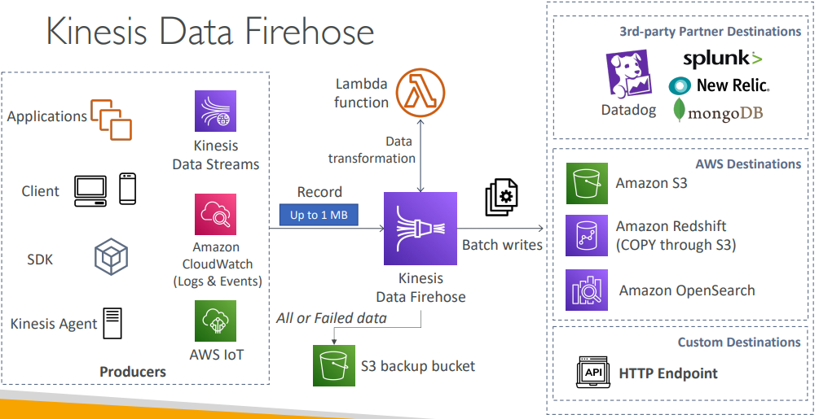

**Kinesis Data Firehose**

* Fully Managed Service, no administration, automatic scaling, serverless
  + AWS: Redshift / Amazon S3 / OpenSearch
  + 3rd party partner: Splunk / MongoDB / DataDog / NewRelic / …
  + Custom: send to any HTTP endpoint
* Pay for data going through Firehose
* Near Real Time
  + Buffer interval: 0 seconds (no buffering) to 900 seconds
  + Buffer size: minimum 1MB
* Supports many data formats, conversions, transformations, compression
* Supports custom data transformations using AWS Lambda
* Can send failed or all data to a backup S3 bucket

**Kinesis Data Streams vs Firehose**



|  |  |
| --- | --- |
| • Streaming service for ingest at scale  • Write custom code (producer /  consumer)  • Real-time (~200 ms)  • Manage scaling (shard splitting /  merging)  • Data storage for 1 to 365 days  • Supports replay capability | • Load streaming data into S3 / Redshift / OpenSearch / 3rd party / custom HTTP  • Fully managed  • Near real-time  • Automatic scaling  • No data storage  • Doesn’t support replay capability |

**Ordering data into Kinesis**

|  |  |
| --- | --- |
| * Imagine you have 100 trucks (truck_1, truck_2, … truck_100) on the road sending their GPS positions regularly into AWS. * You want to consume the data in order for each truck, so that you can track their movement accurately. * How should you send that data into Kinesis? * Answer: send using a “Partition Key” value of the “truck_id” * The same key will always go to the same shard |  |

**Ordering data into SQS**

* For SQS standard, there is no ordering.
* For SQS FIFO, if you don’t use a Group ID, messages are consumed in the order they are sent, with only one consumer

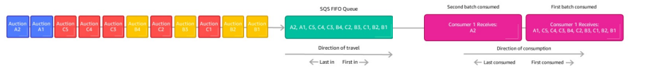

* You want to scale the number of consumers, but you want messages to be “grouped” when they are related to each other
* Then you use a Group ID (similar to Partition Key in Kinesis)

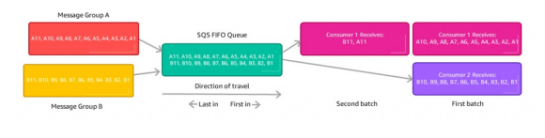

**Kinesis vs SQS ordering**

* Let’s assume 100 trucks, 5 kinesis shards, 1 SQS FIFO
* Kinesis Data Streams:
  + On average you’ll have 20 trucks per shard
  + Trucks will have their data ordered within each shard
  + The maximum amount of consumers in parallel we can have is 5
  + Can receive up to 5 MB/s of data
* SQS FIFO
  + You only have one SQS FIFO queue
  + You will have 100 Group ID
  + You can have up to 100 Consumers (due to the 100 Group ID)
  + You have up to 300 messages per second (or 3000 if using batching)

**SQS vs SNS vs Kinesis**

|  |  |  |
| --- | --- | --- |
| SQS:  • Consumer “pull data”  • Data is deleted after being  consumed  • Can have as many workers  (consumers) as we want  • No need to provision  throughput  • Ordering guarantees only on  FIFO queues  • Individual message delay  capability | SNS:  • Push data to many  subscribers  • Up to 12,500,000 subscribers  • Data is not persisted (lost if  not delivered)  • Pub/Sub  • Up to 100,000 topics  • No need to provision  throughput  • Integrates with SQS for fan- out architecture pattern  • FIFO capability for SQS FIFO | Kinesis:  • Standard: pull data  • 2 MB per shard  • Enhanced-fan out: push data  • 2 MB per shard per consumer  • Possibility to replay data  • Meant for real-time big data,  analytics and ETL  • Ordering at the shard level  • Data expires after X days  • Provisioned mode or ondemand capacity mode |

Amazon MQ

* SQS, SNS are “cloud-native” services: proprietary protocols from AWS
* Traditional applications running from on-premises may use open protocols such as: MQTT, AMQP, STOMP, Openwire, WSS
* When migrating to the cloud, instead of re-engineering the application to use SQS and SNS, we can use Amazon MQ
* Amazon MQ is a managed message broker service for



* Amazon MQ doesn’t “scale” as much as SQS / SNS
* Amazon MQ runs on servers, can run in Multi-AZ with failover
* Amazon MQ has both queue feature (~SQS) and topic features (~SNS)

**Amazon MQ – High Availability**

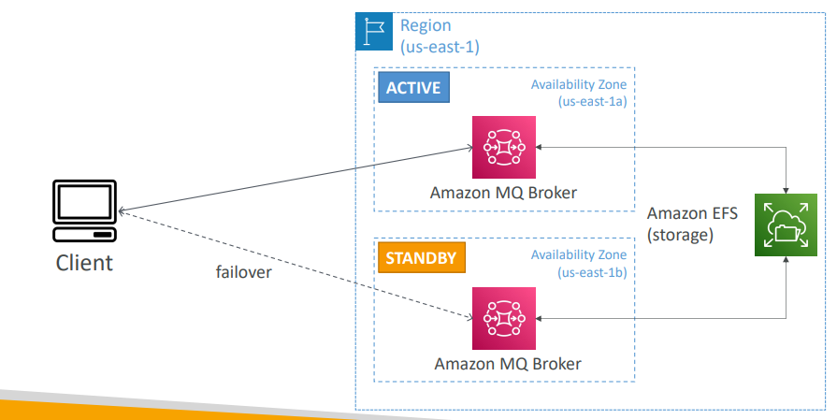

# Containers on AWS

What is Docker?

* Docker is a software development platform to deploy apps
* Apps are packaged in containers that can be run on any OS
* Apps run the same, regardless of where they’re run
* Any machine
* No compatibility issues
* Predictable behavior
* Less work
* Easier to maintain and deploy
* Works with any language, any OS, any technology
* Use cases: microservices architecture, lift-and-shift apps from on- premises to the AWS cloud, …

**Docker on an OS**

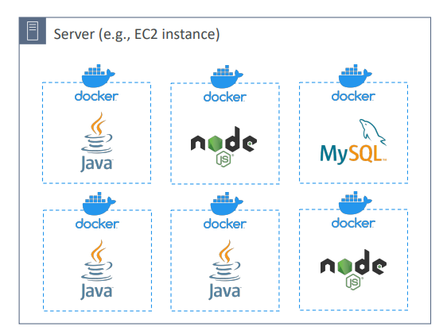

**Where are Docker images stored?**

* Docker images are stored in Docker Repositories
* Docker Hub (https://hub.docker.com)
* Public repository
* Find base images for many technologies or OS (e.g., Ubuntu, MySQL, …)
* Amazon ECR (Amazon Elastic Container Registry)
* Private repository
* Public repository (Amazon ECR Public Gallery <https://gallery.ecr.aws>)

**Docker vs. Virtual Machines**

* Docker is ”sort of” a virtualization technology, but not exactly
* Resources are shared with the host => many containers on one server

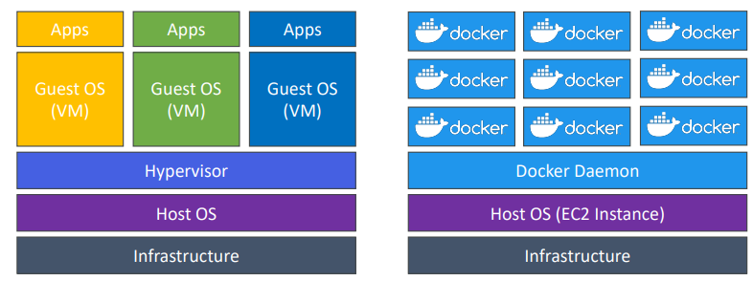

**Getting Started with Docker**

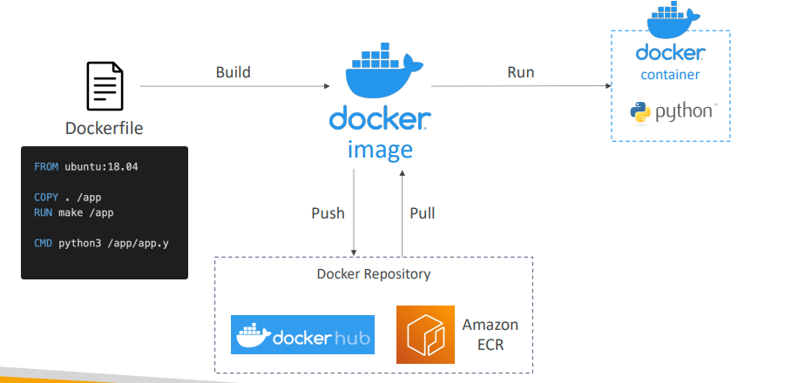

**Docker Containers Management on AWS**

|  |  |
| --- | --- |
| * Amazon Elastic Container Service (Amazon ECS)   + Amazon’s own container platform * Amazon Elastic Kubernetes Service (Amazon EKS)   + Amazon’s managed Kubernetes (open source) * AWS Fargate   + Amazon’s own Serverless container platform   + Works with ECS and with EKS * Amazon ECR:   + Store container images |  |

**Amazon ECS - EC2 Launch Type**

|  |  |
| --- | --- |
| * ECS = Elastic Container Service * Launch Docker containers on AWS = Launch ECS Tasks on ECS Clusters * EC2 Launch Type: you must provision & maintain the infrastructure (the EC2 instances) * Each EC2 Instance must run the ECS Agent to register in the ECS Cluster * AWS takes care of starting / stopping containers |  |

**Amazon ECS – Fargate Launch Type**

|  |  |
| --- | --- |
| * Launch Docker containers on AWS * You do not provision the infrastructure (no EC2 instances to manage) * It’s all Serverless! * You just create task definitions * AWS just runs ECS Tasks for you based on the CPU / RAM you need * To scale, just increase the number of tasks. Simple - no more EC2 instances |  |

**Amazon ECS – IAM Roles for ECS**

|  |  |
| --- | --- |
| * EC2 Instance Profile (EC2 Launch Type only):   + Used by the ECS agent   + Makes API calls to ECS service   + Send container logs to CloudWatch Logs   + Pull Docker image from ECR   + Reference sensitive data in Secrets Manager or SSM Parameter Store * ECS Task Role:   + Allows each task to have a specific role   + Use different roles for the different ECS Services you run   + Task Role is defined in the task definition |  |

**Amazon ECS – Load Balancer Integrations**

|  |  |
| --- | --- |
| * Application Load Balancer supported and works for most use cases * Network Load Balancer recommended only for high throughput / high performance use cases, or to pair it with AWS Private Link * Classic Load Balancer supported but not recommended (no advanced features – no Fargate) |  |

**Amazon ECS – Data Volumes (EFS)**

|  |  |
| --- | --- |
| * Mount EFS file systems onto ECS tasks * Works for both EC2 and Fargate launch types * Tasks running in any AZ will share the same data in the EFS file system * Fargate + EFS = Serverless * Use cases: persistent multi-AZ shared storage for your containers * Note:   + Amazon S3 cannot be mounted as a file system |  |

**ECS Service Auto Scaling**

* Automatically increase/decrease the desired number of ECS tasks
* Amazon ECS Auto Scaling uses AWS Application Auto Scaling
  + ECS Service Average CPU Utilization
  + ECS Service Average Memory Utilization - Scale on RAM
  + ALB Request Count Per Target – metric coming from the ALB
* Target Tracking – scale based on target value for a specific CloudWatch metric
* Step Scaling – scale based on a specified CloudWatch Alarm
* Scheduled Scaling – scale based on a specified date/time (predictable changes)
* ECS Service Auto Scaling (task level) ≠ EC2 Auto Scaling (EC2 instance level)
* Fargate Auto Scaling is much easier to setup (because Serverless)

**EC2 Launch Type – Auto Scaling EC2 Instances**

* Accommodate ECS Service Scaling by adding underlying EC2 Instances
  + Auto Scaling Group Scaling
  + Scale your ASG based on CPU Utilization
* Add EC2 instances over time
* ECS Cluster Capacity Provider
  + Used to automatically provision and scale the infrastructure for your ECS Tasks
  + Capacity Provider paired with an Auto Scaling Group
  + Add EC2 Instances when you’re missing capacity (CPU, RAM…)

**ECS Scaling – Service CPU Usage Example**

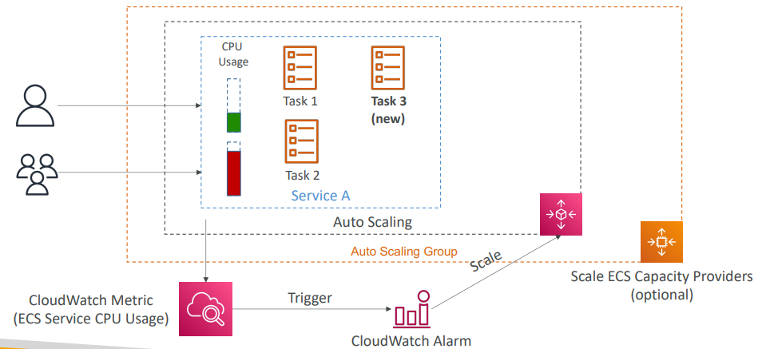

**ECS tasks invoked by Event Bridge**

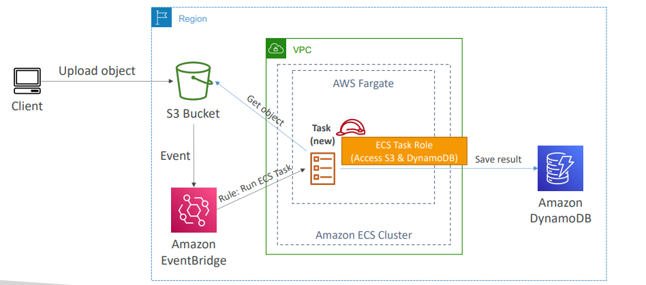

**ECS tasks invoked by Event Bridge Schedule**

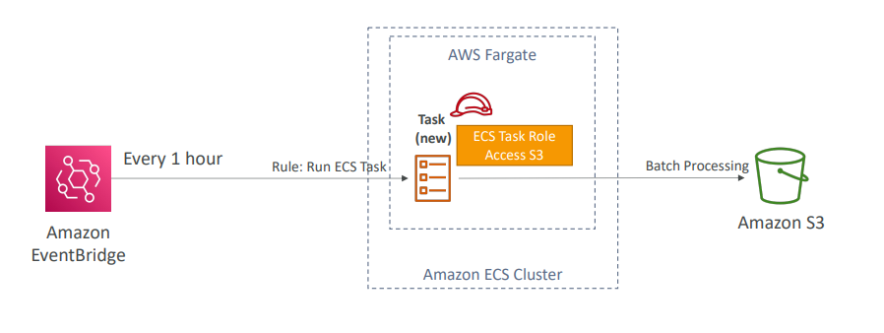

**E** **CS – SQS Queue Example**

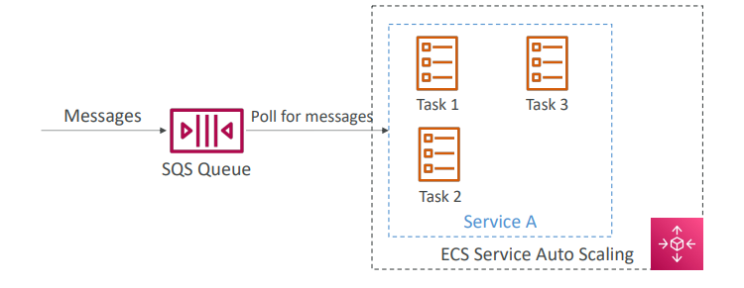

**ECS – Intercept Stopped Tasks using EventBridge**

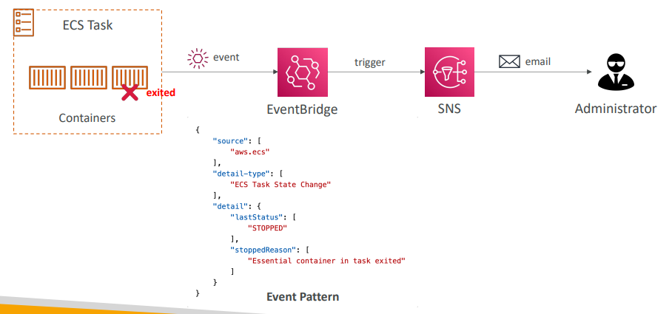

**Amazon ECR**

|  |  |
| --- | --- |
| * ECR = Elastic Container Registry * Store and manage Docker images on AWS * Private and Public repository (Amazon ECR Public Gallery https://gallery.ecr.aws) * Fully integrated with ECS, backed by Amazon S3 * Access is controlled through IAM (permission errors => policy)   Supports image vulnerability scanning, versioning, image tags, image lifecycle, … |  |

**Amazon EKS Overview**

* Amazon EKS = Amazon Elastic Kubernetes Service
* It is a way to launch managed Kubernetes clusters on AWS
* Kubernetes is an open-source system for automatic deployment, scaling and management of containerized (usually Docker) application
* It’s an alternative to ECS, similar goal but different API
* EKS supports EC2 if you want to deploy worker nodes or Fargate to deploy serverless containers
* Use case: if your company is already using Kubernetes on-premises or in another cloud, and wants to migrate to AWS using Kubernetes
* Kubernetes is cloud-agnostic (can be used in any cloud – Azure, GCP…)
* For multiple regions, deploy one EKS cluster per region
* Collect logs and metrics using CloudWatch Container Insights

**Amazon EKS – Diagram**

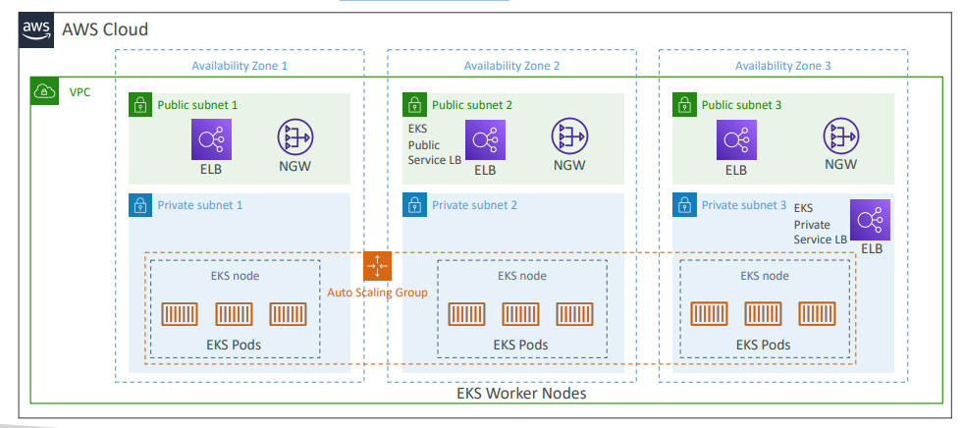

**Amazon EKS – Node Types**

* Managed Node Groups
  + Creates and manages Nodes (EC2 instances) for you
  + Nodes are part of an ASG managed by EKS
  + Supports On-Demand or Spot Instances
* Self-Managed Nodes
  + Nodes created by you and registered to the EKS cluster and managed by an ASG
  + You can use prebuilt AMI - Amazon EKS Optimized AMI
  + Supports On-Demand or Spot Instances
* AWS Fargate
  + No maintenance required; no nodes managed

**Amazon EKS – Data Volumes**

|  |  |
| --- | --- |
| * Need to specify StorageClass manifest on your EKS cluster * Leverages a Container Storage Interface (CSI) compliant driver * Support for… * Amazon EBS * Amazon EFS (works with Fargate) * Amazon FSx for Lustre * Amazon FSx for NetApp ONTAP |  |

**AWS App Runner**

|  |  |
| --- | --- |
| * Fully managed service that makes it easy to deploy web applications and APIs at scale * No infrastructure experience required * Start with your source code or container image * Automatically builds and deploy the web app * Automatic scaling, highly available, load balancer, encryption * VPC access support * Connect to database, cache, and message queue services * Use cases: web apps, APIs, microservices, rapid production deployments |  |

**AWS App2Container (A2C)**

* CLI tool for migrating and modernizing Java and .NET web apps into Docker Containers
* Lift-and-shift your apps running in on-premises bare metal, virtual machines, or in any Cloud to AWS
* Accelerate modernization, no code changes, migrate legacy apps…
* Generates CloudFormation templates (compute, network…)
* Register generated Docker containers to ECR
* Deploy to ECS, EKS, or App Runner
* Supports pre-built CI/CD pipelines

**AWS App2Container (A2C)**

